Referred {

@@@<https://www.youtube.com/watch?v=fAAZixBzIAI>

}

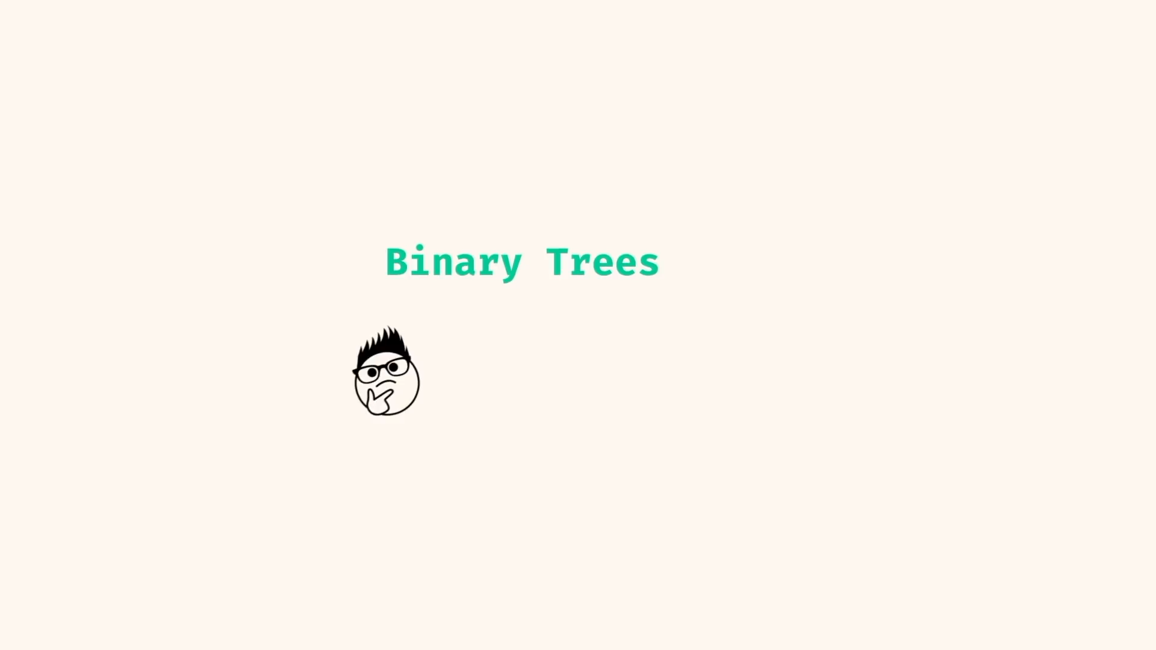

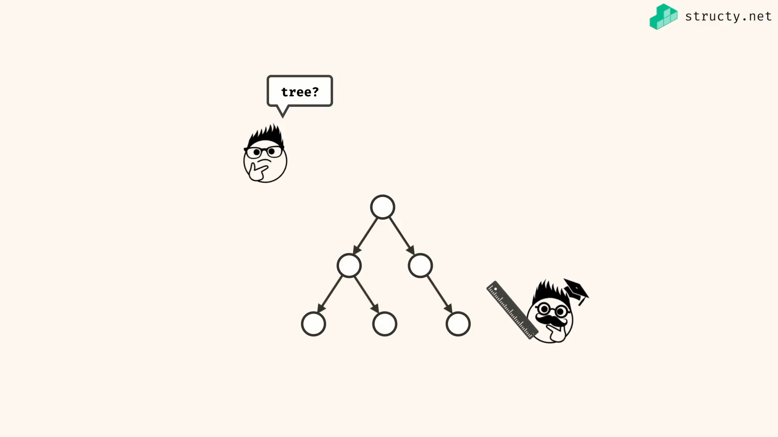

Tree – single directed top to down nodes with edges of graph..

Terminologies

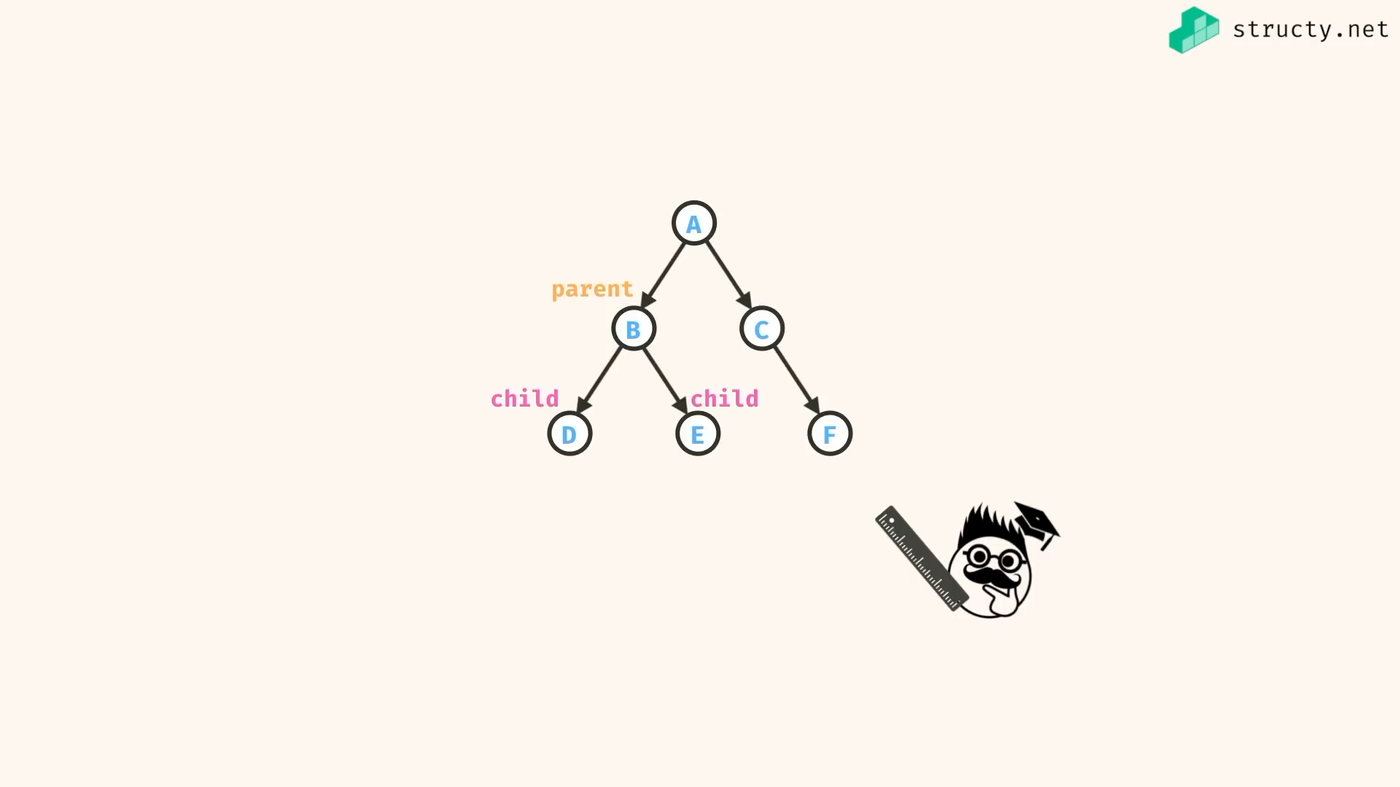

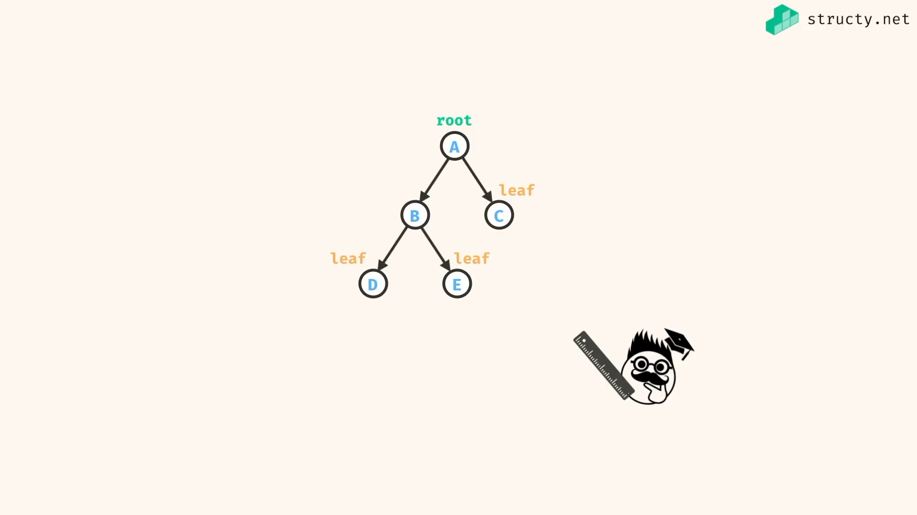

Root – node with no parent

Leaf – node with no child

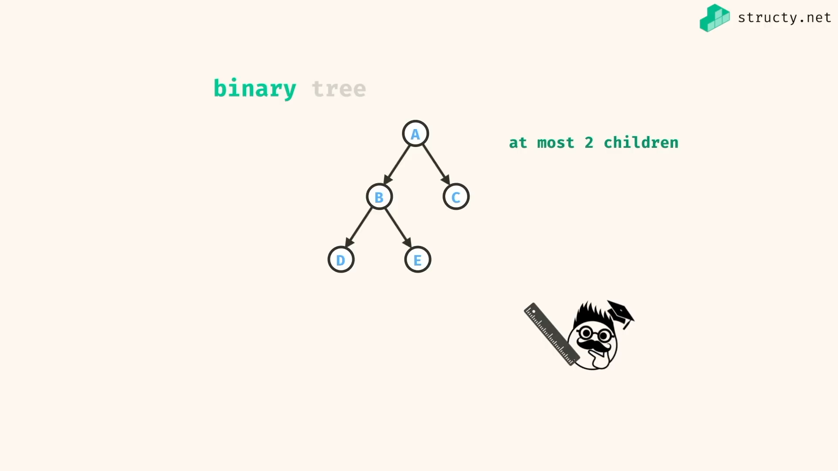

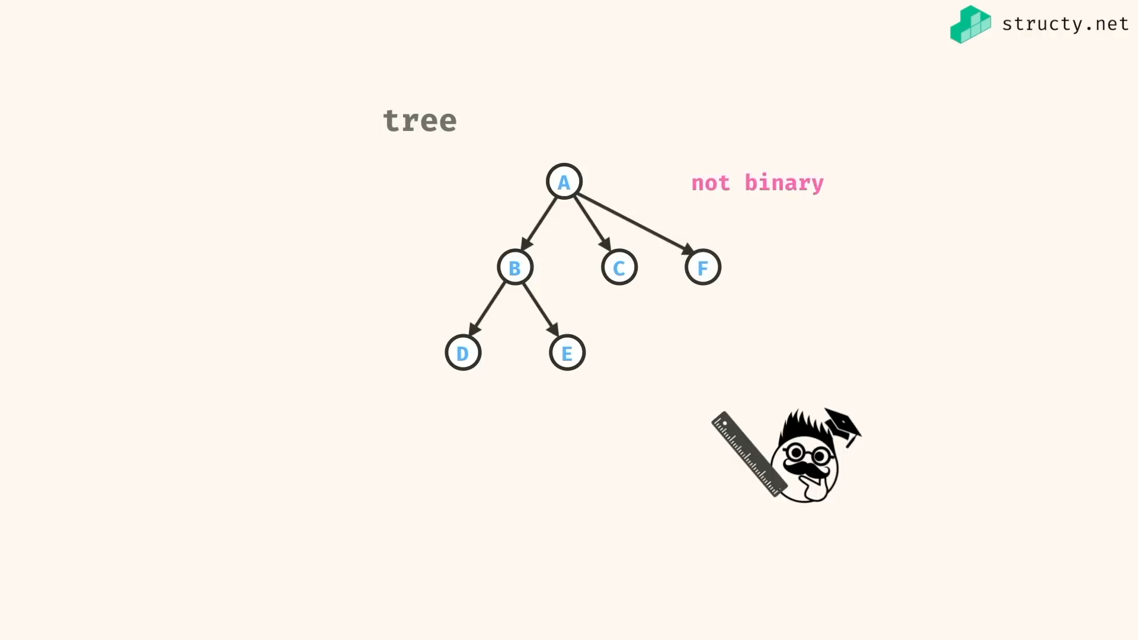

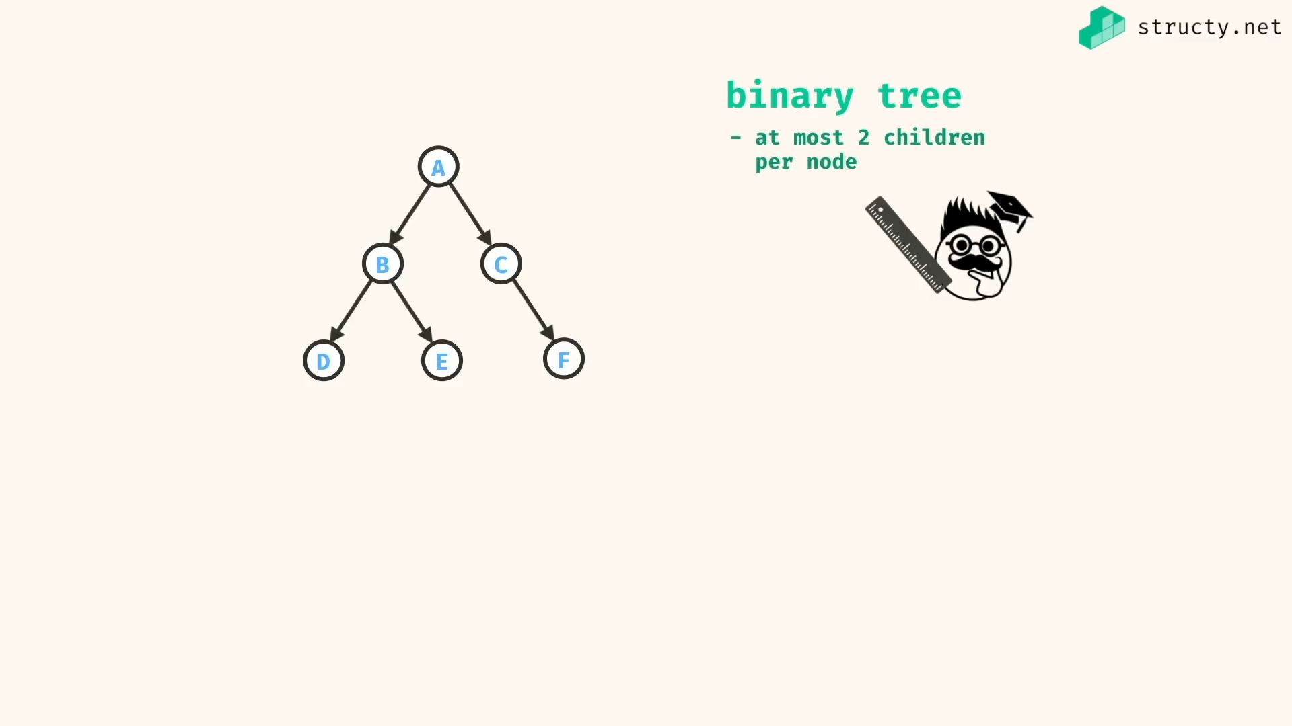

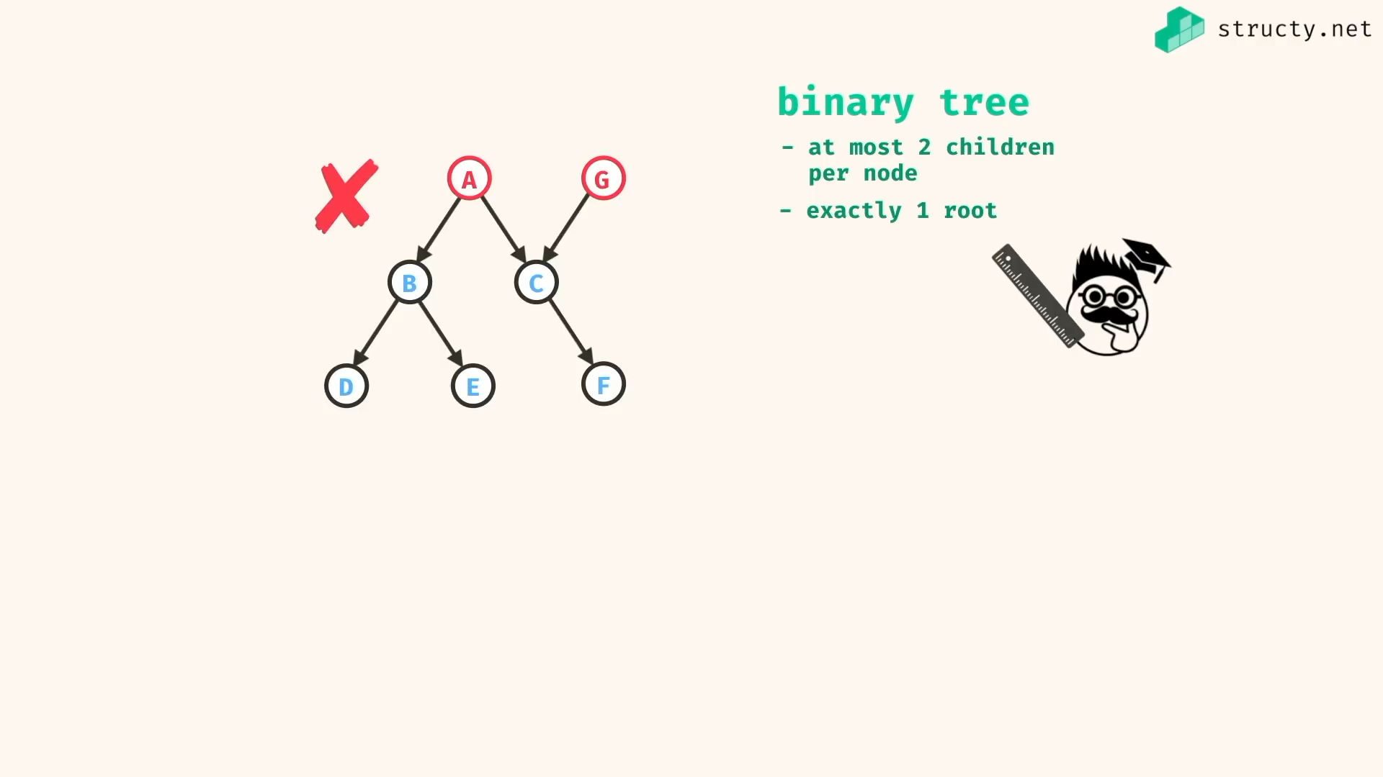

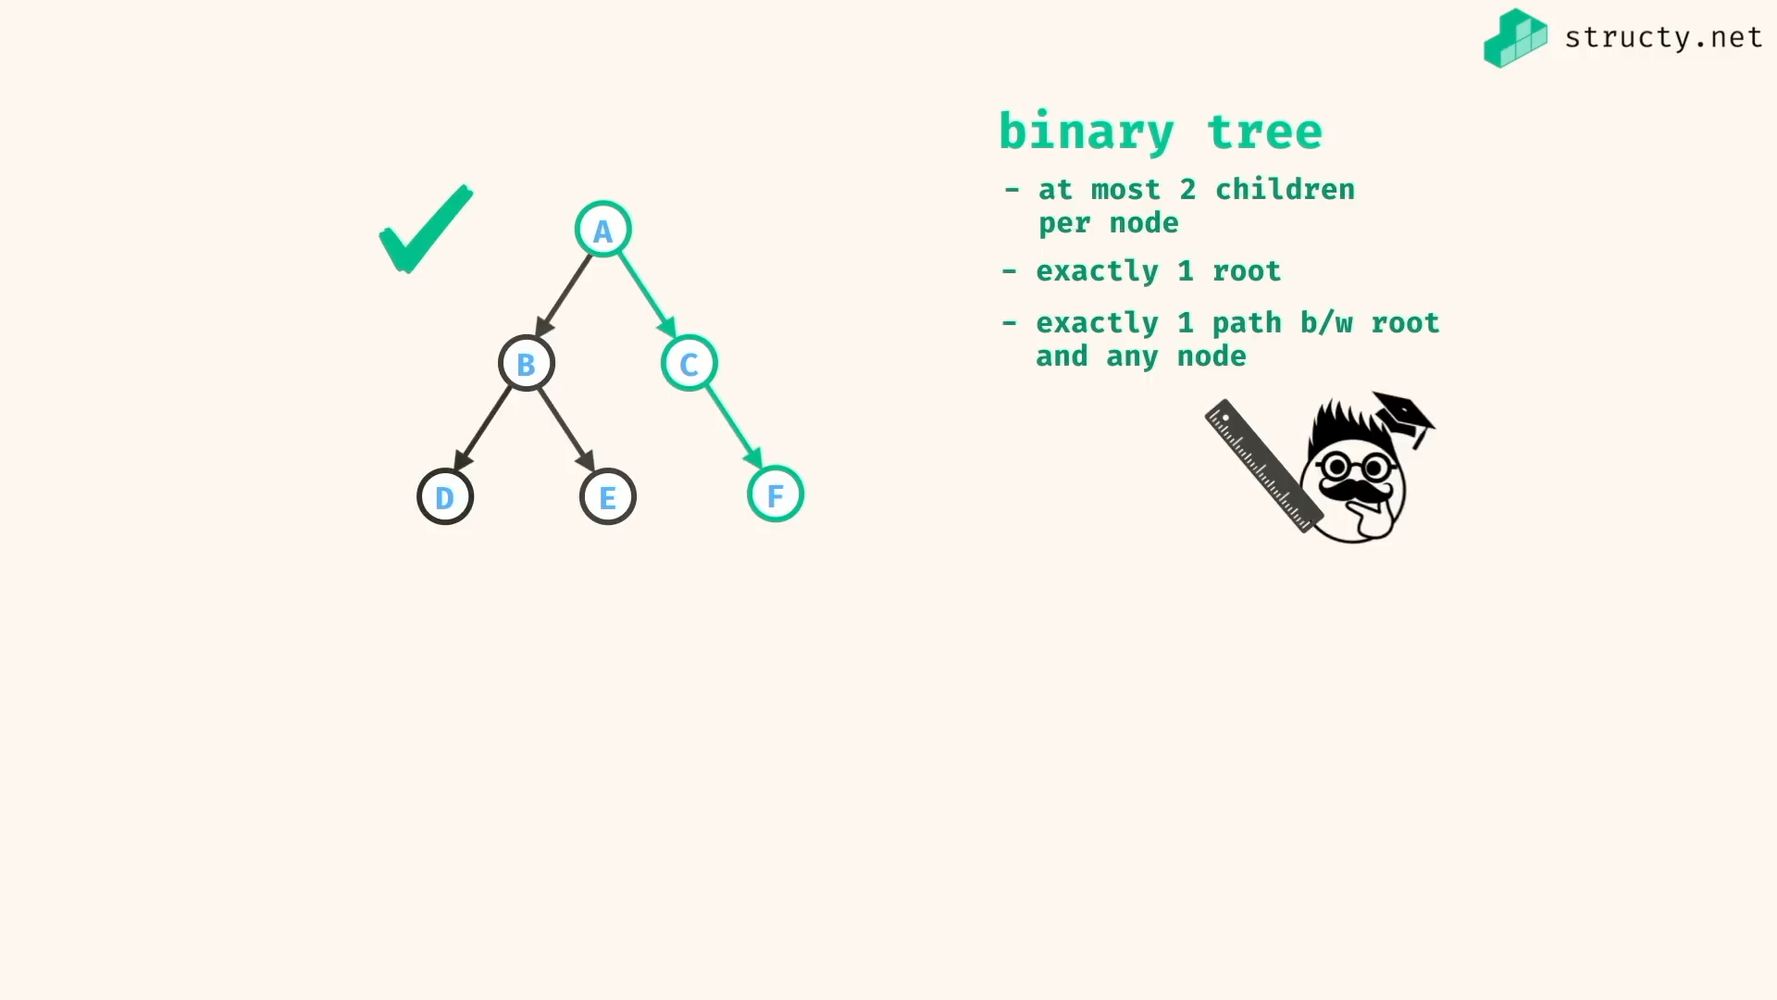

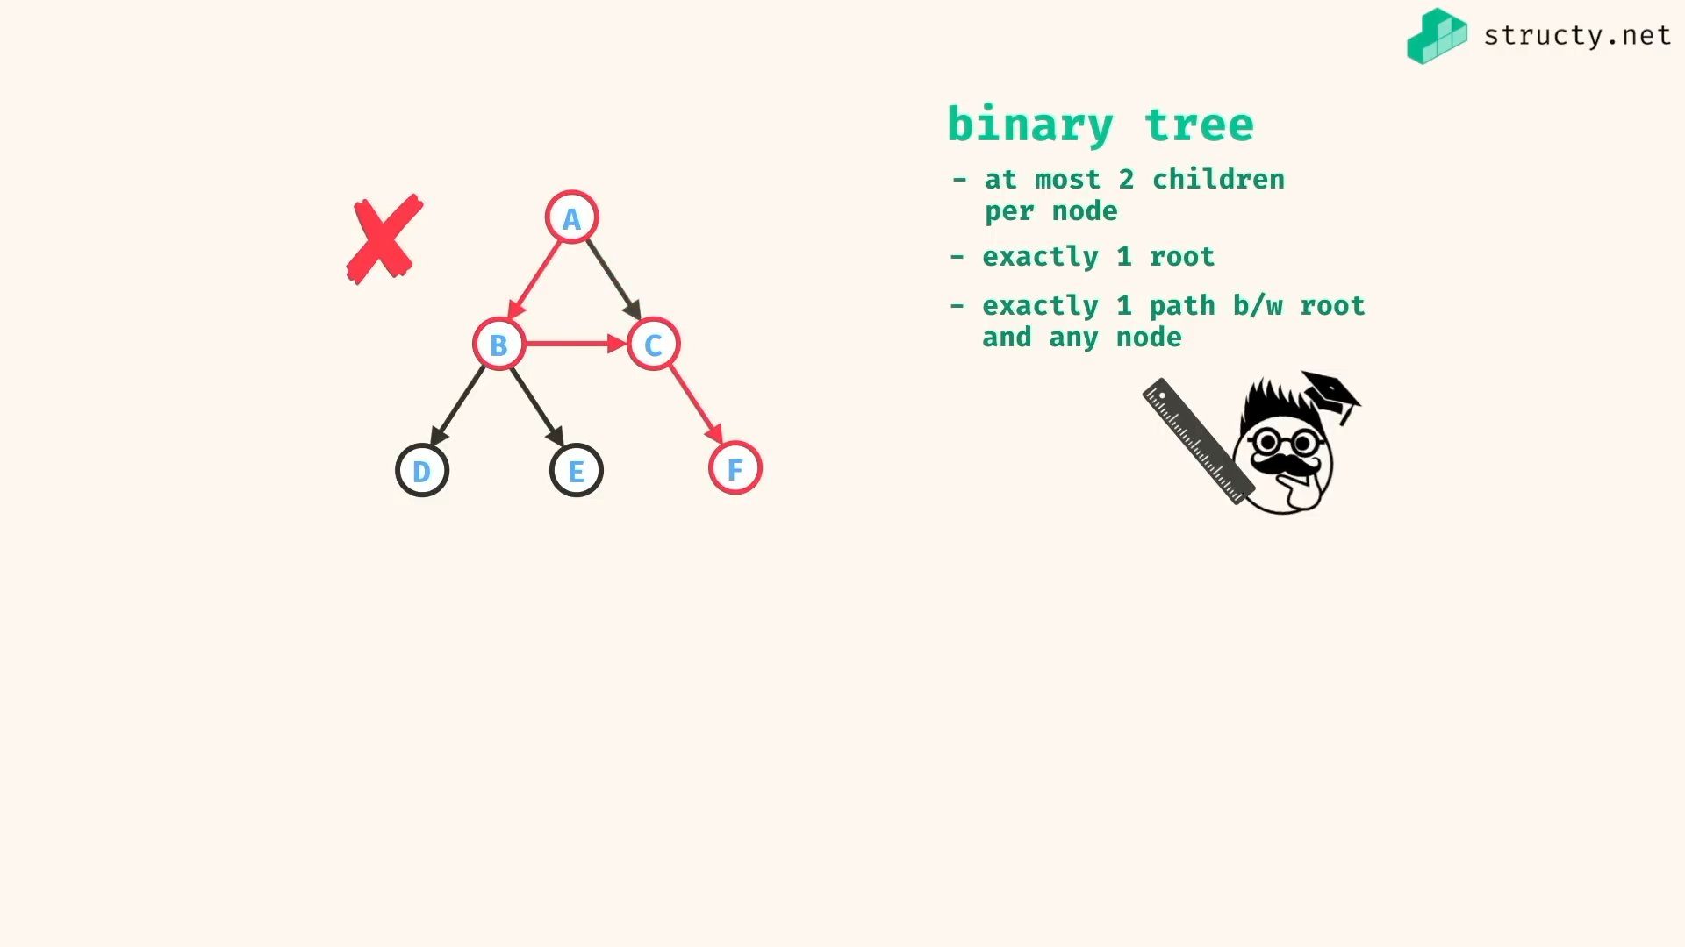

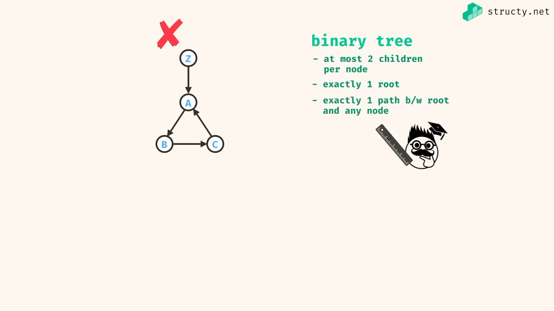

Having cycle is not binary tree…

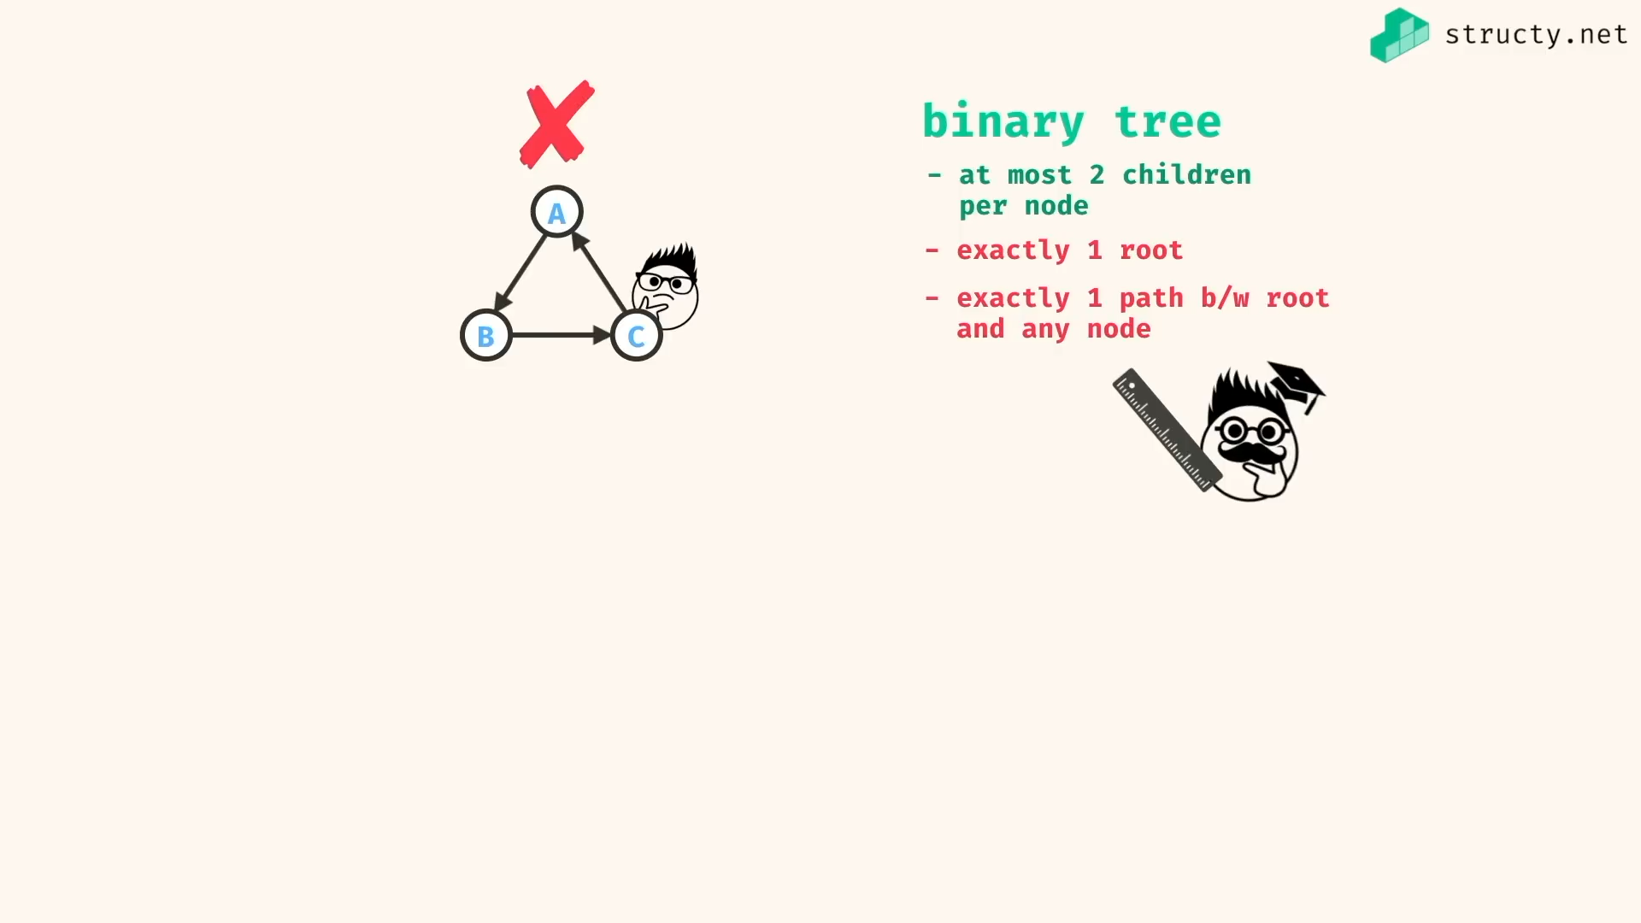

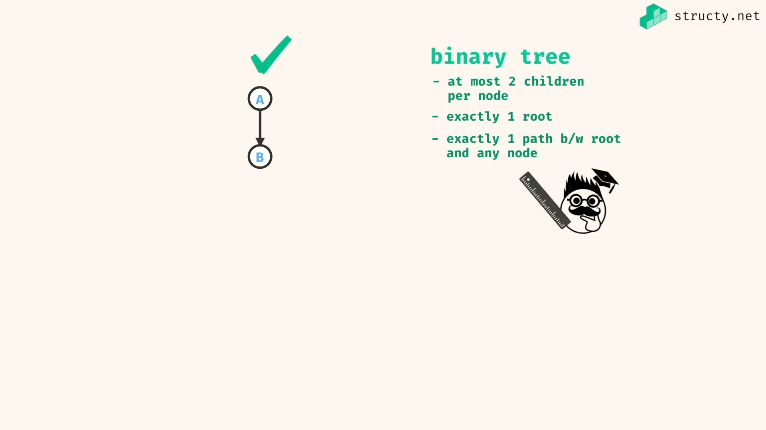

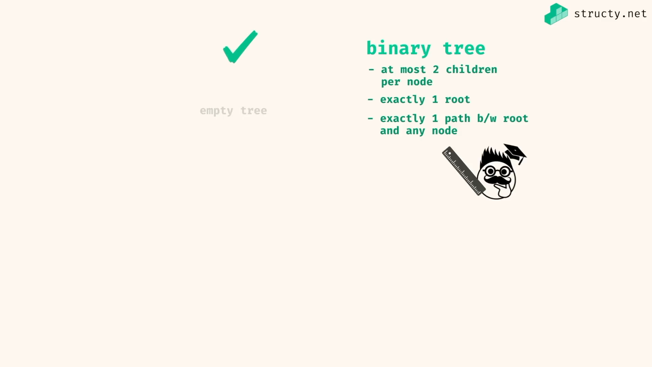

Empty tree – tree with no nodes.. will also be considered as binary tree…

This logic help in many algo of binary tree..

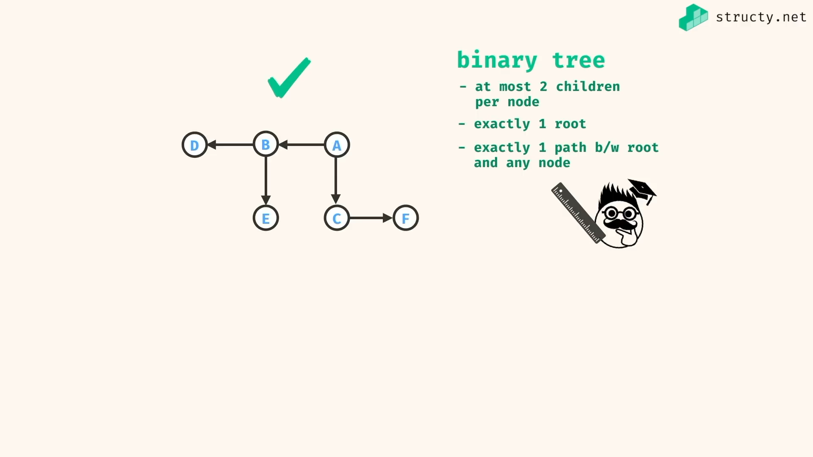

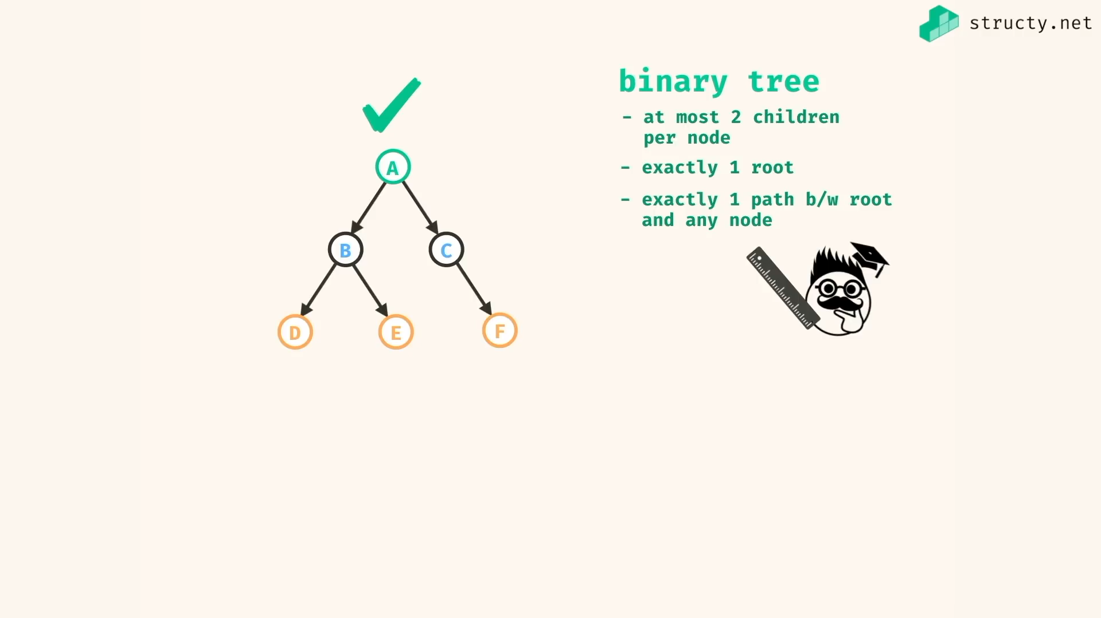

Tree in code:

Ever node is an object…

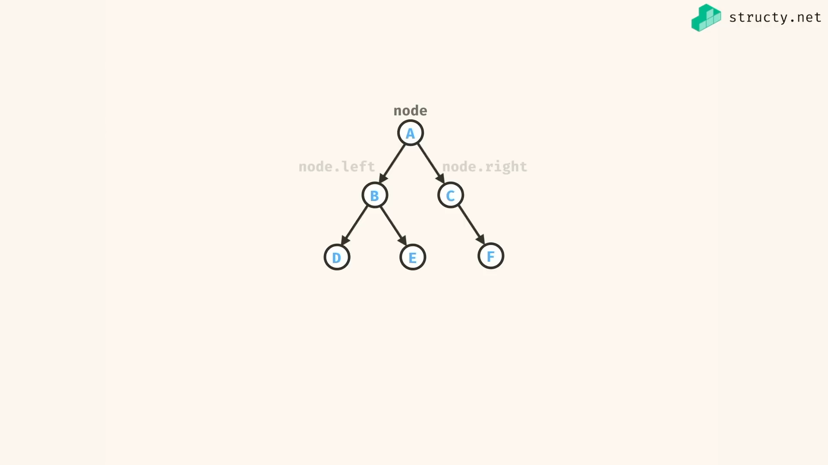

//+ binary tree simple implementation

*class* Node {

constructor(*val*){

*this*.val = val;

*this*.left = null;

*this*.right = null;

}

}

*const* a = new Node('a')

*const* b = new Node('b')

*const* c = new Node('c')

*const* d = new Node('d')

*const* e = new Node('e')

*const* f = new Node('f')

a.left = b;

a.right = c;

b.left = d;

b.right = e;

c.right = f;

/\*

a

/ \

b c

/ \ \

d e f

\*/

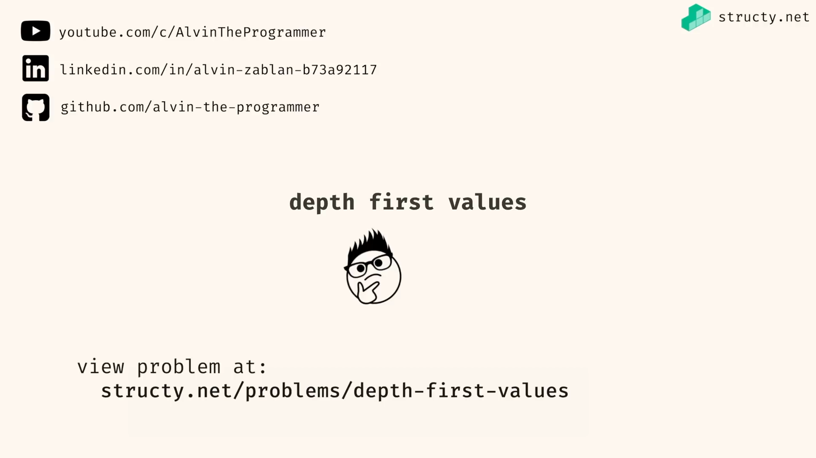

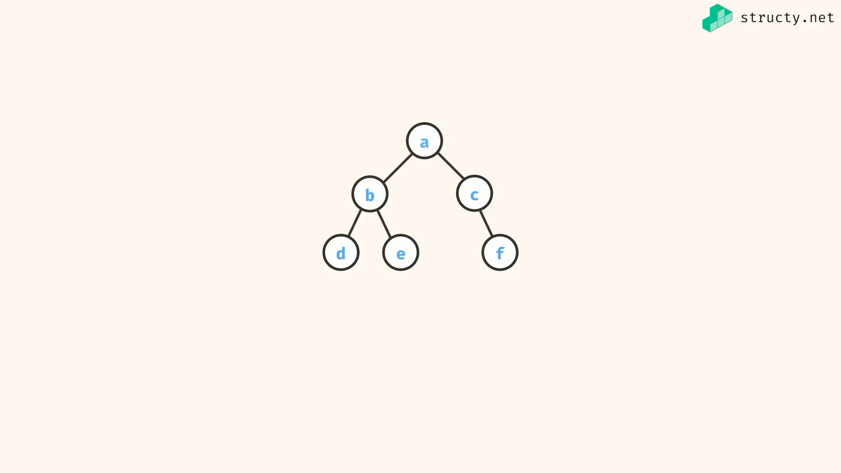

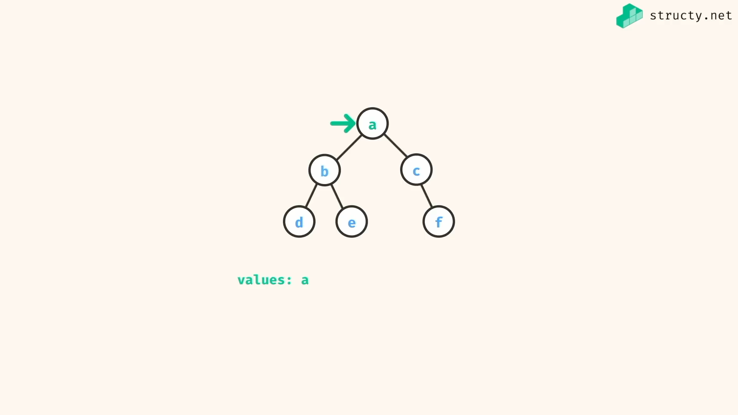

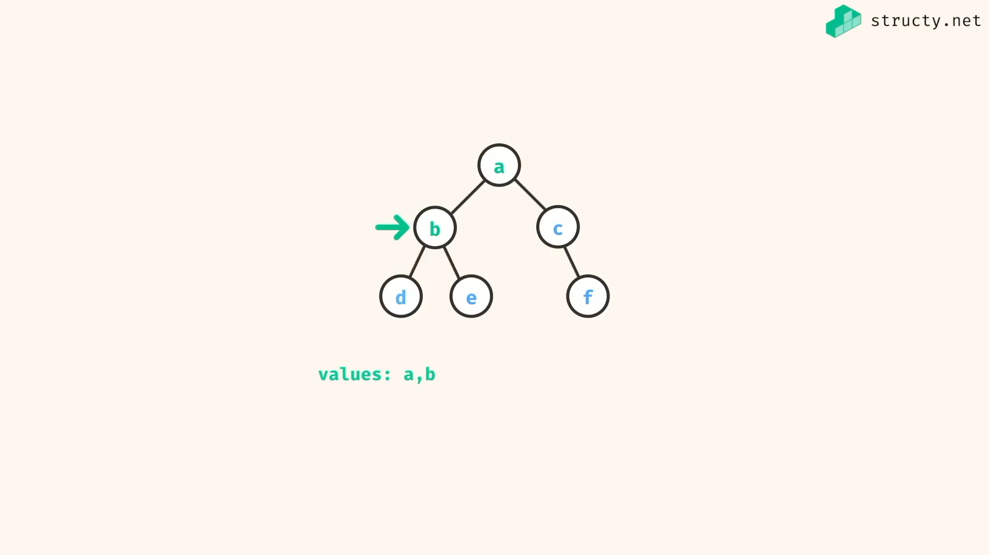

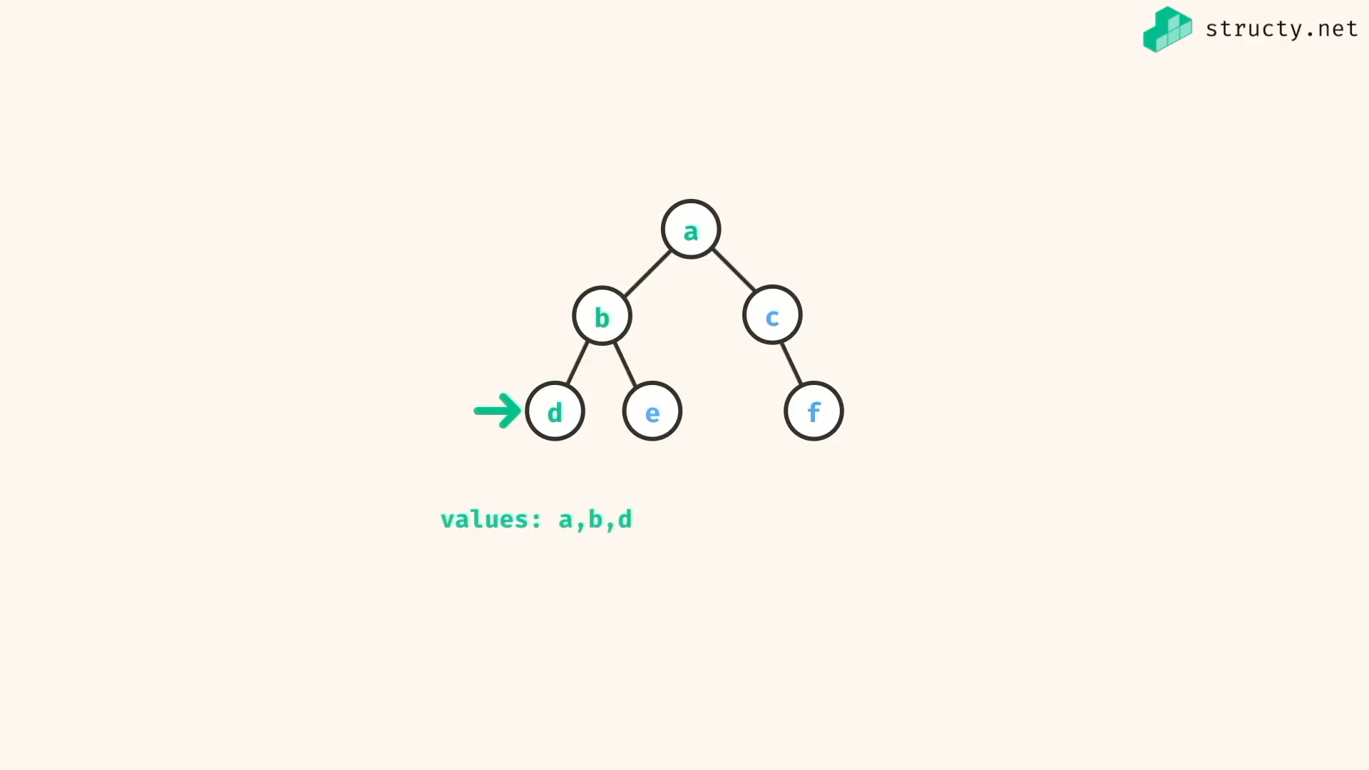

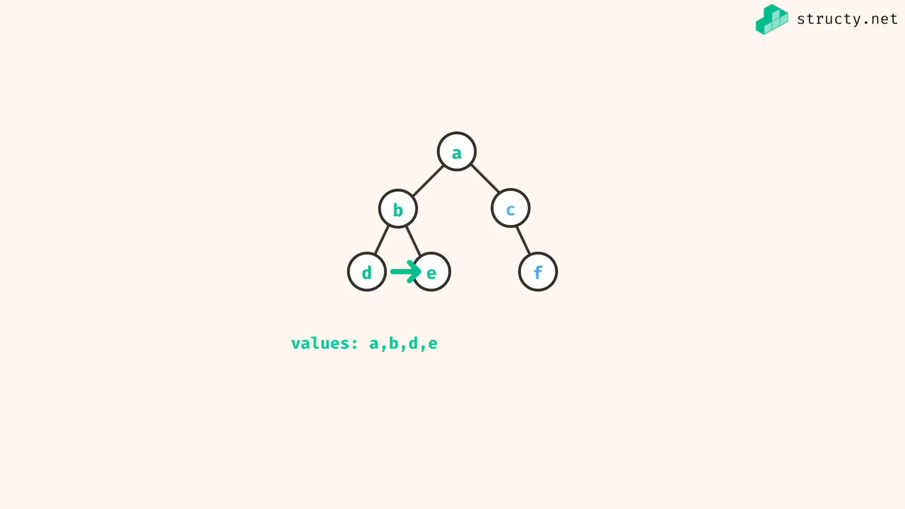

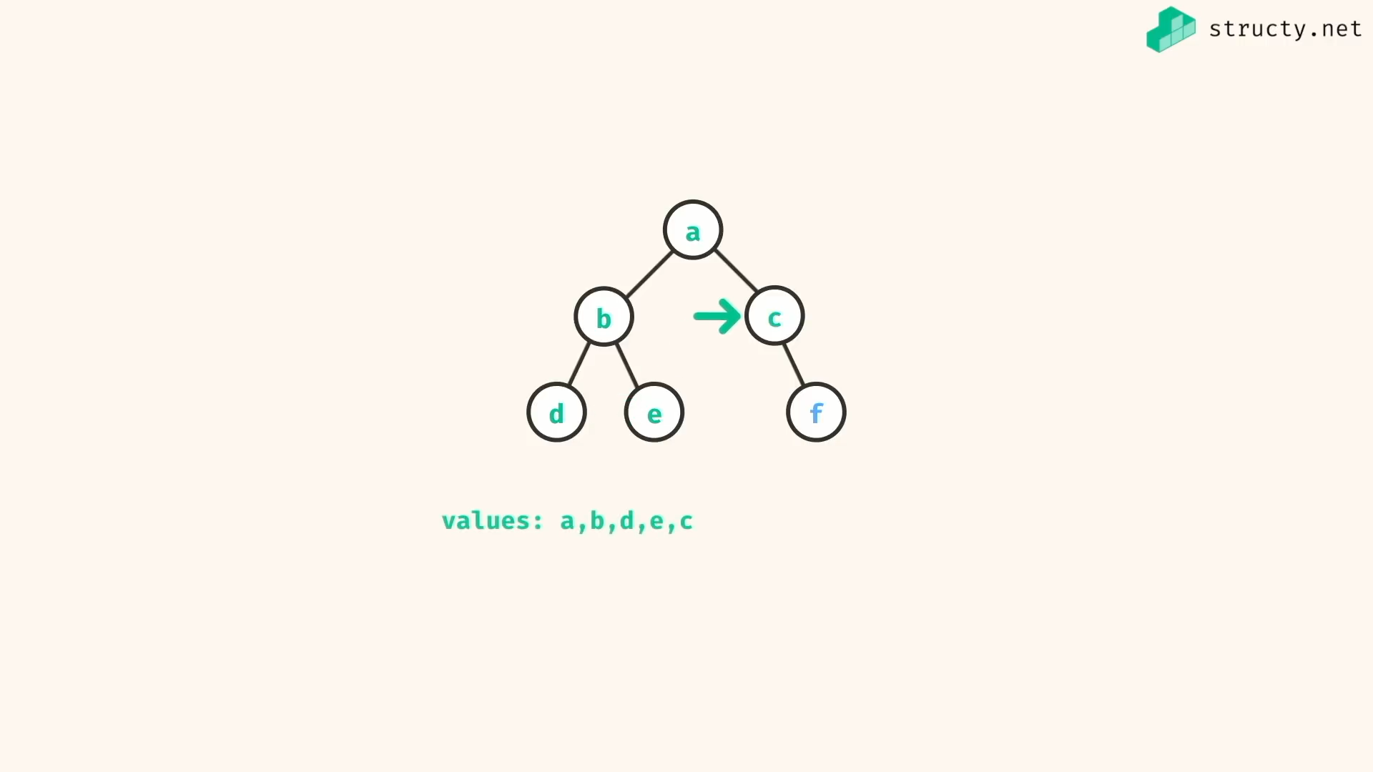

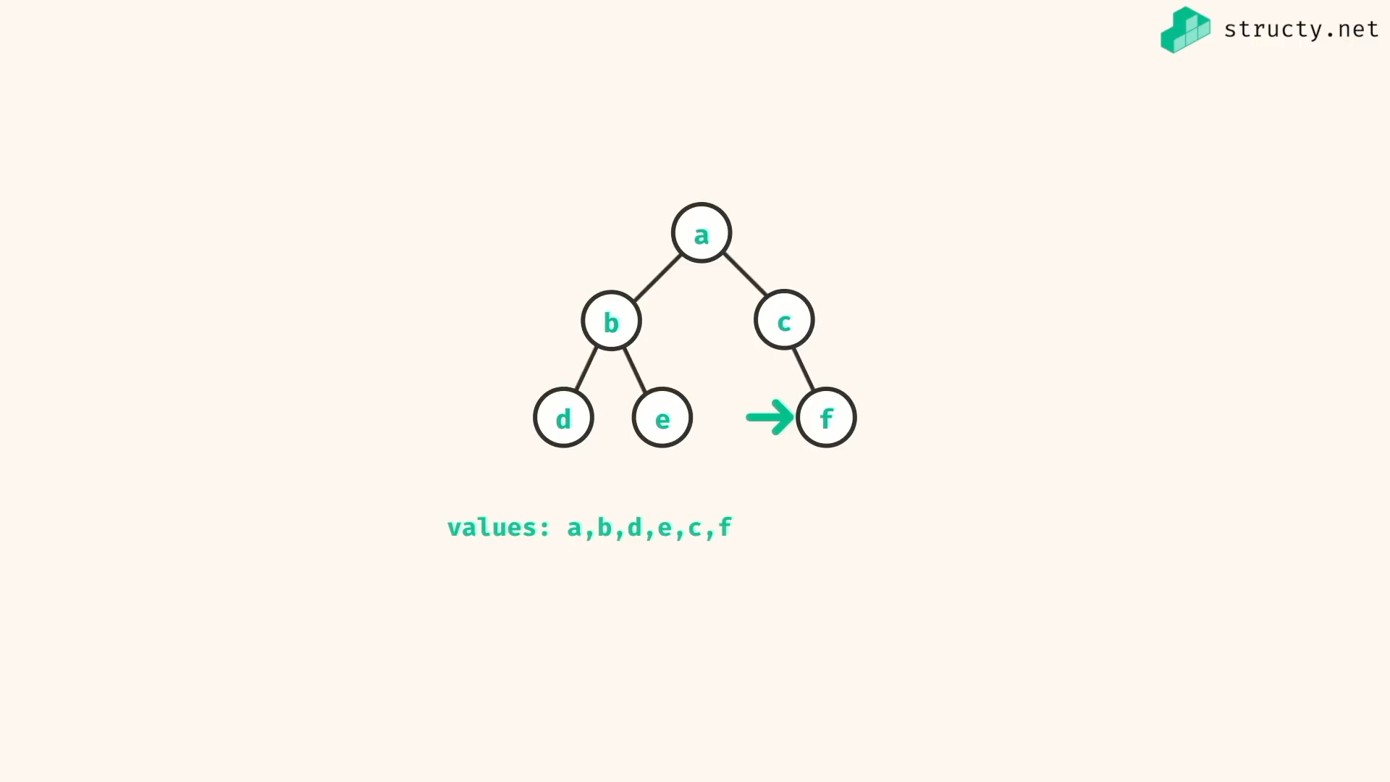

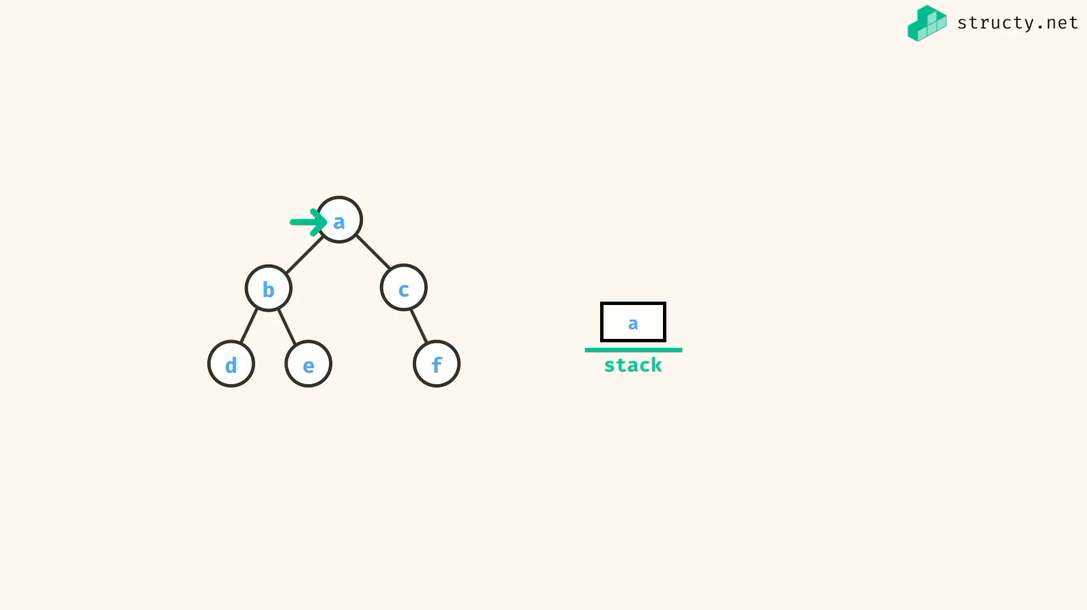

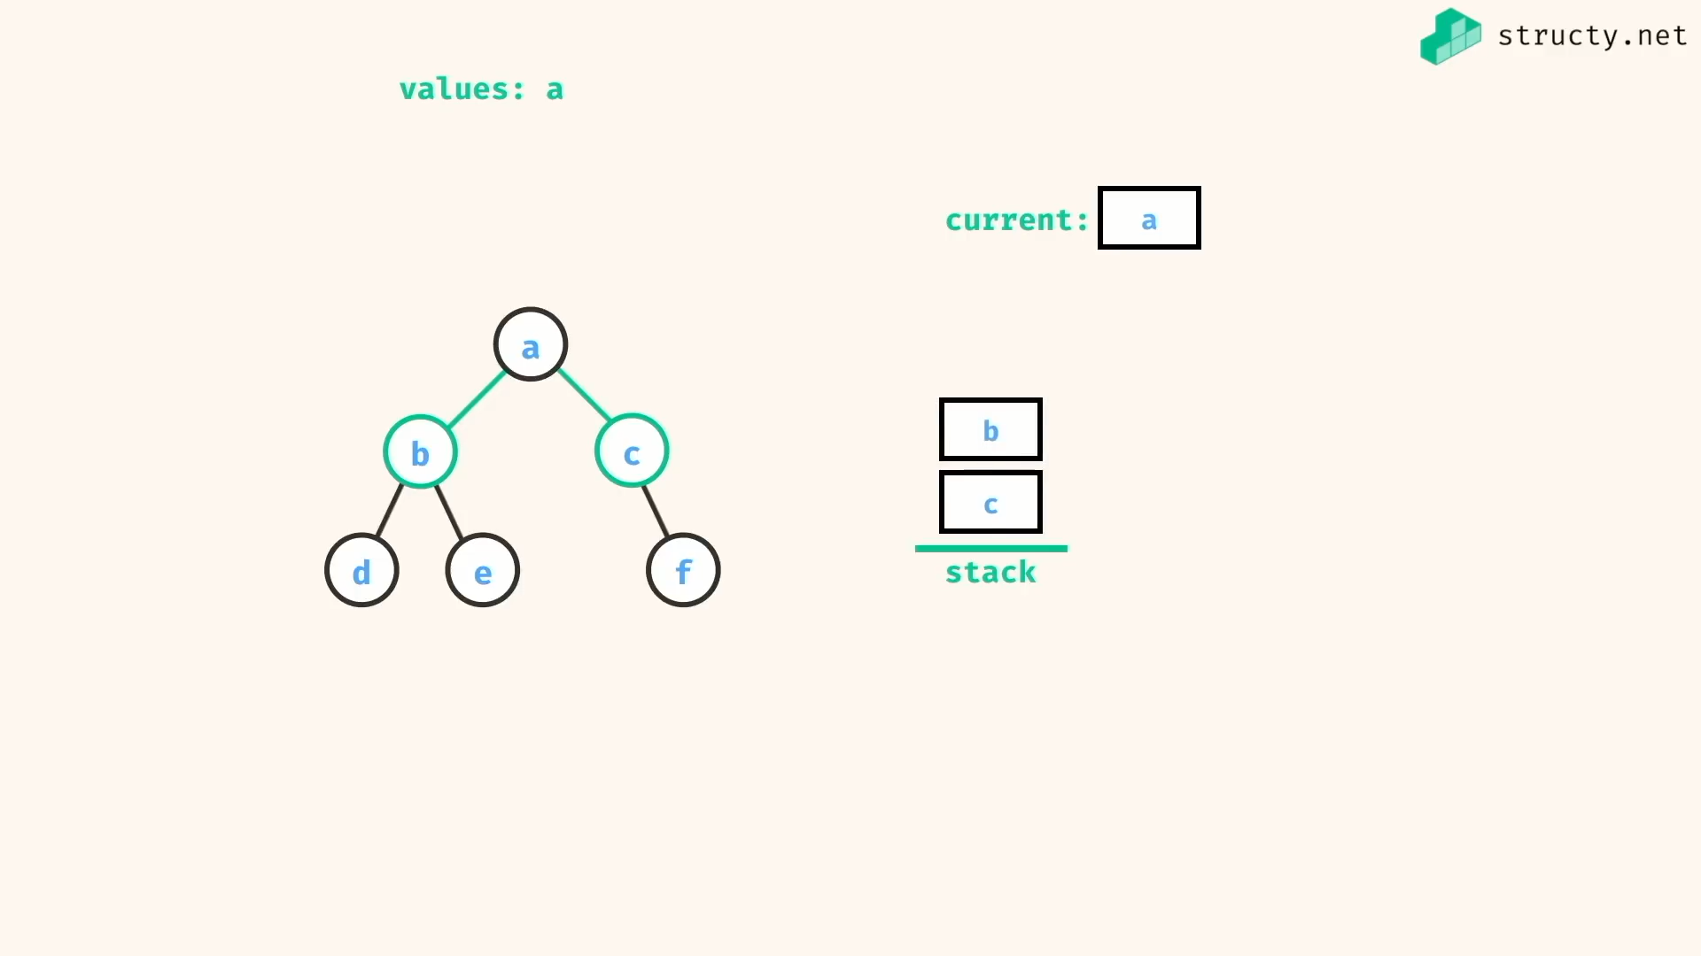

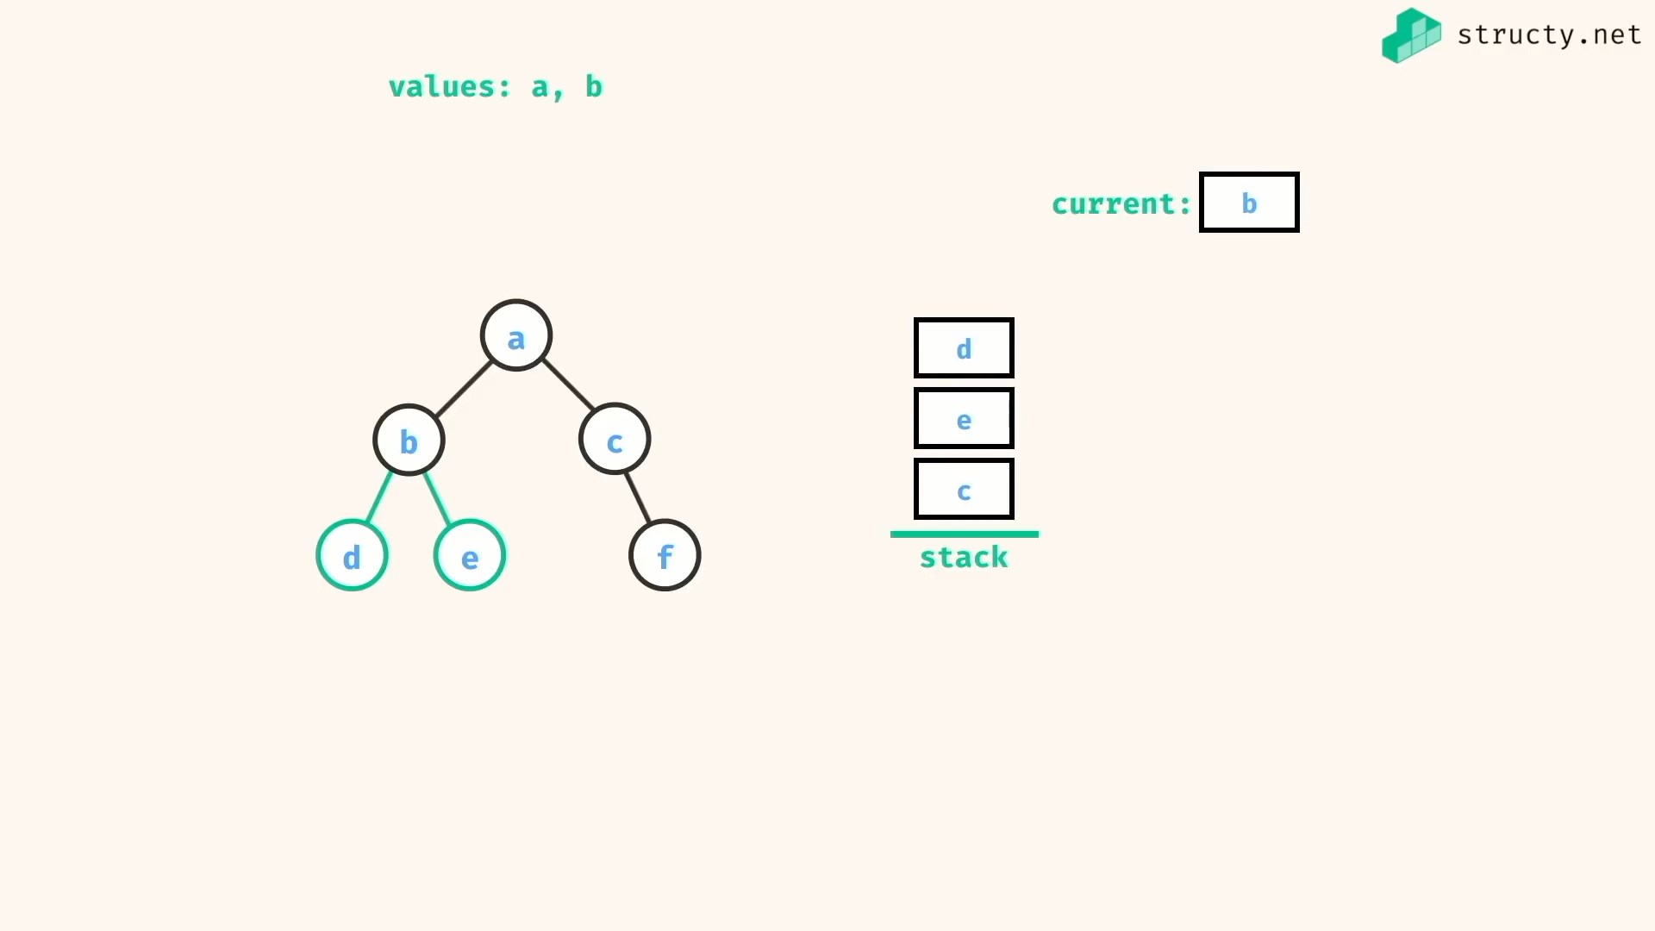

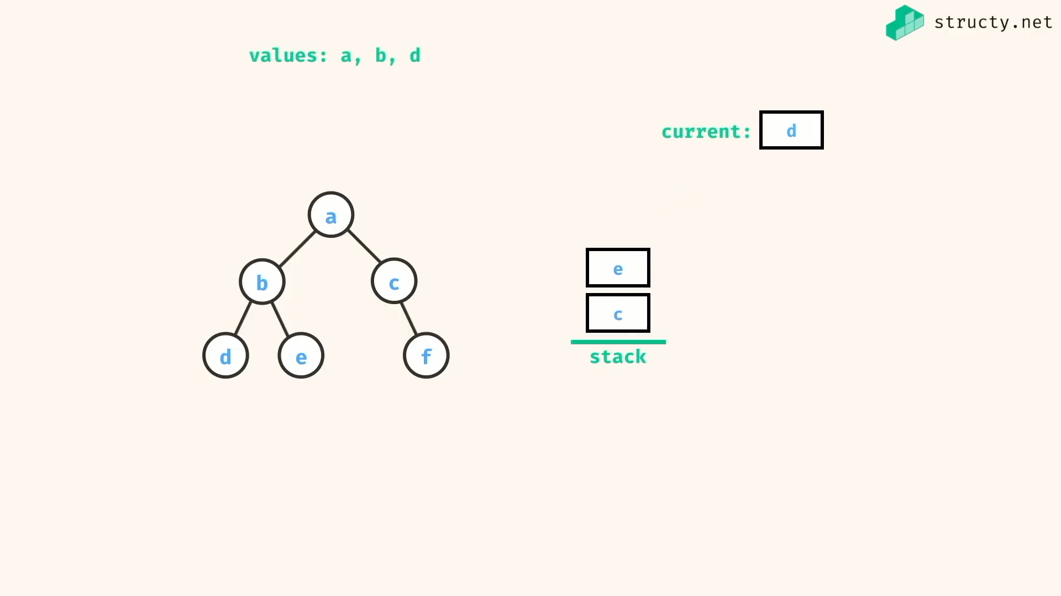

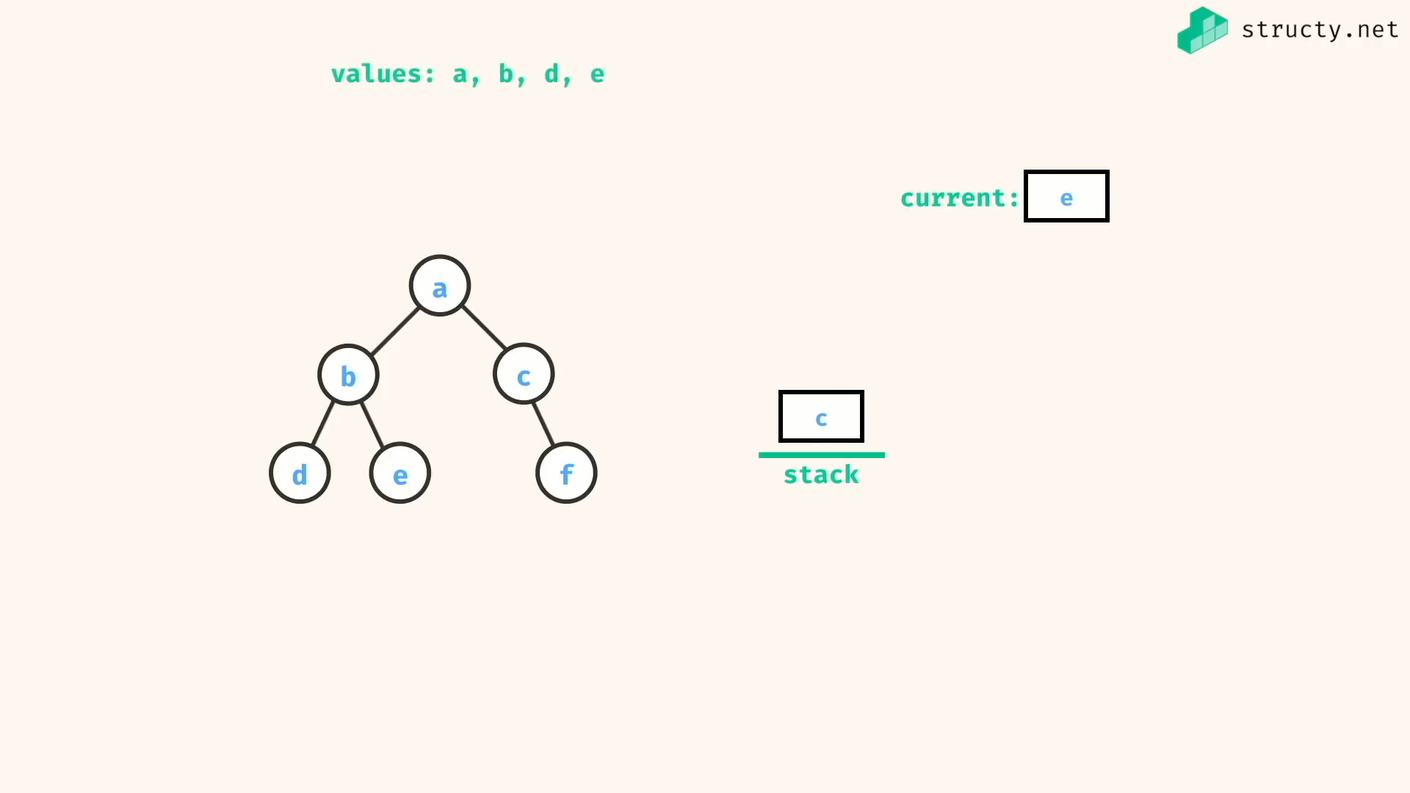

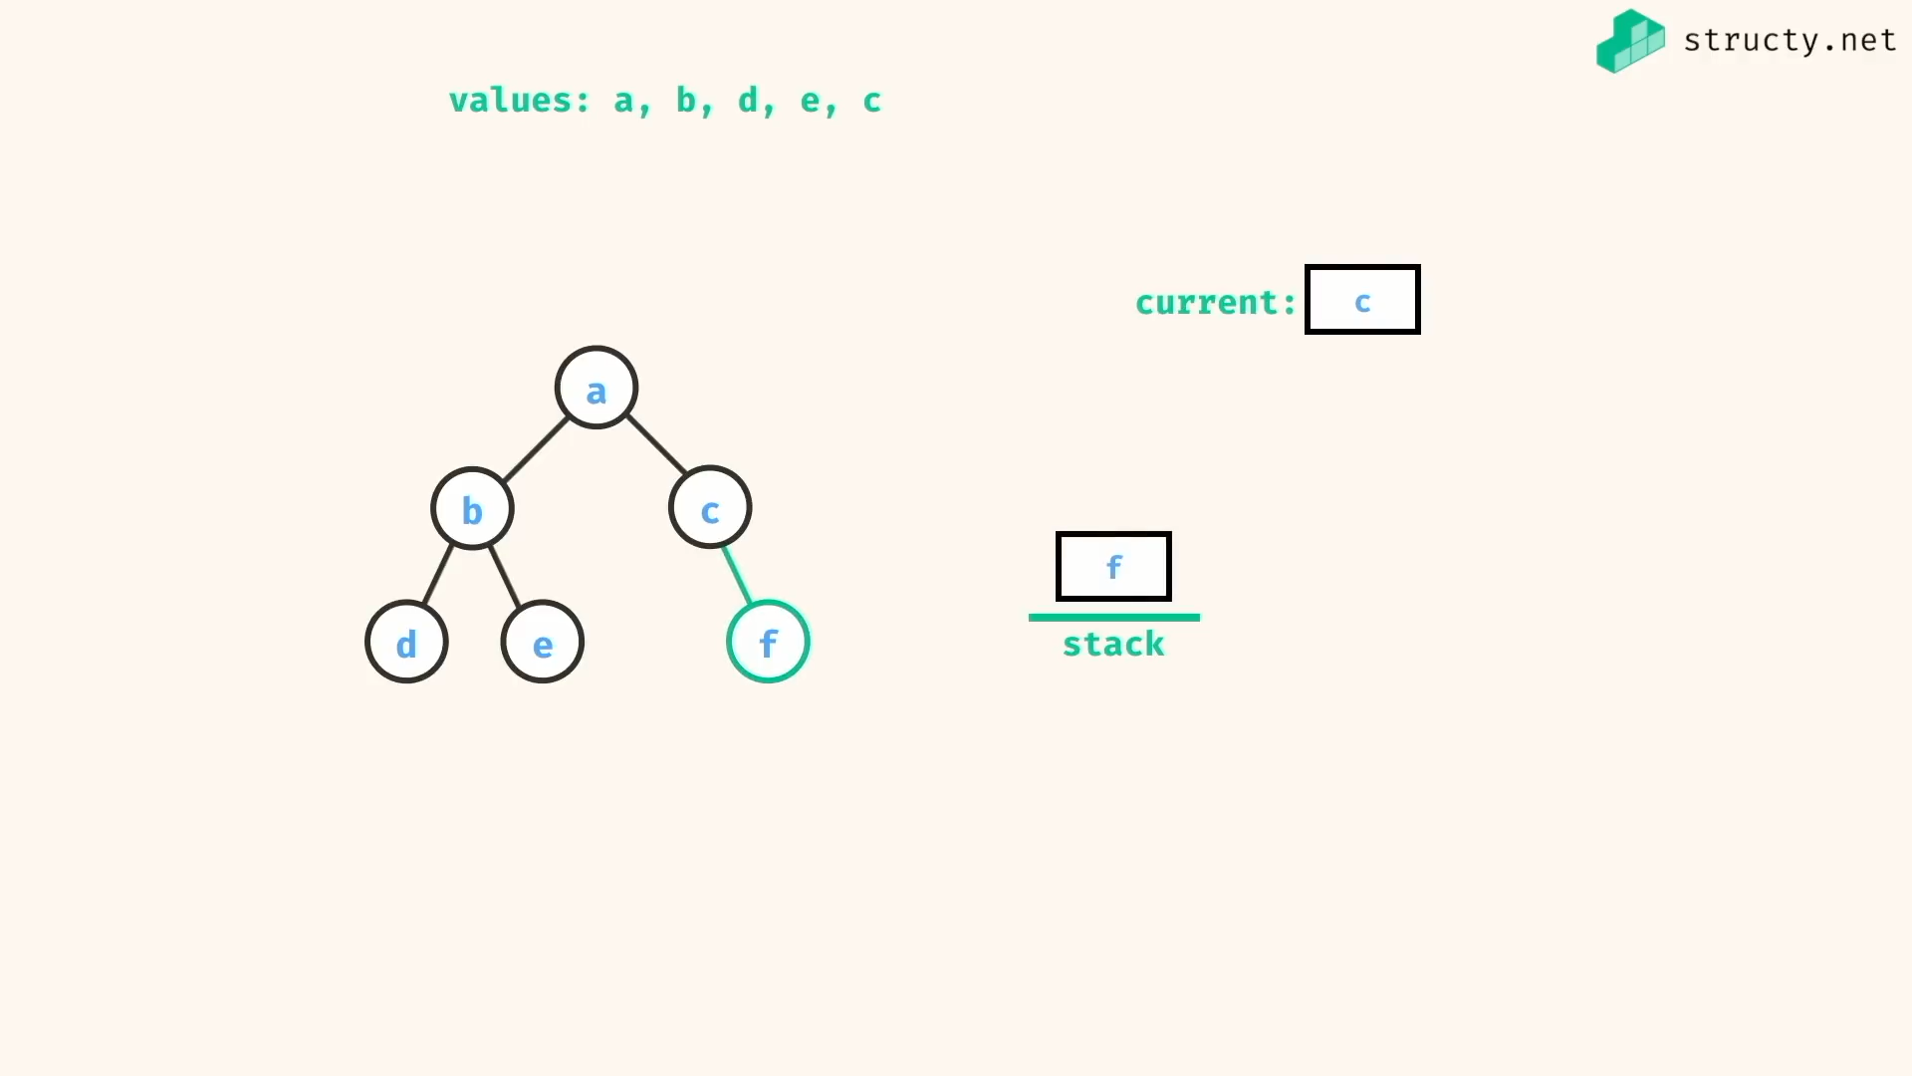

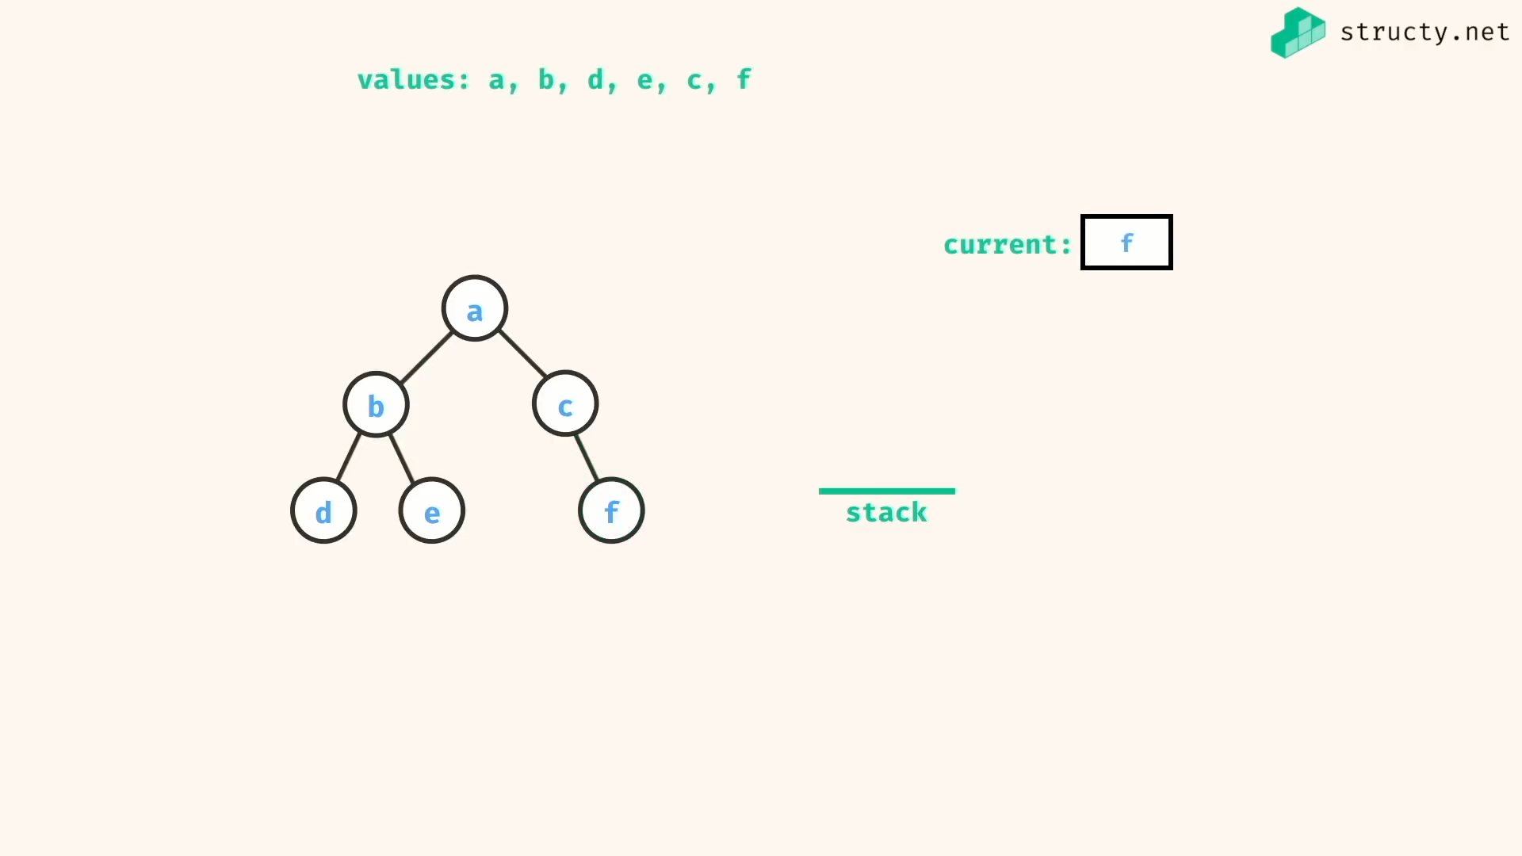

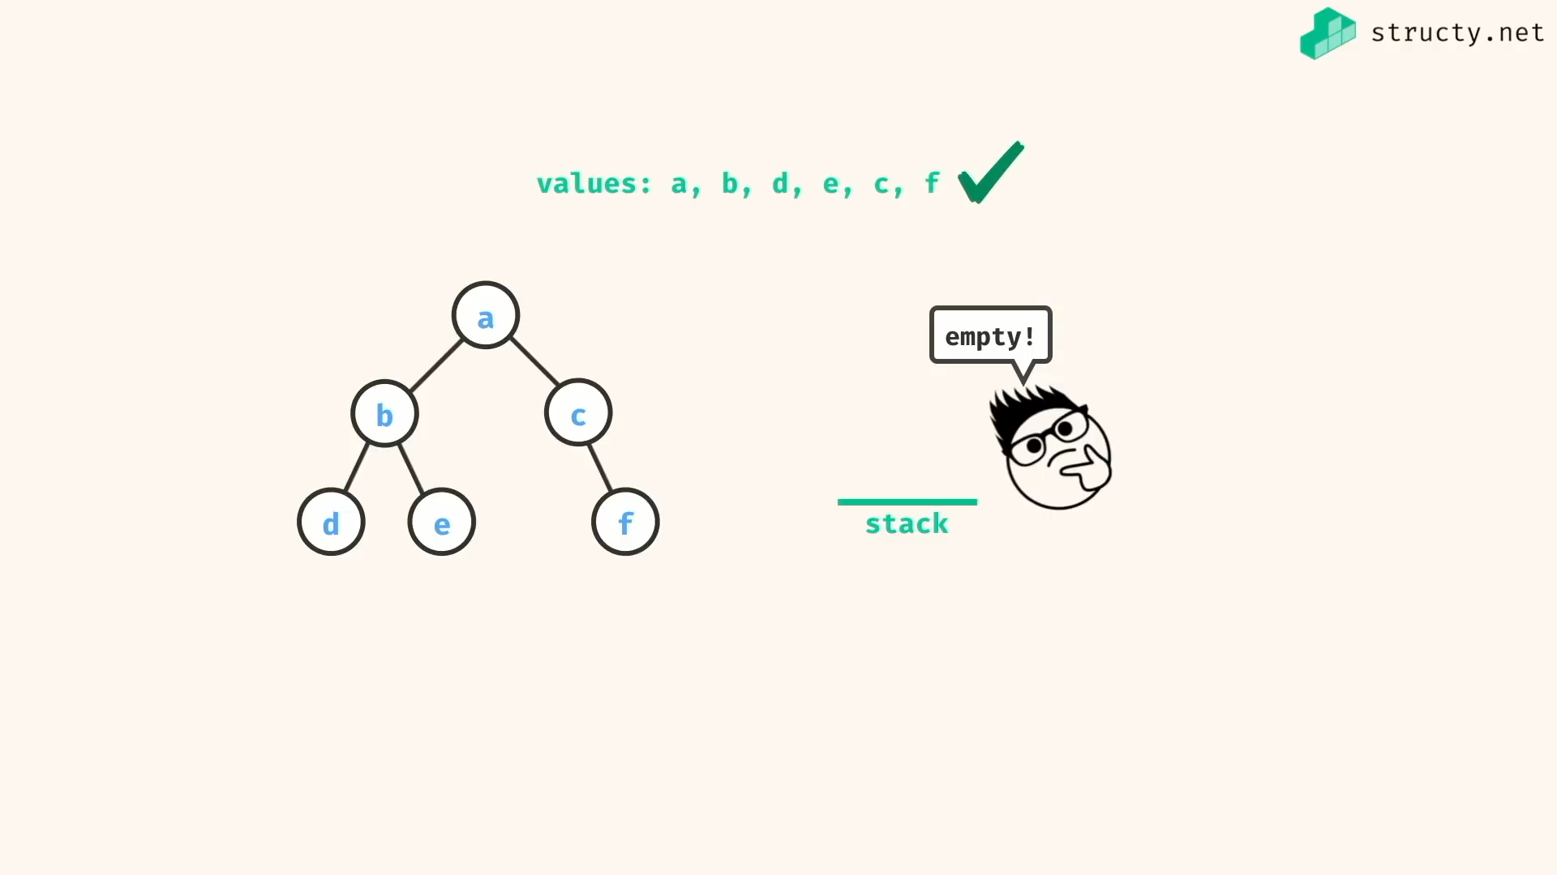

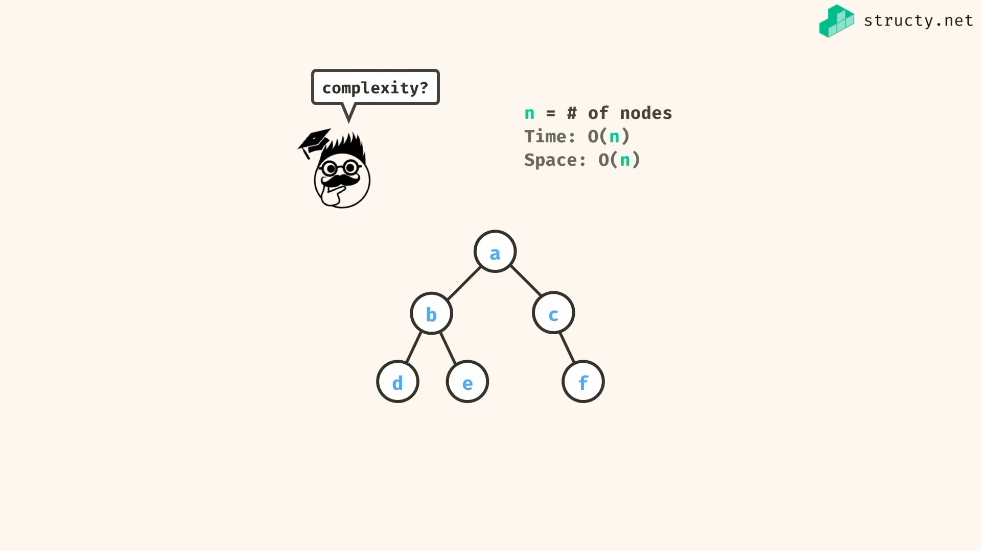

Problem:

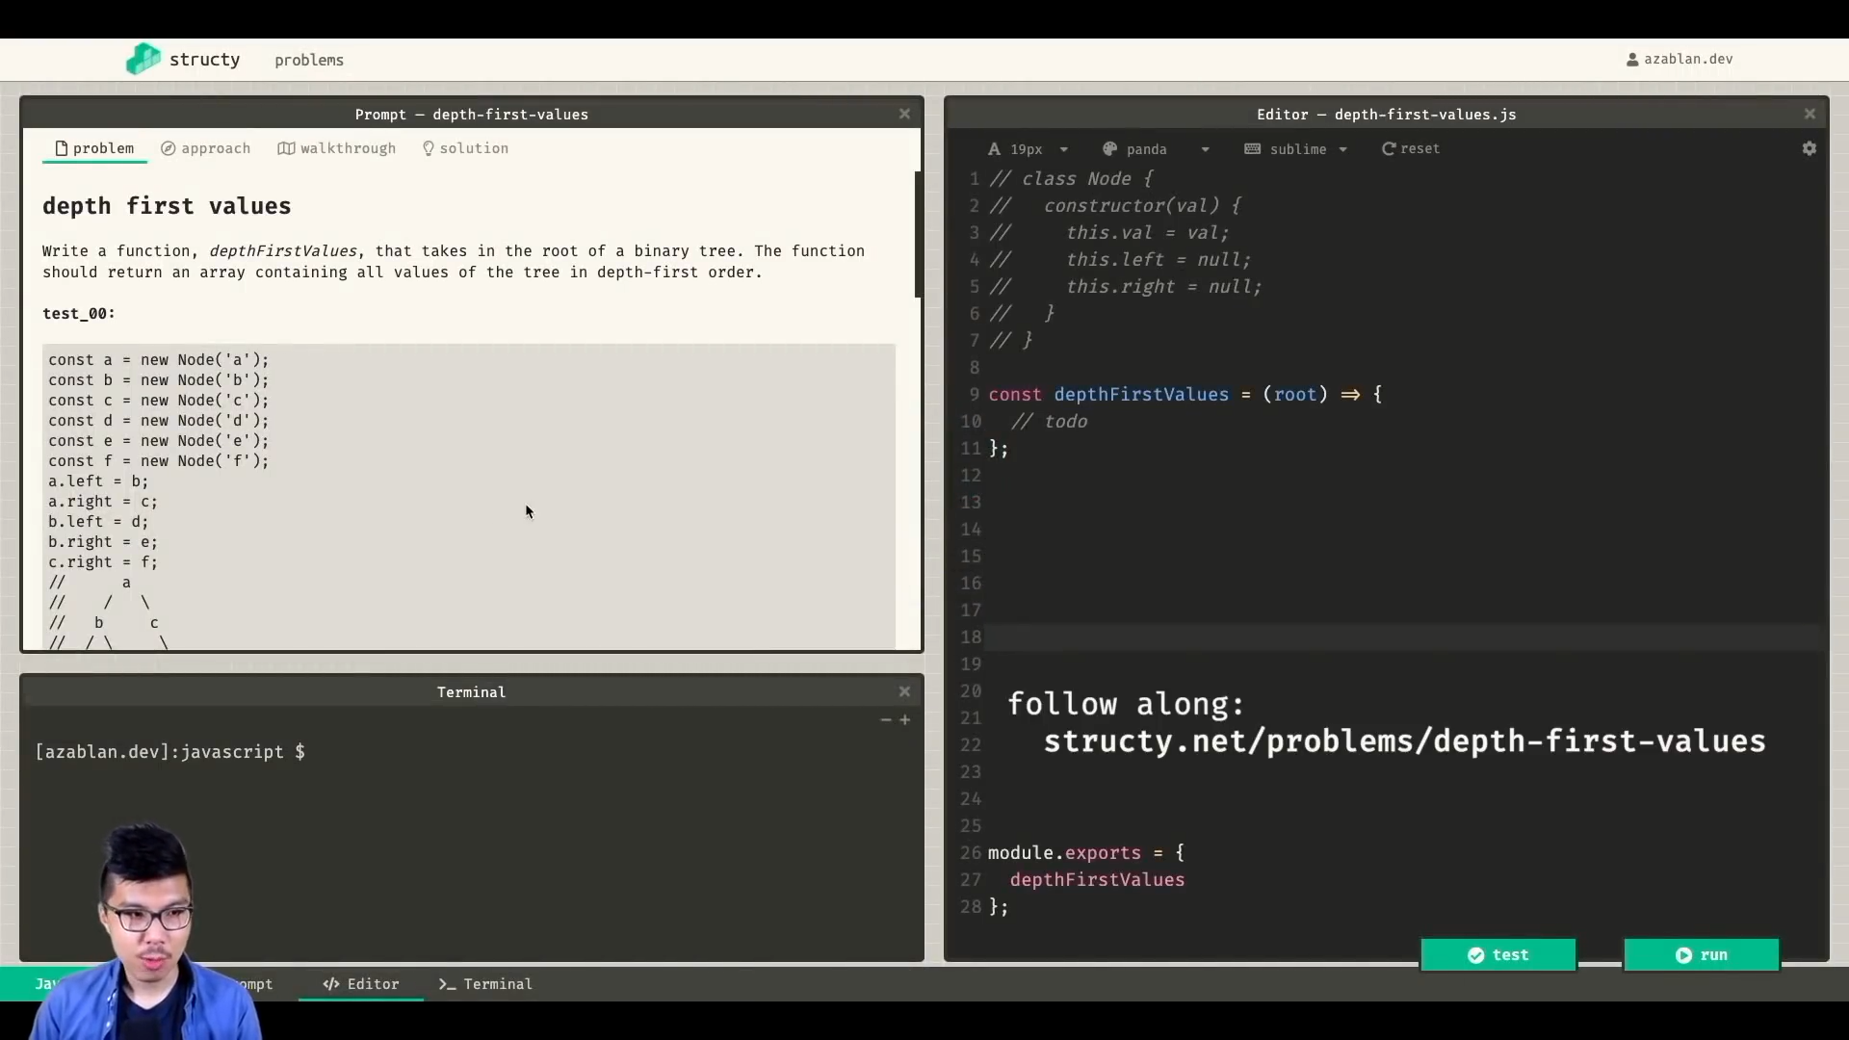

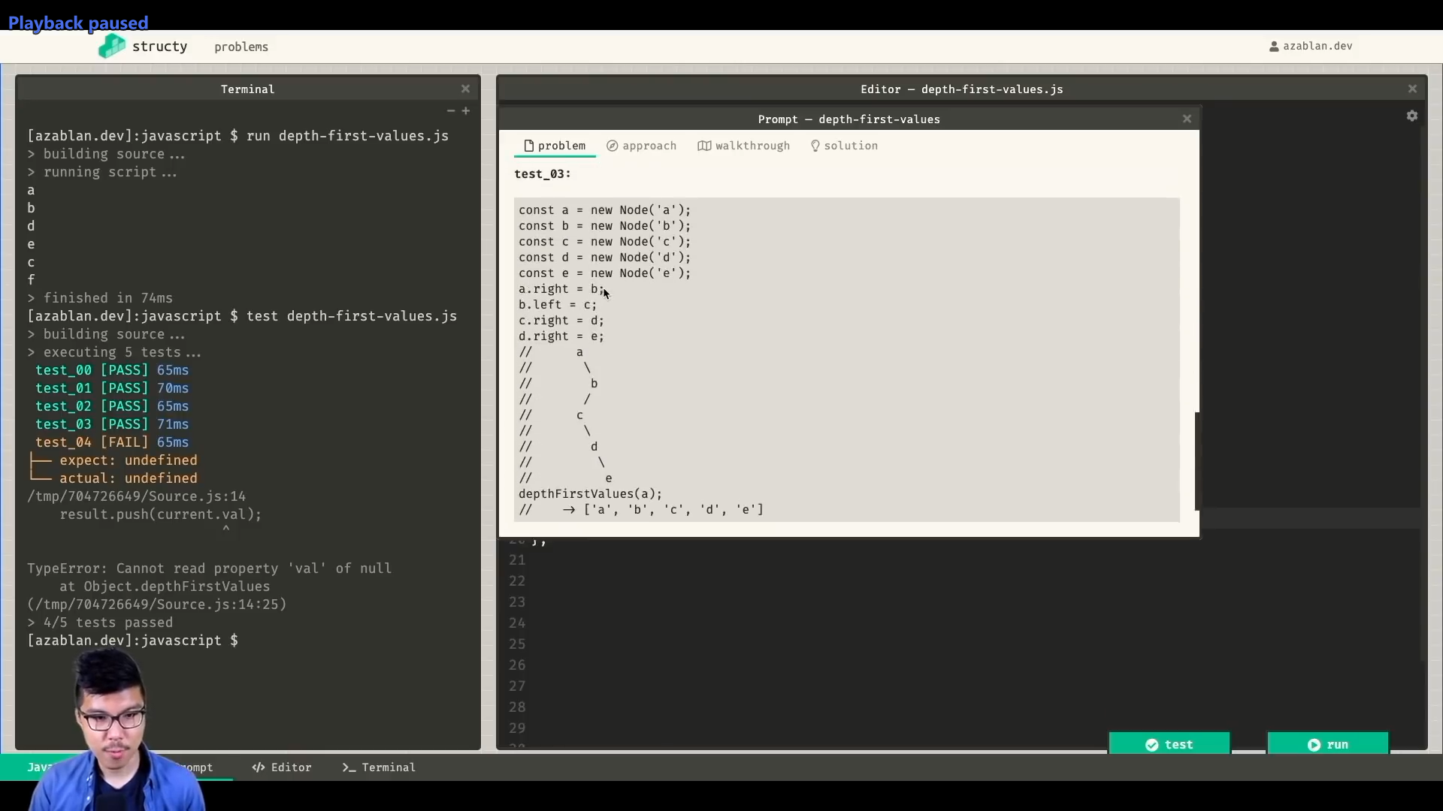

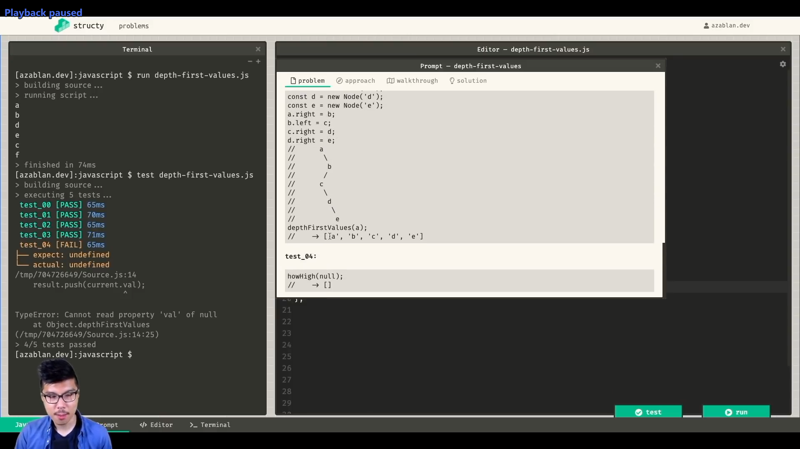

*const* depthFirstValuesIter = (*root*) *=>* {

if(!root) return;

*const* stack = [ root ];

while(stack.length > 0){

*const* currentNode = stack.pop();

*console*.log(currentNode.val);

*const* rightChild = currentNode.right;

*const* leftChild = currentNode.left;

// right child first to make left child top most - DFS

if(rightChild !== null) stack.push(rightChild)

if(leftChild !== null) stack.push(leftChild)

}

}

*const* depthFirstValuesRecur = (*root*) *=>* {

if(root === null) return [];

*const* current = root.val;

*const* leftValues = depthFirstValuesRecur(root.left);

*const* rightValues = depthFirstValuesRecur(root.right);

return [current, ...leftValues, ...rightValues];

}

*class* Node {

constructor(*val*){

*this*.val = val;

*this*.left = null;

*this*.right = null;

}

}

*const* a = new Node('a')

*const* b = new Node('b')

*const* c = new Node('c')

*const* d = new Node('d')

*const* e = new Node('e')

*const* f = new Node('f')

a.left = b;

a.right = c;

b.left = d;

b.right = e;

c.right = f;

/\*

a

/ \

b c

/ \ \

d e f

\*/

depthFirstValuesIter(a)

//=> a b d e c f

*console*.log(depthFirstValuesRecur(a))

//=> [ 'a', 'b', 'd', 'e', 'c', 'f' ]

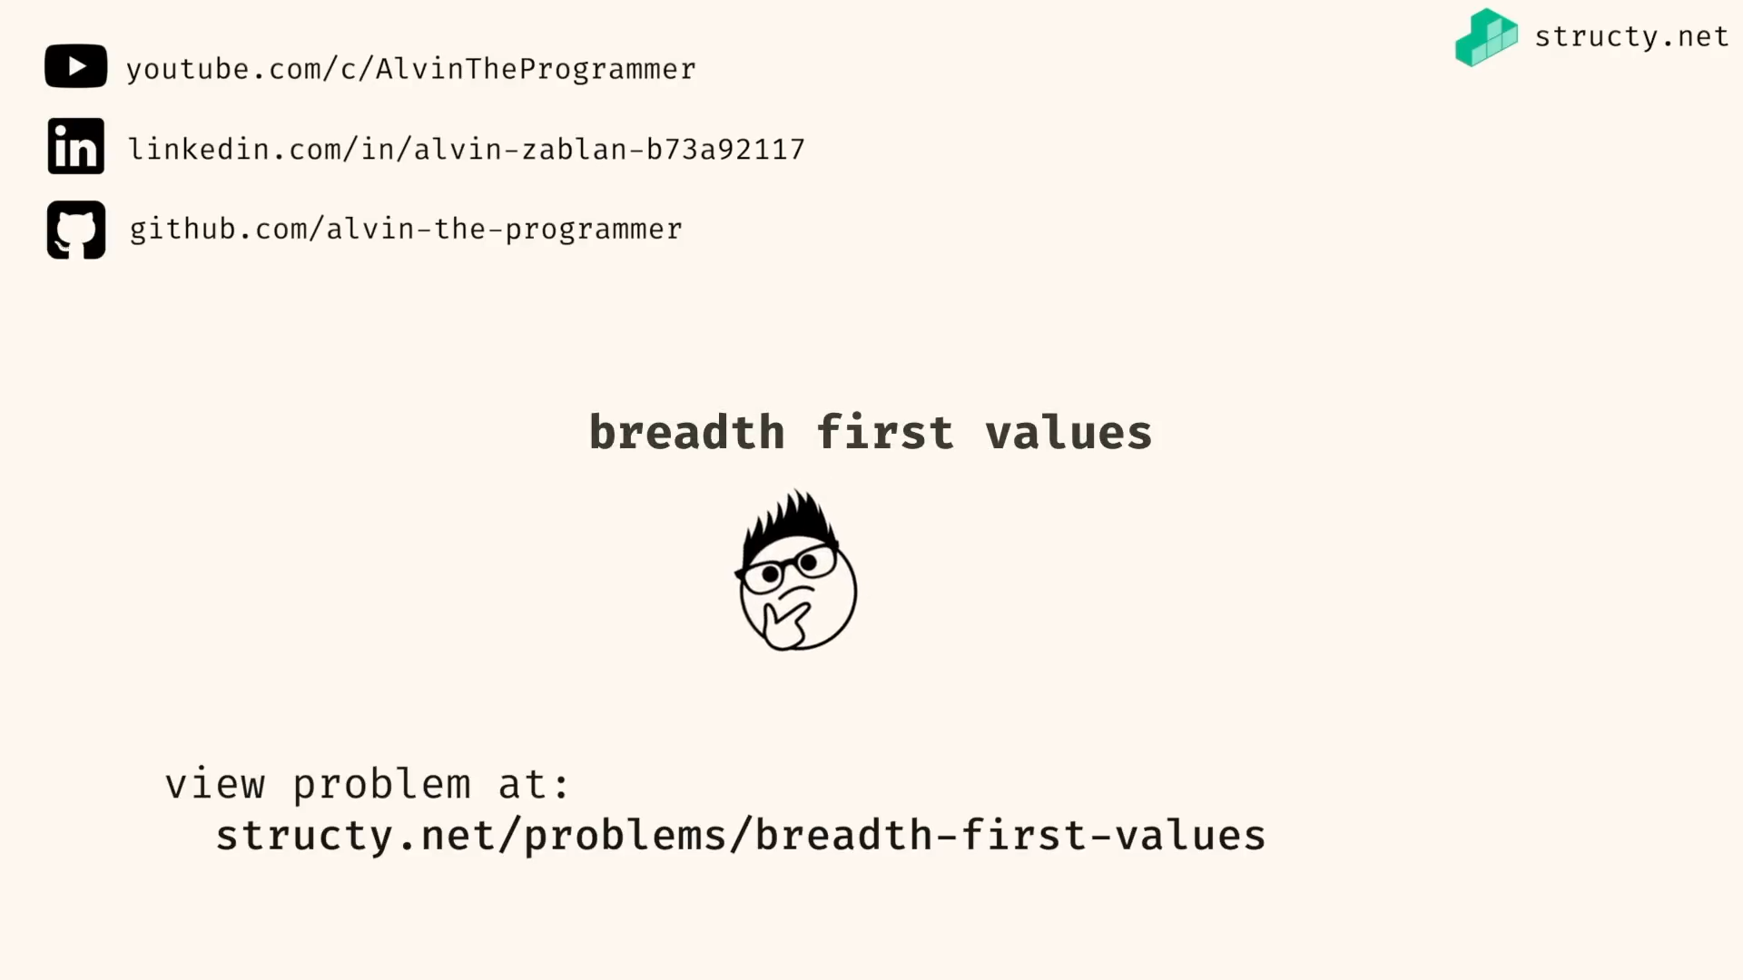

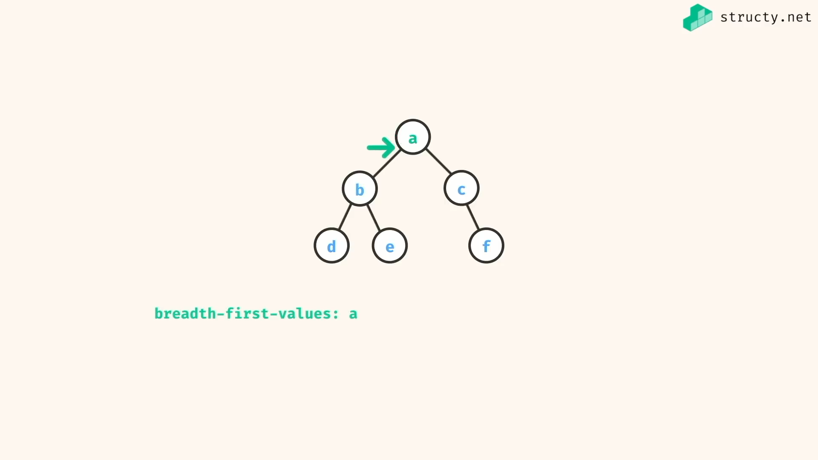

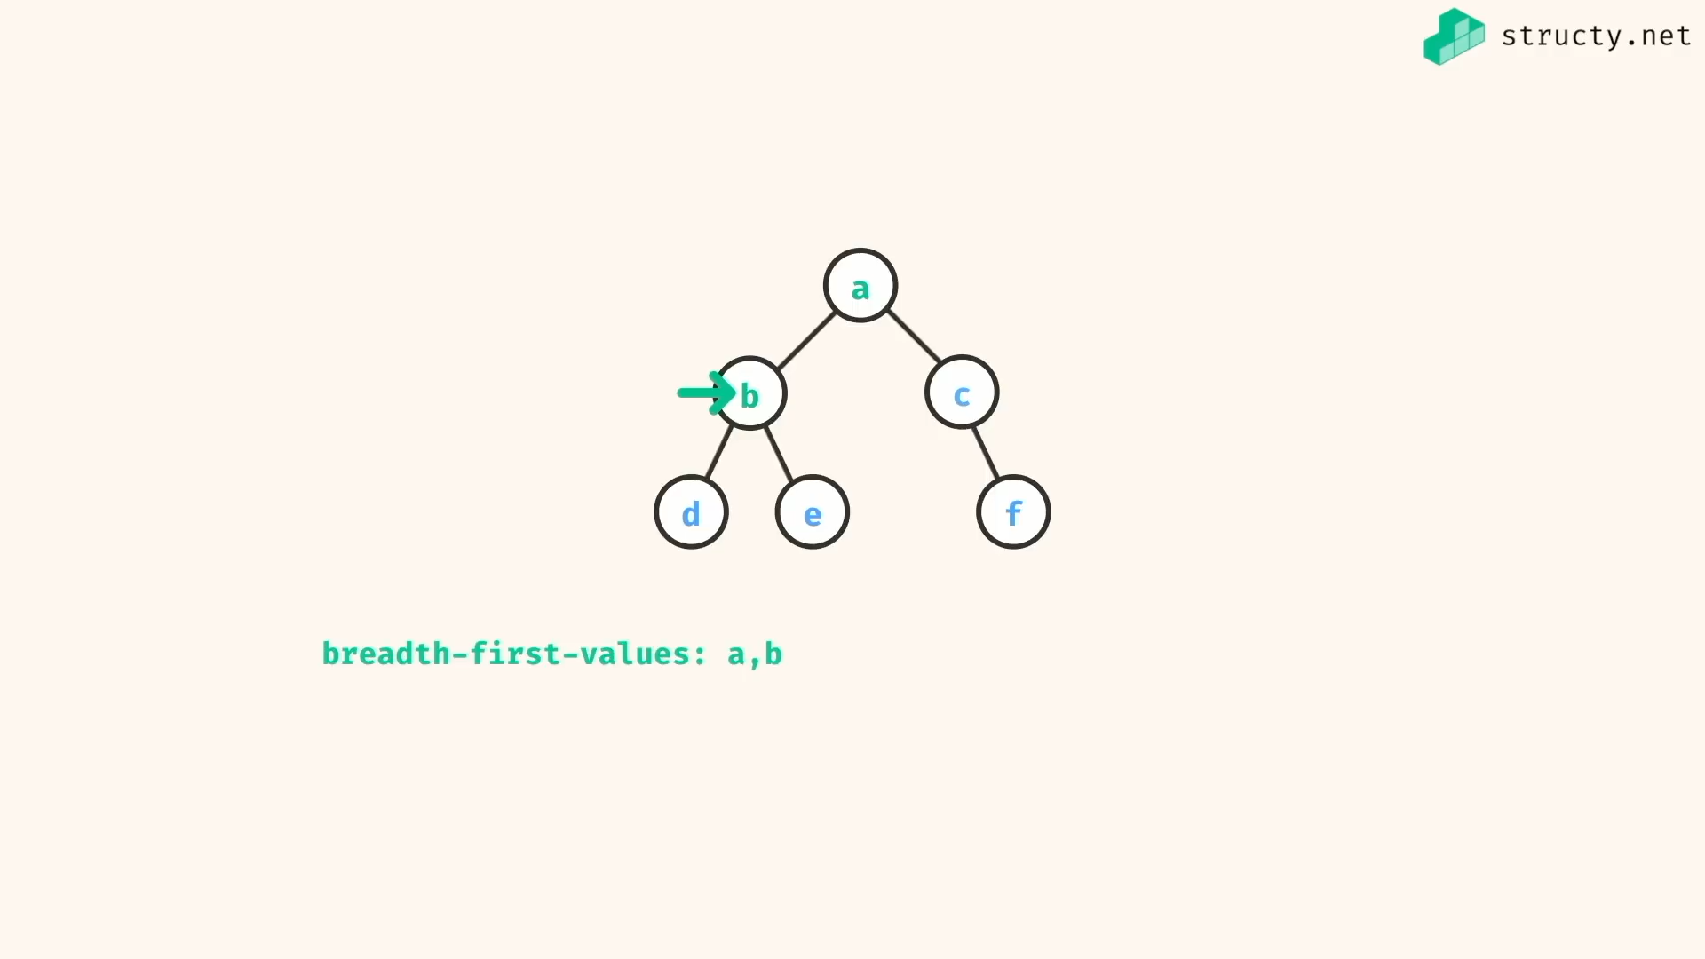

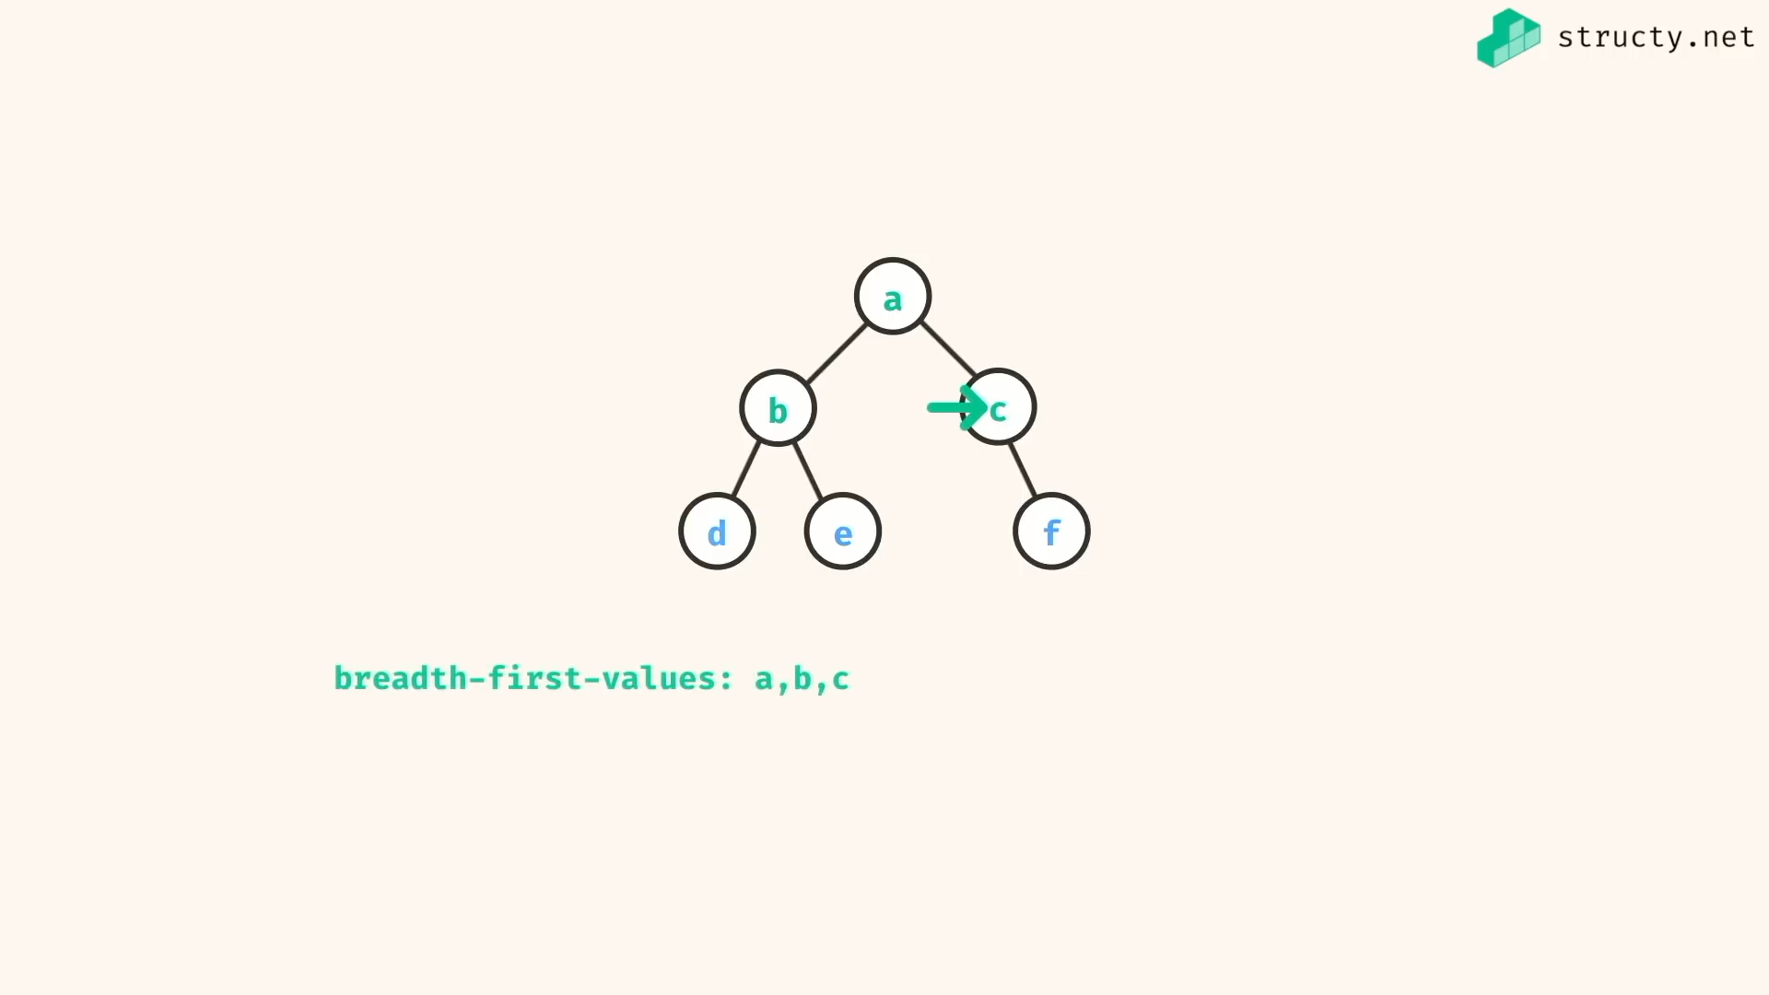

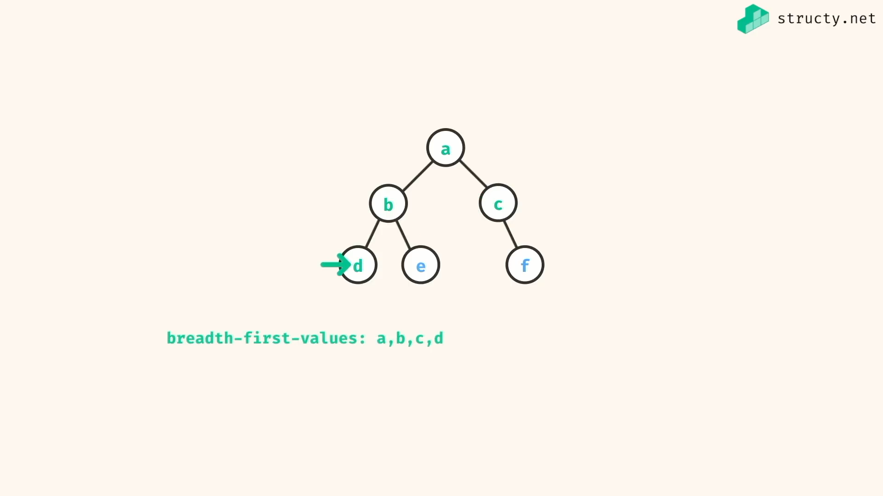

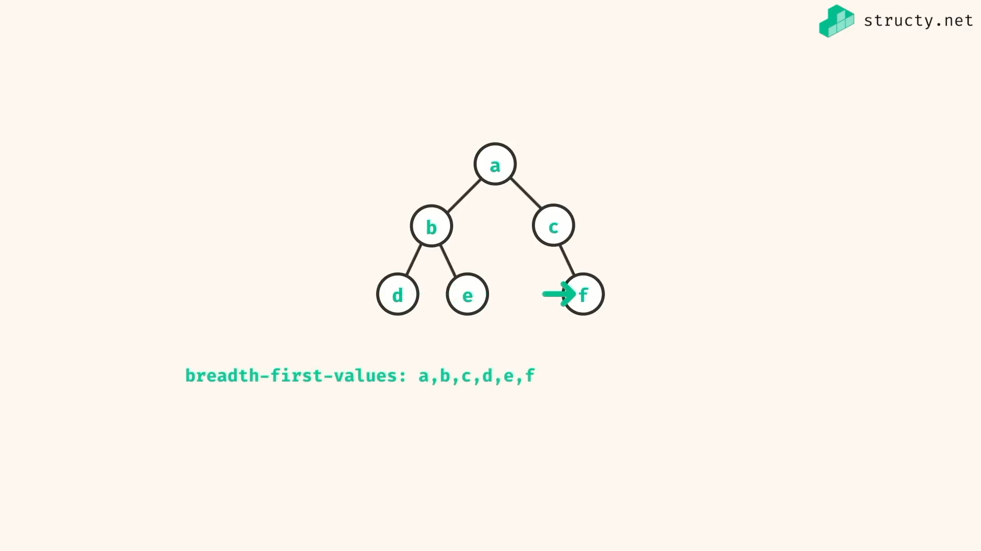

Queue implementation:

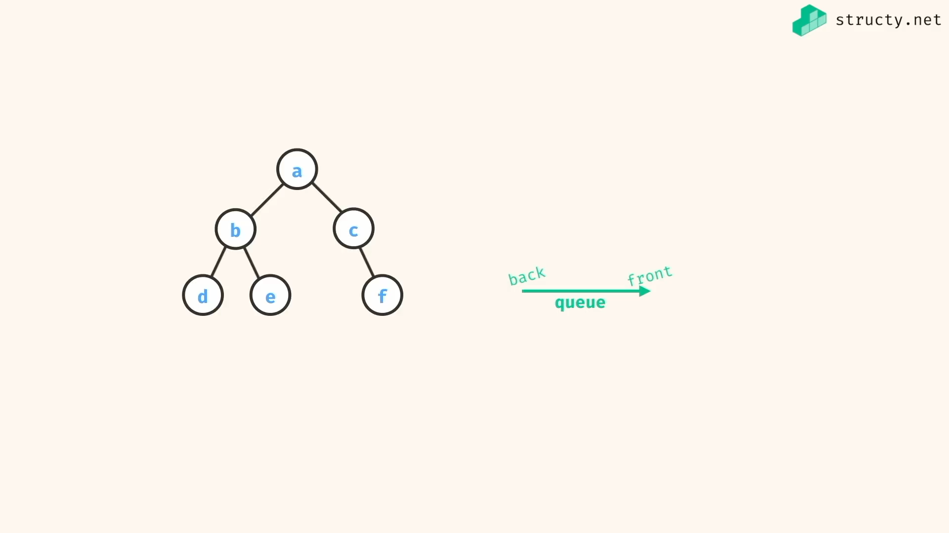

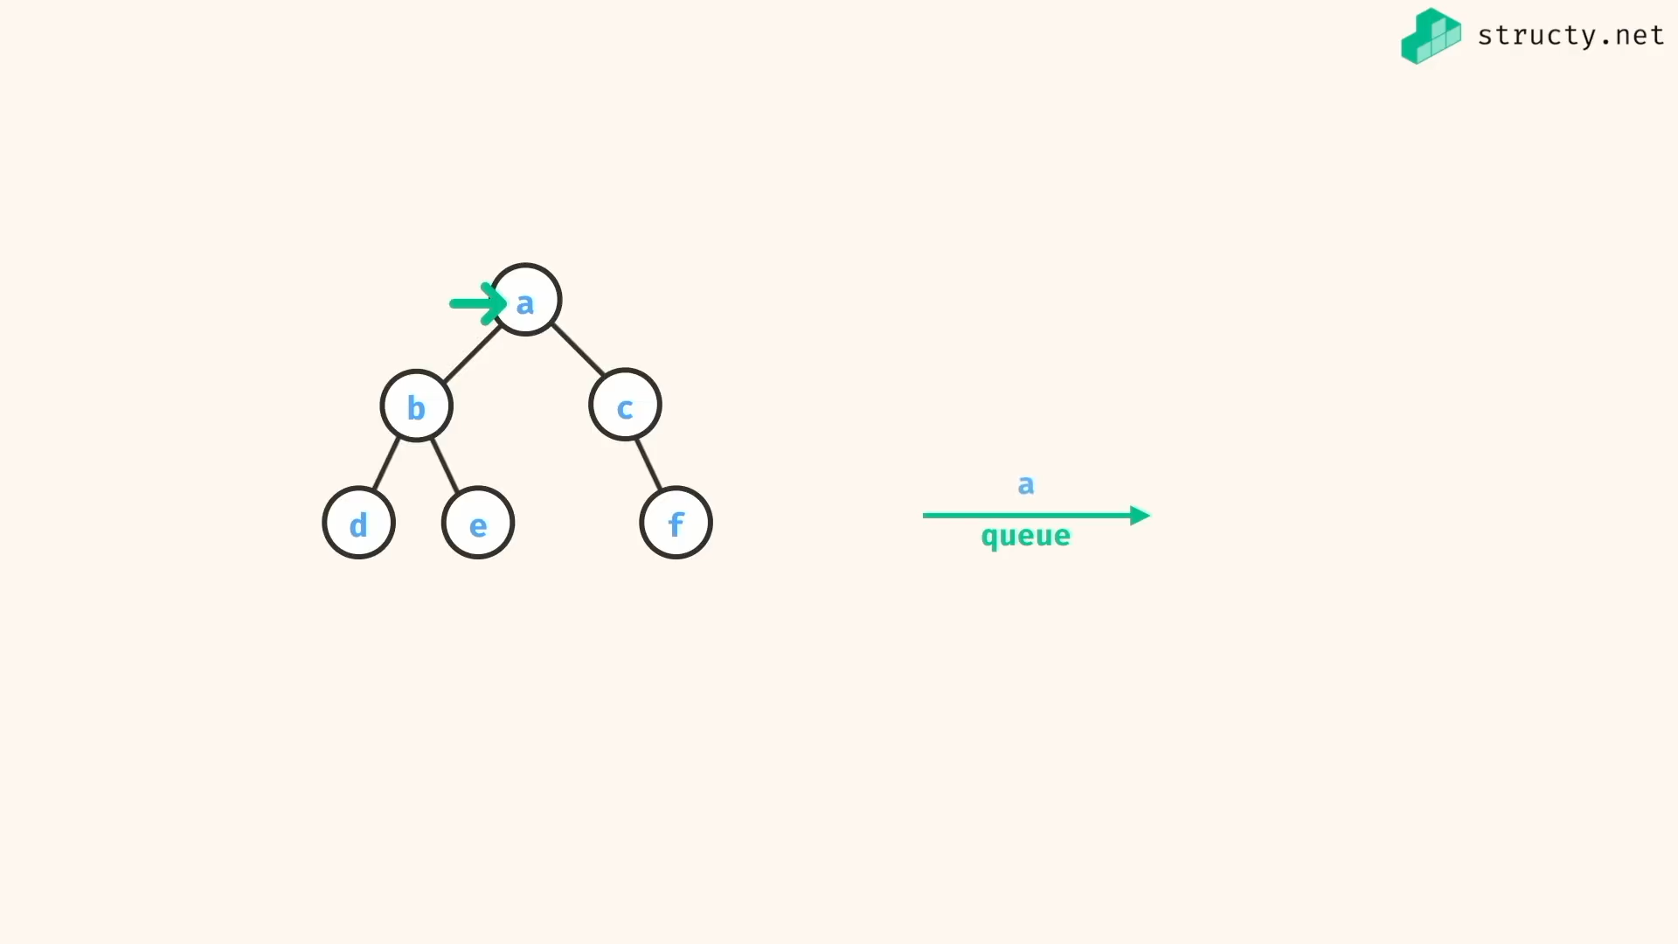

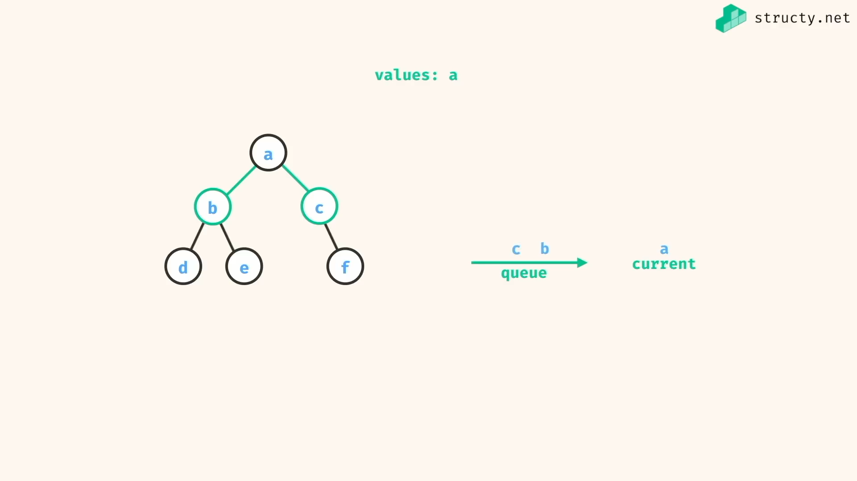

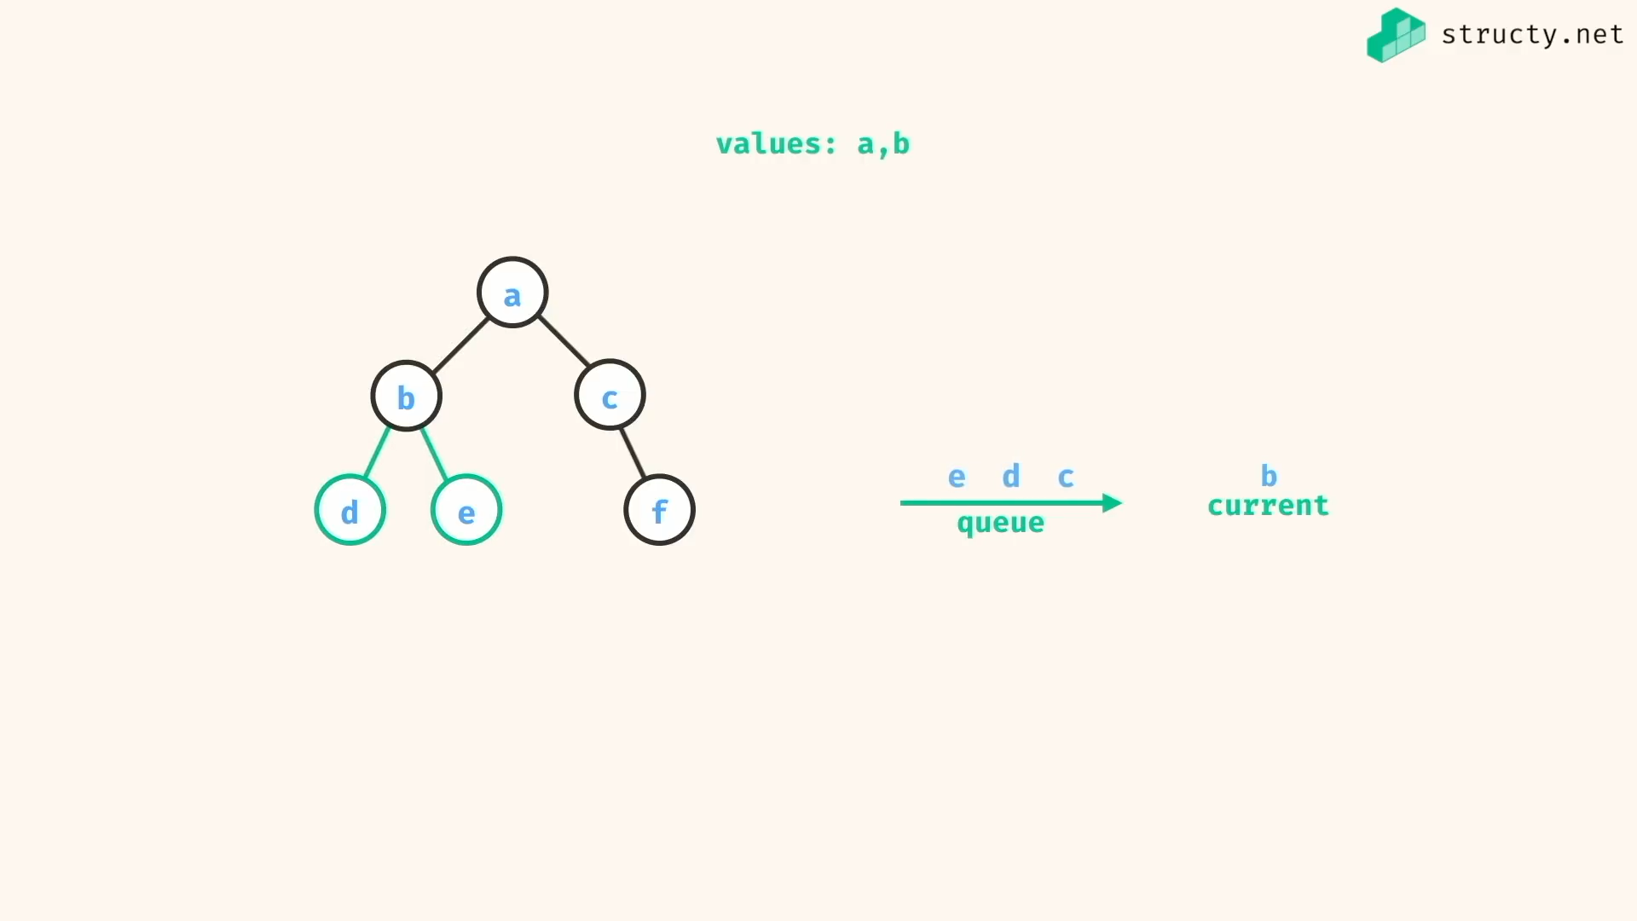

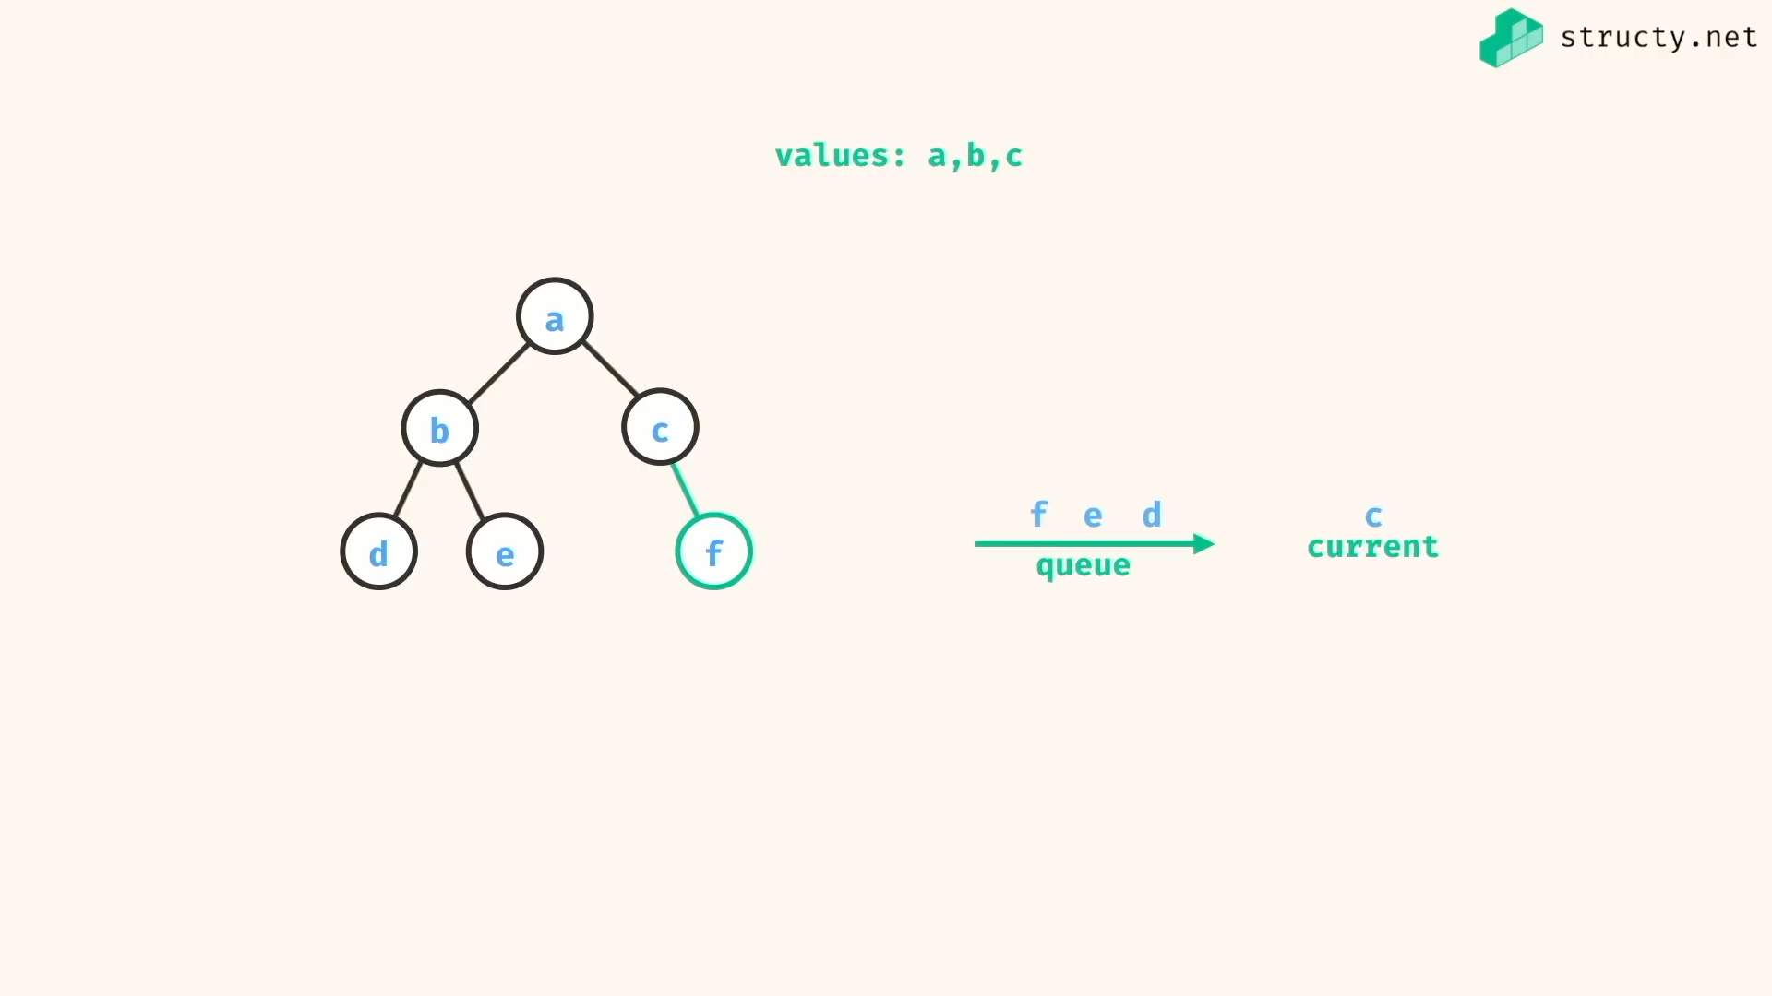

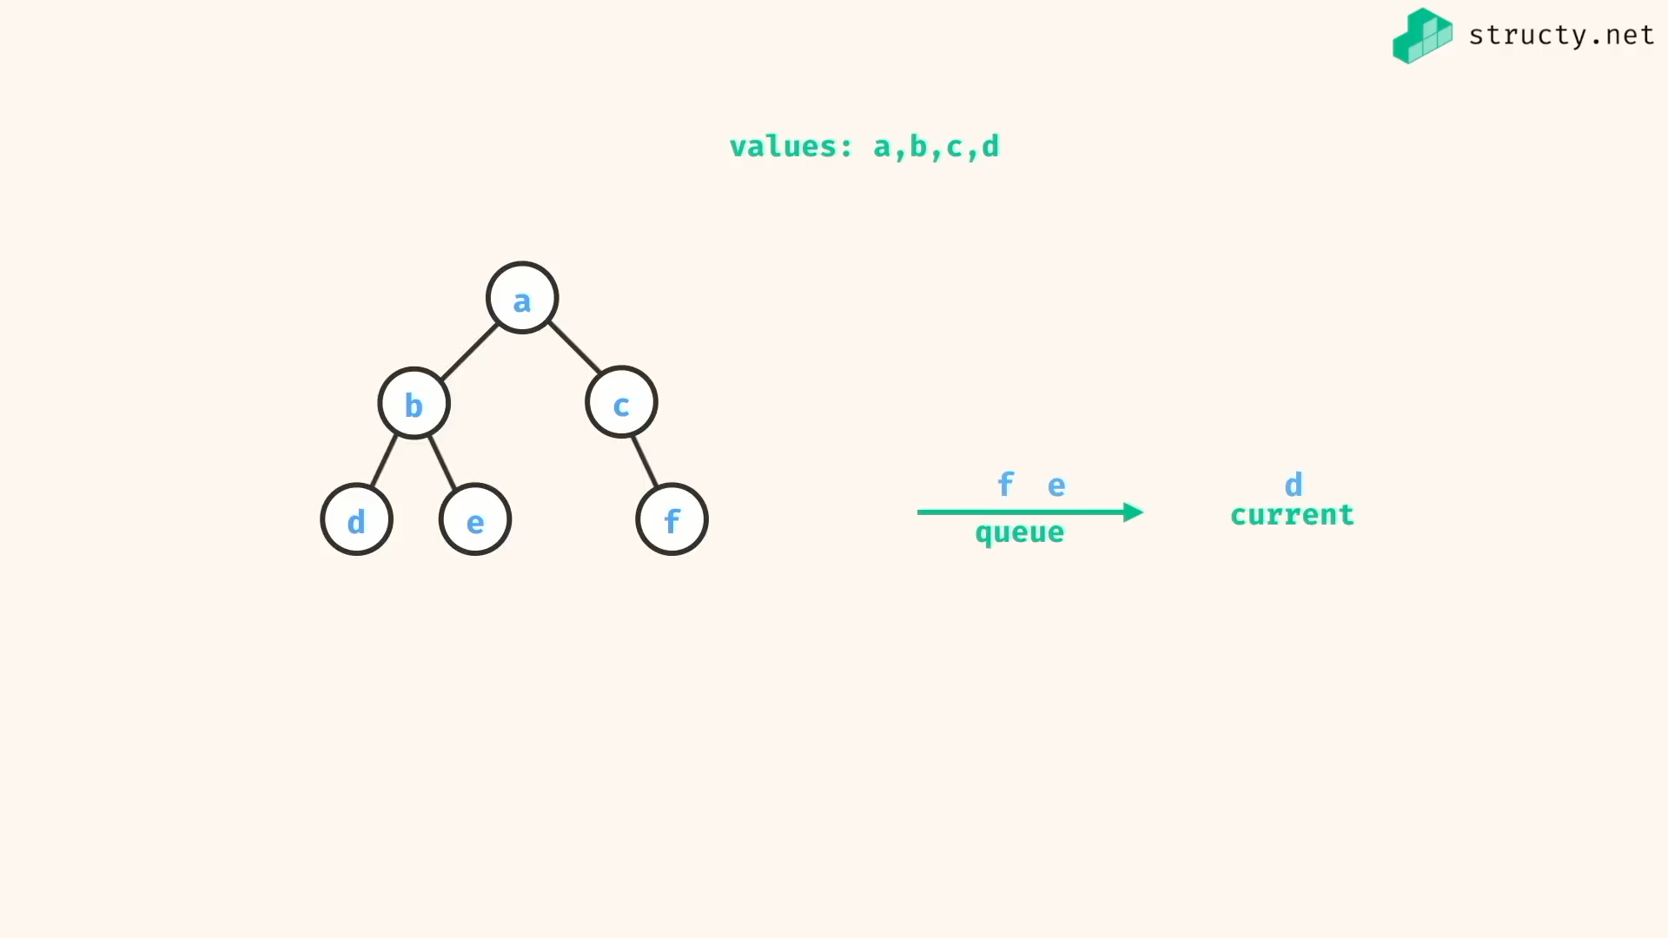

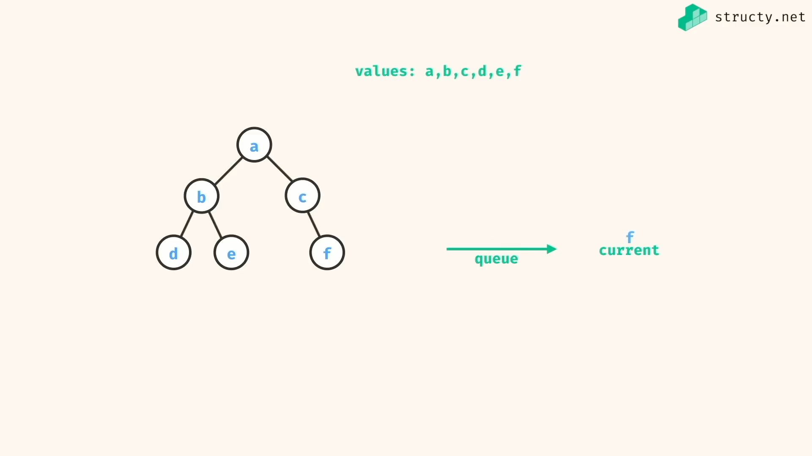

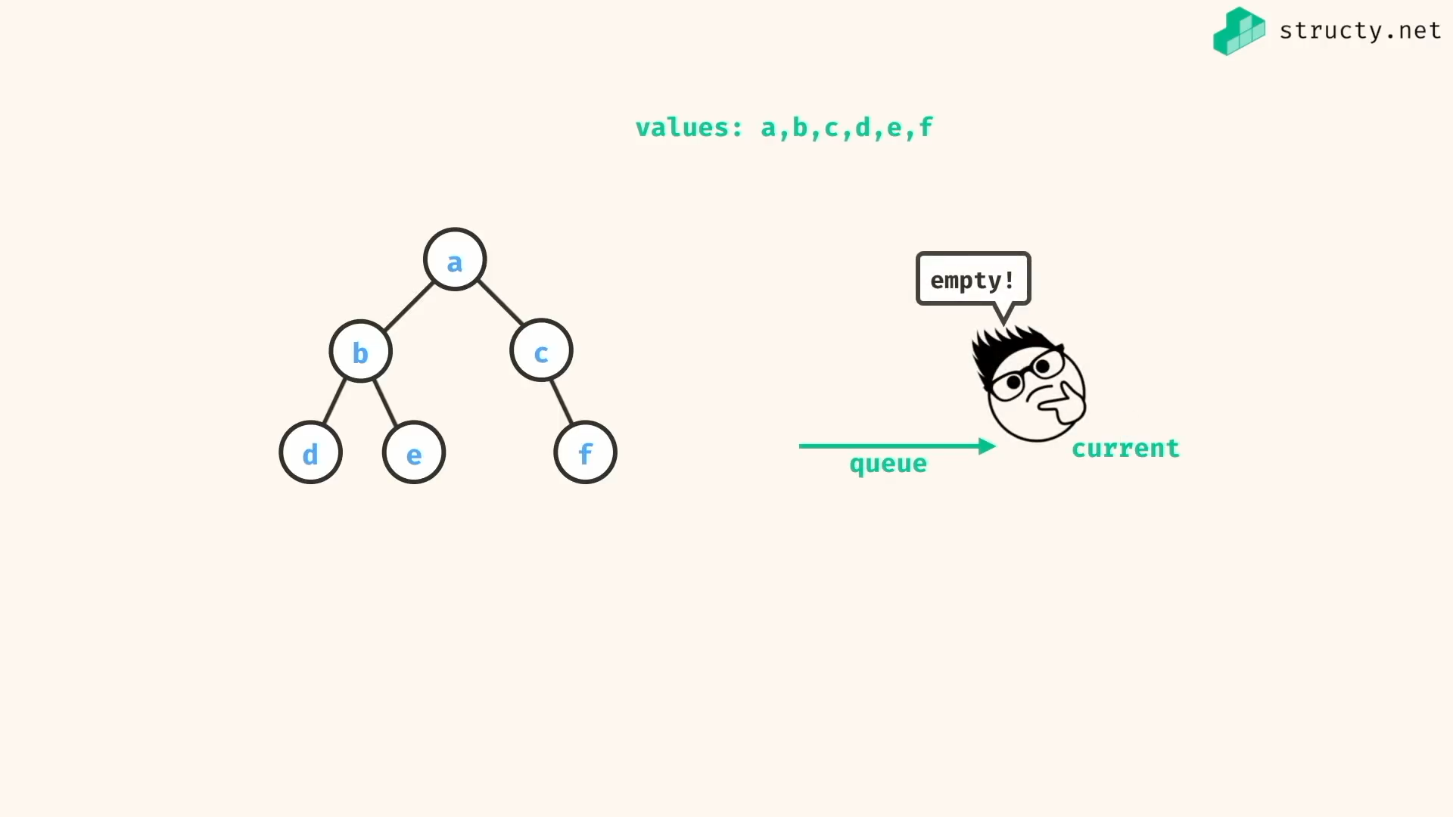

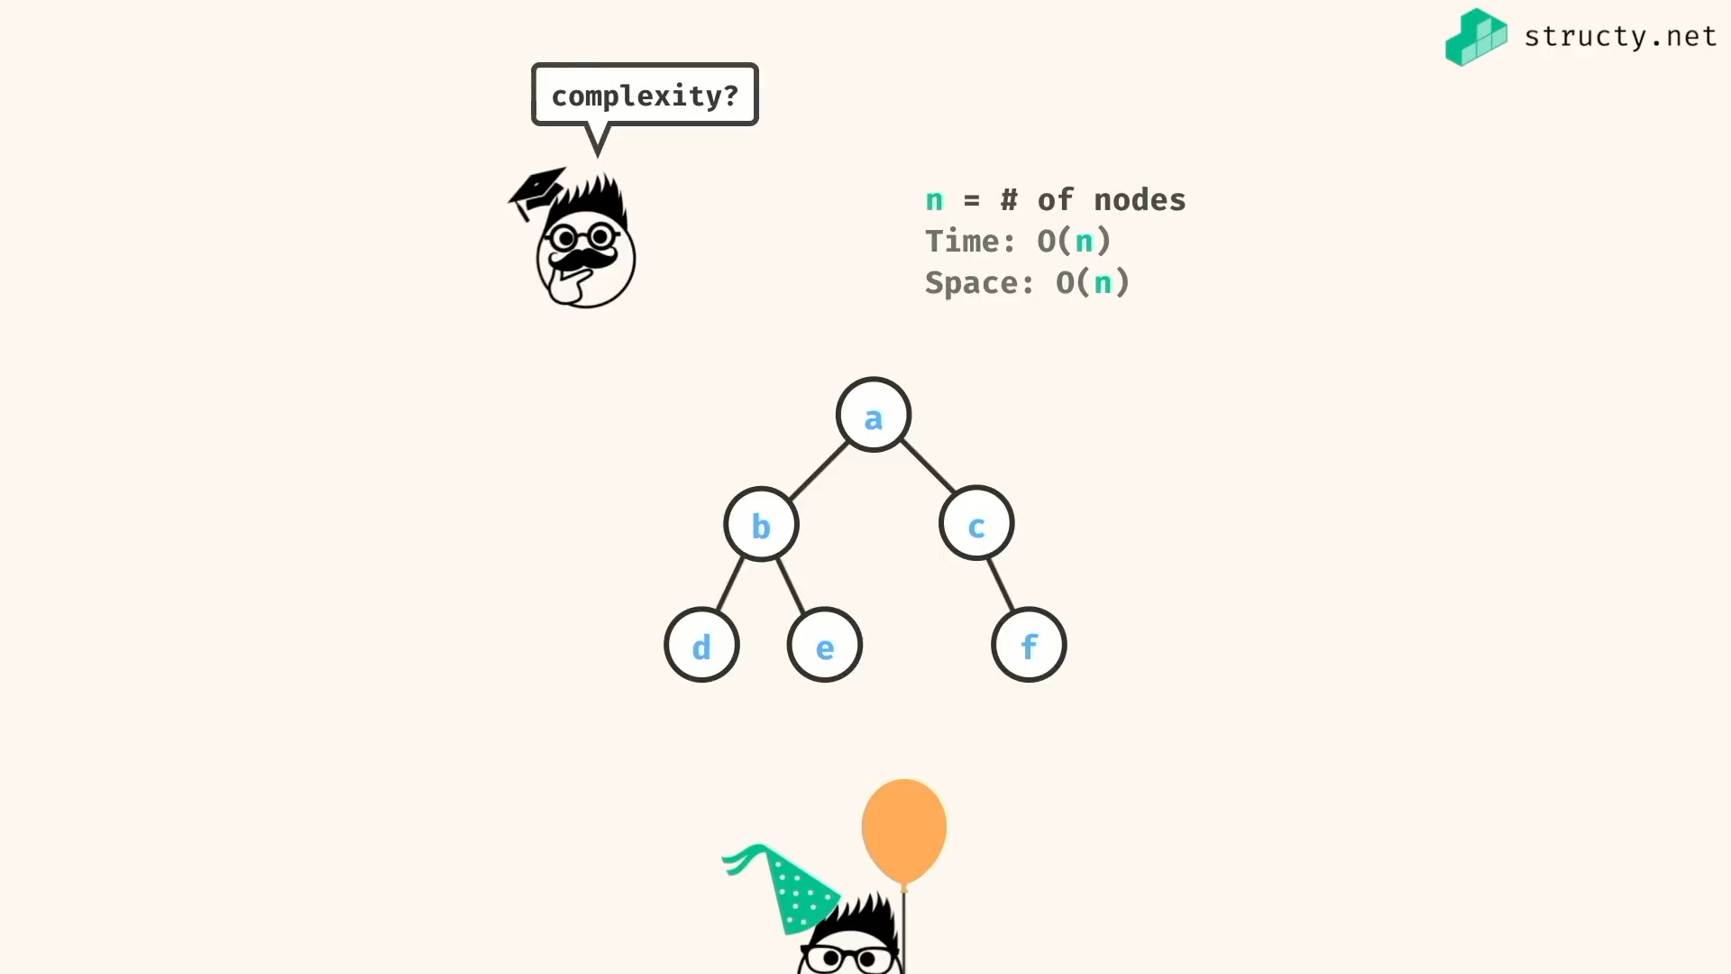

Here this complexity represent that we are implemented maximum efficient queue which add and remove data in O(1) time complexity…

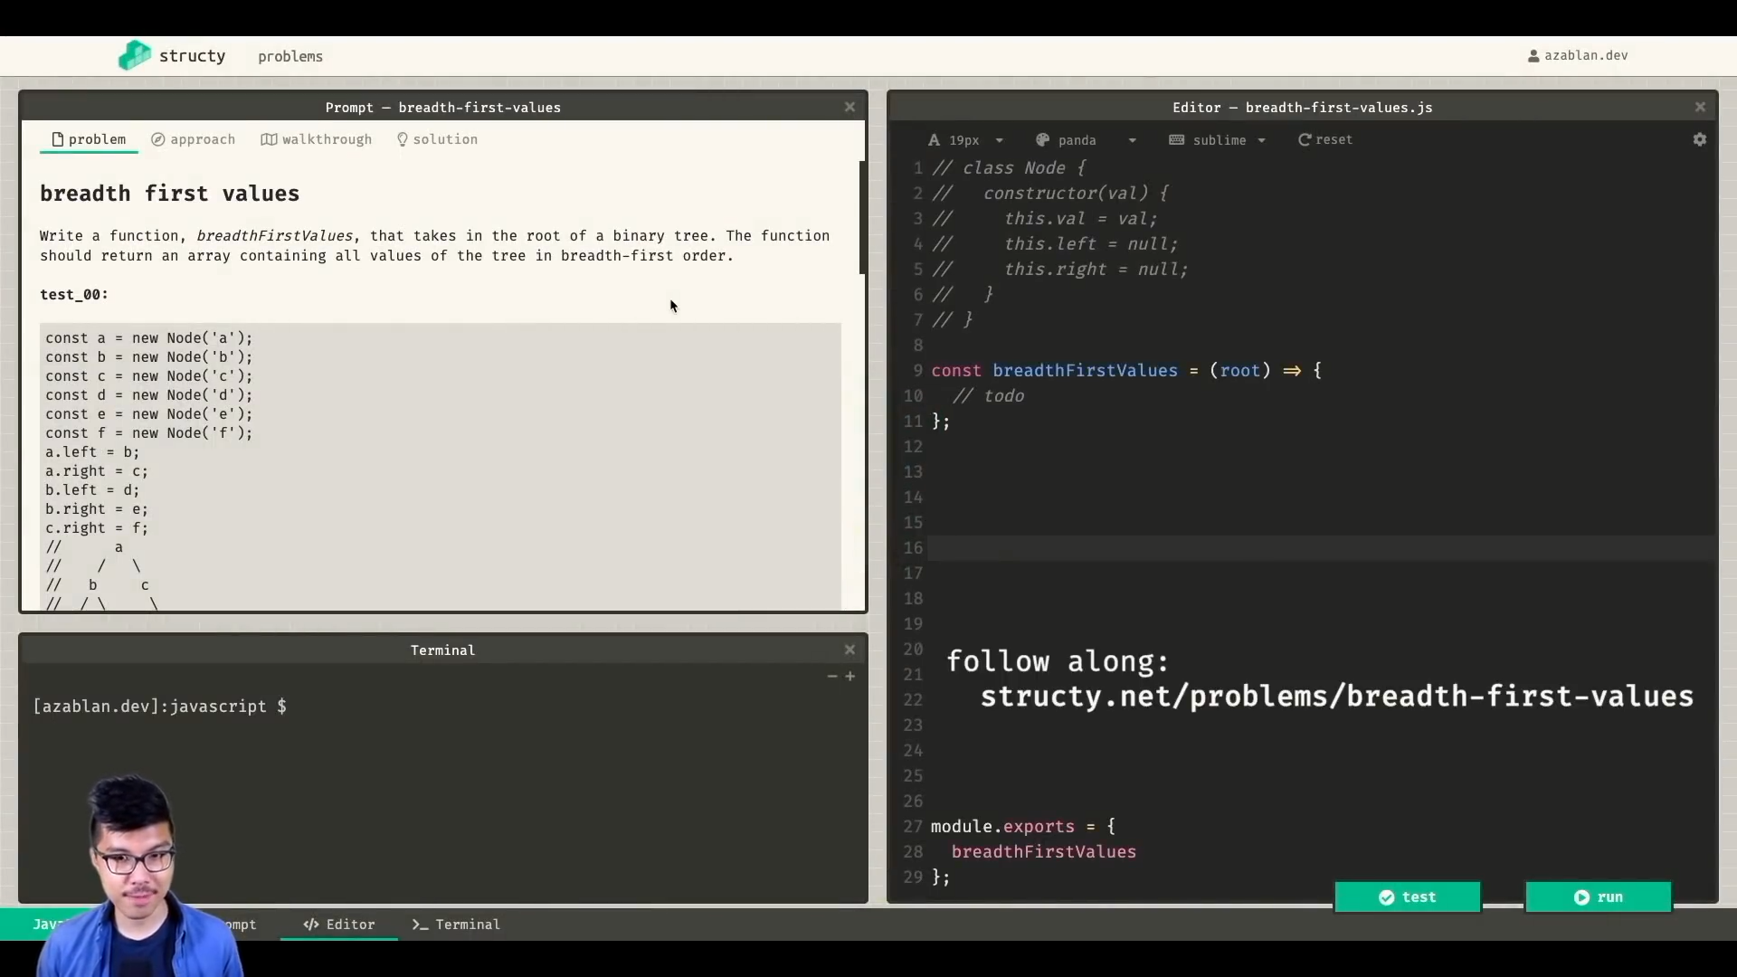

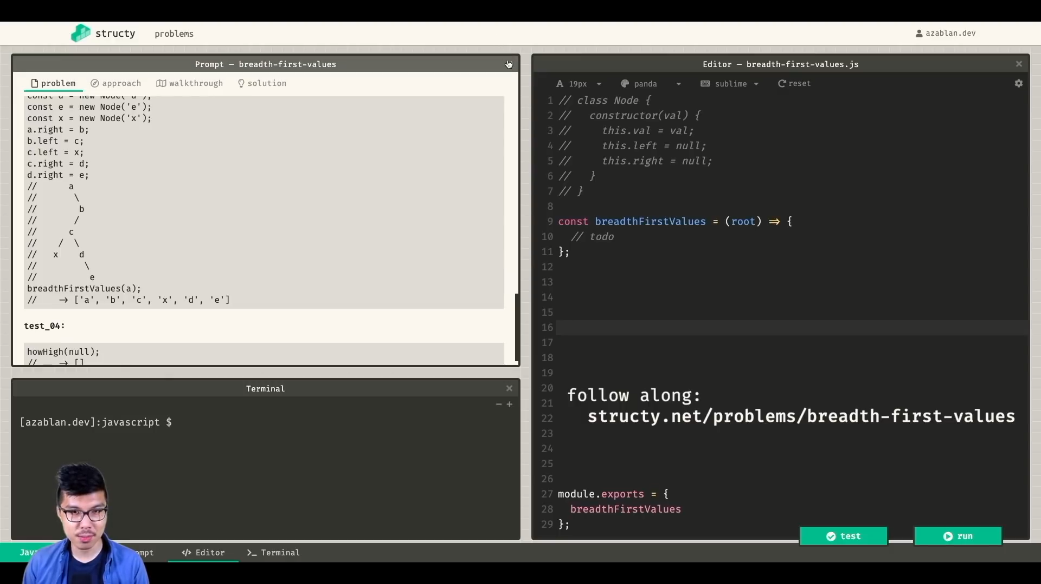

BFS is also known as level order traversal..

Extra level order traversals:

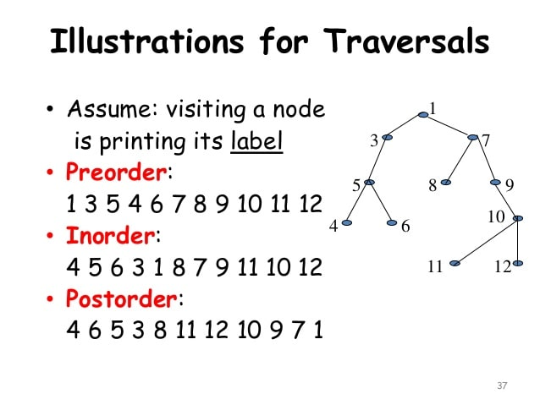

Level order traversal… @ <https://www.youtube.com/watch?v=lXIk1PXb1Jc>

Height 0f tree = largest path’s edge counts

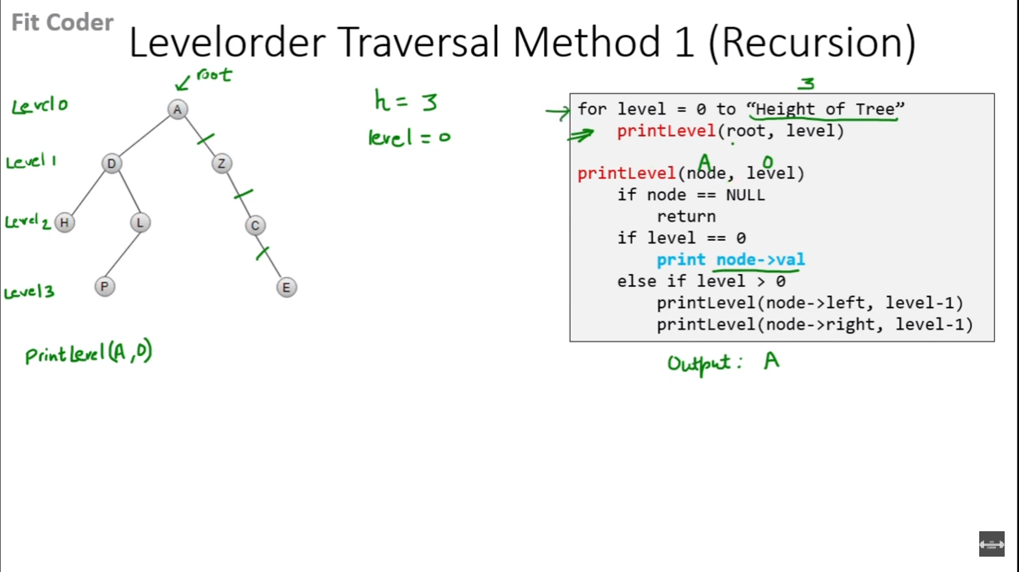

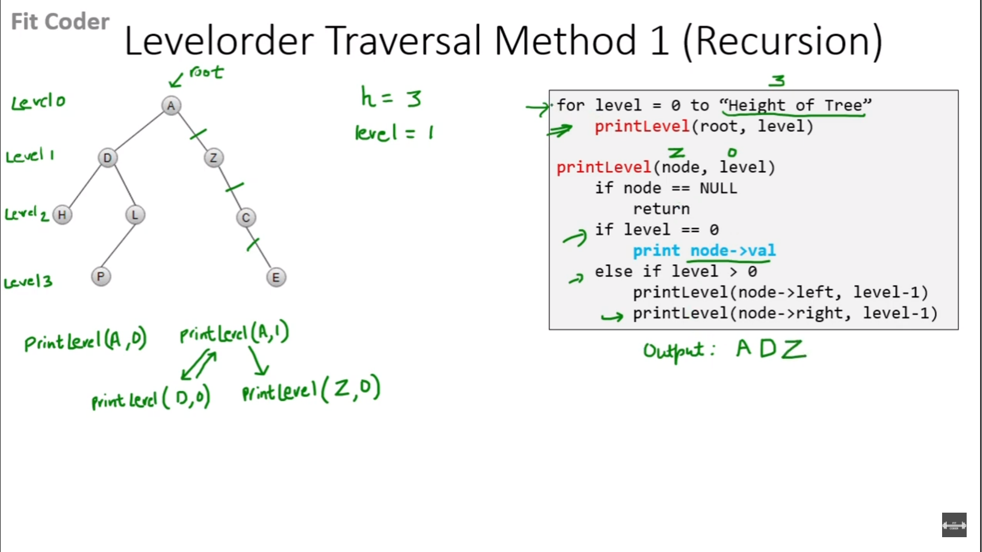

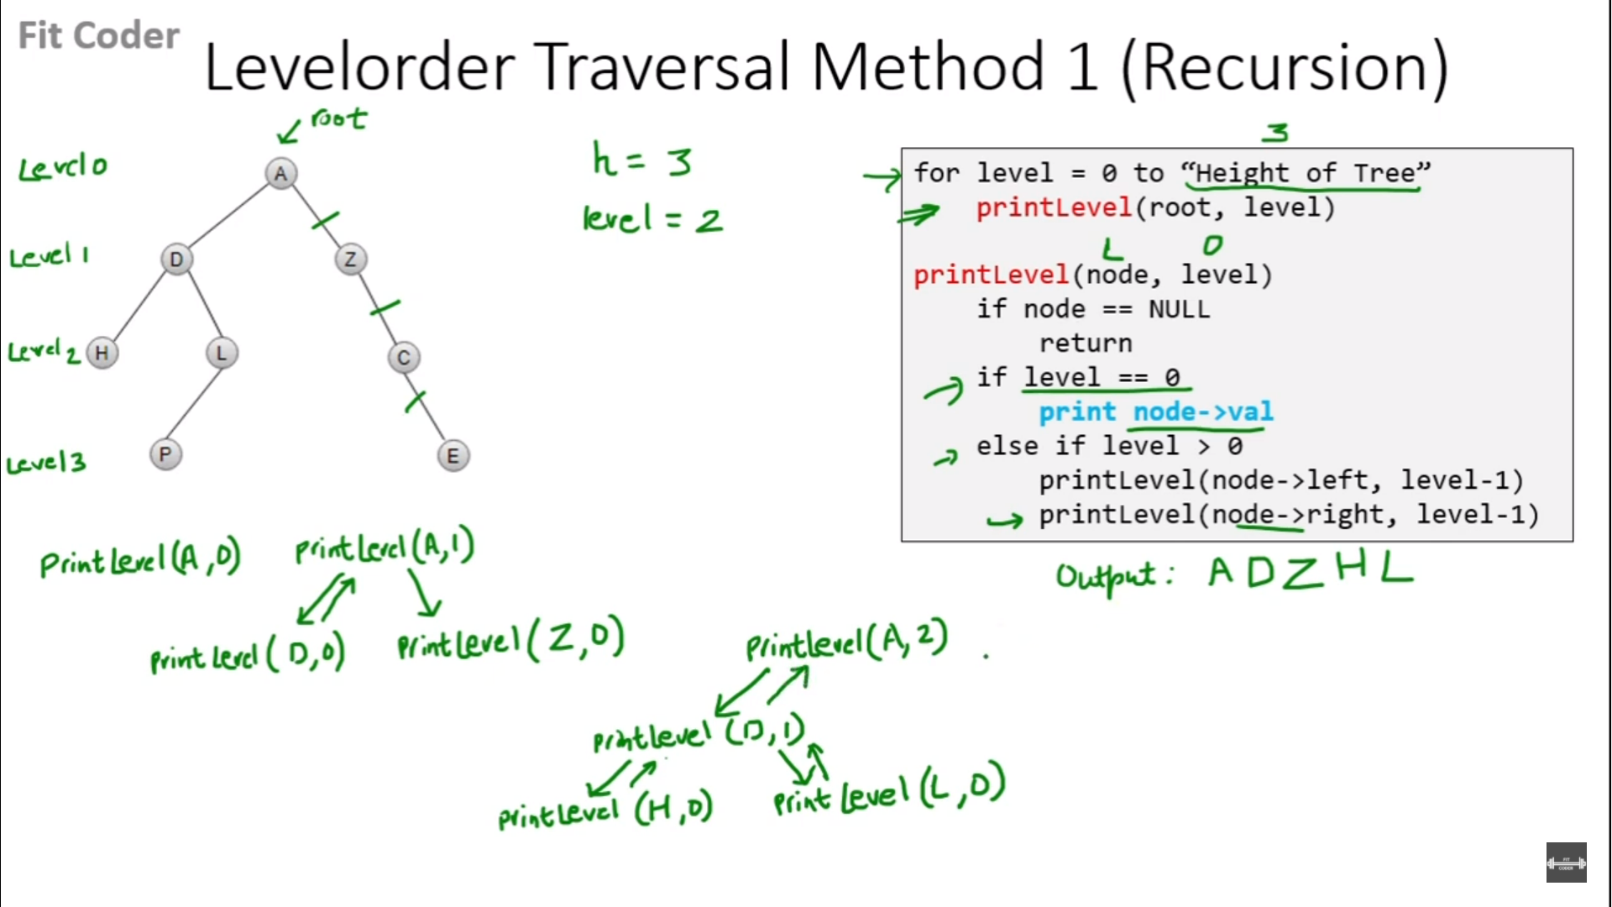

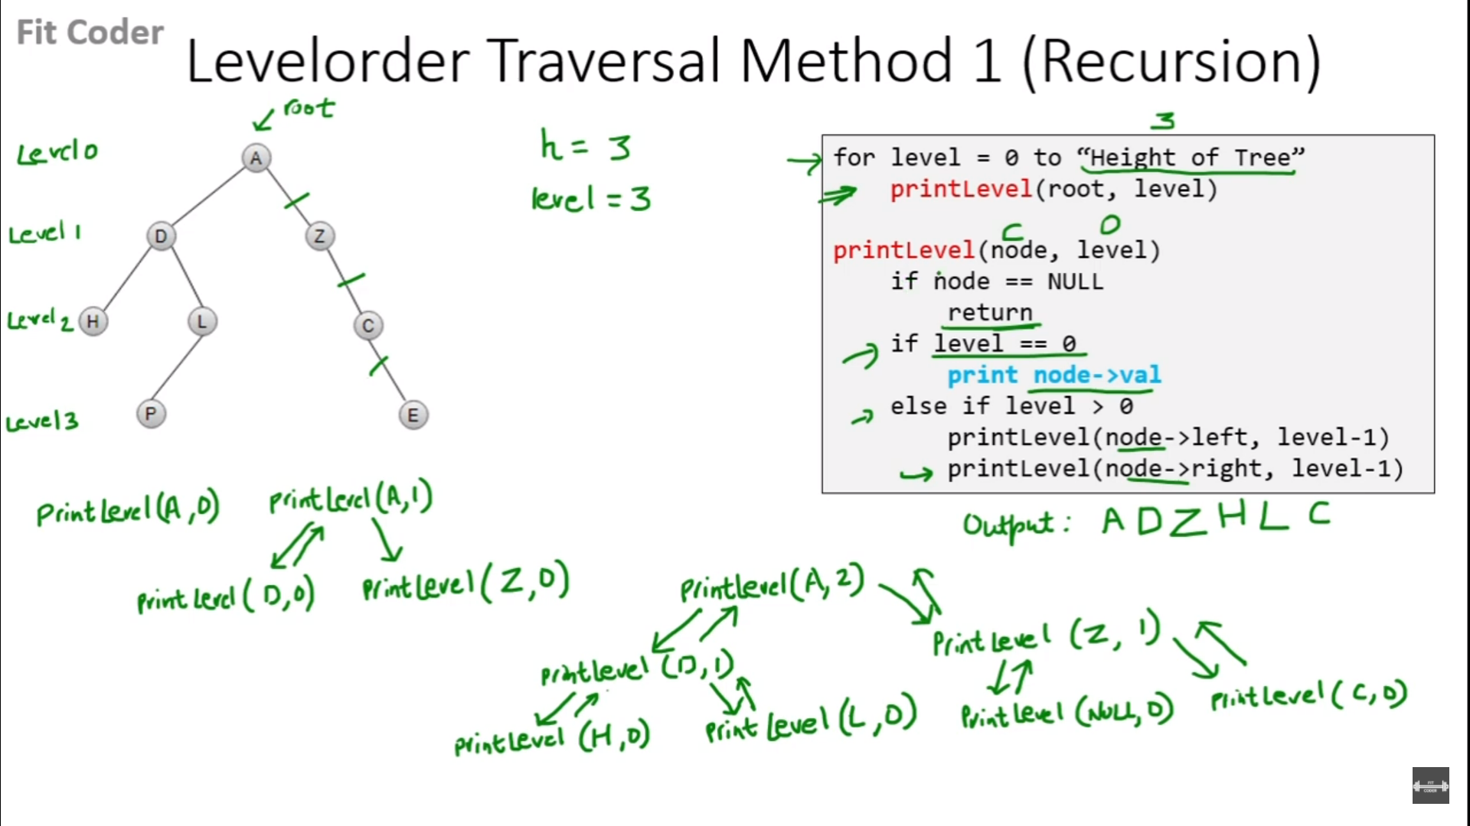

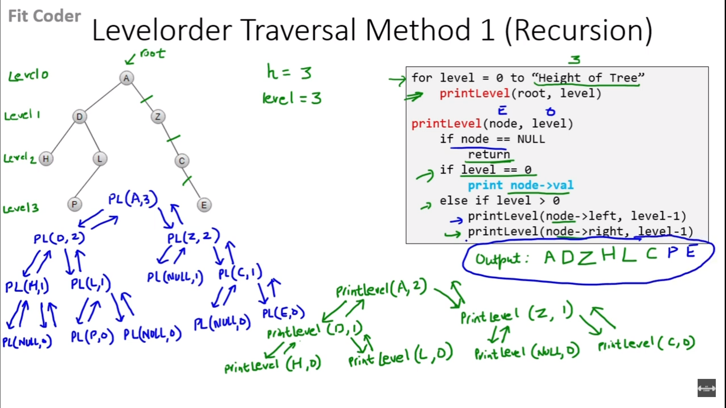

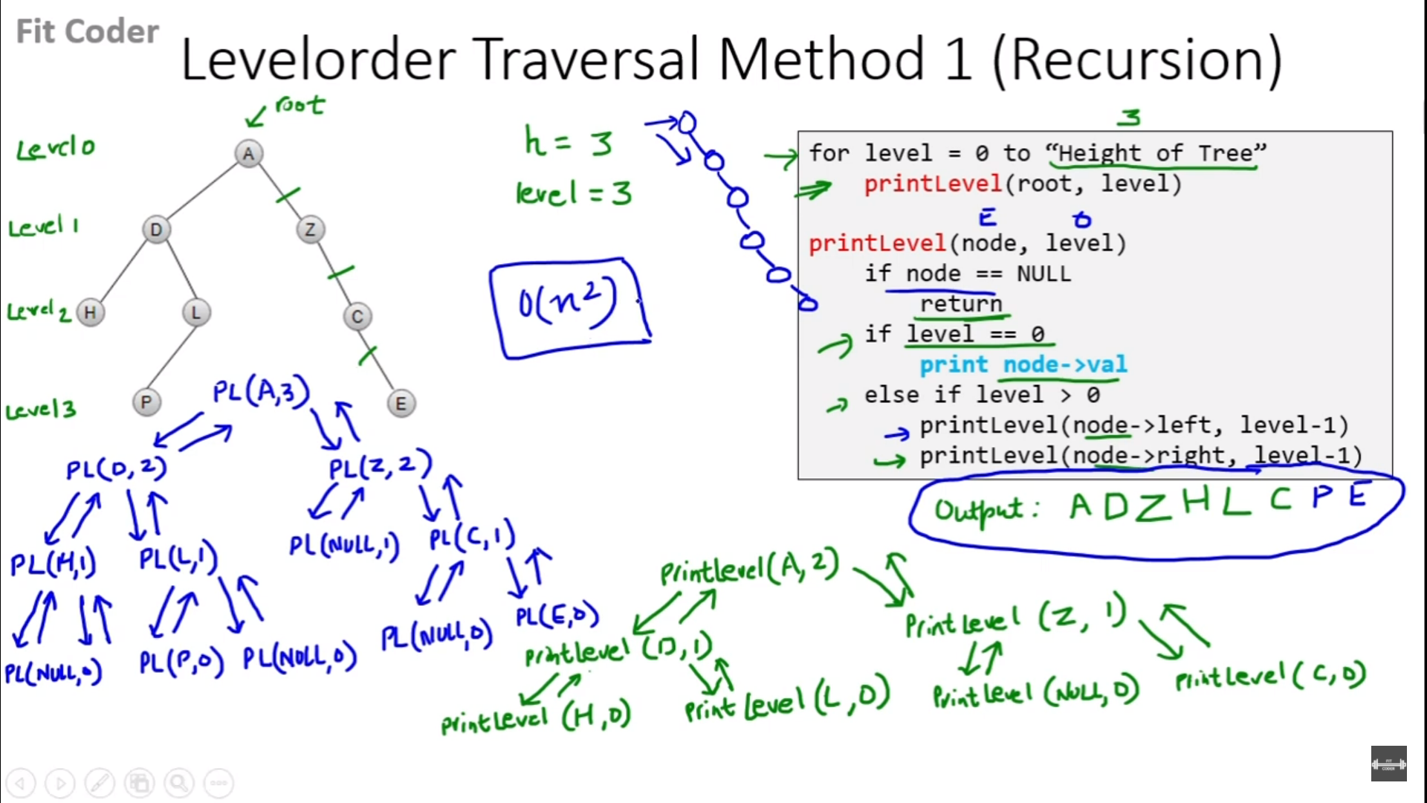

*const* breathFirstValuesIter = (*root*) *=>* {

if(!root) return [];

*const* queue = [ root ];

while(queue.length){

*const* current = queue.shift();

*console*.log(current.val);

current.left && queue.push(current.left)

current.right && queue.push(current.right)

}

}

*const* getMaxHeightOfTree = (*root*) *=>* {

if(!root) return 0;

*const* leftTreeHeight = 1 + getMaxHeightOfTree(root.left);

*const* rightTreeHeight = 1 + getMaxHeightOfTree(root.right);

return leftTreeHeight>rightTreeHeight ? leftTreeHeight : rightTreeHeight ;

}

*const* printNodesOfThatLevel = (*root*,*level*) *=>* {

if(!root){

return;

}else if(level === 0) {

*console*.log(root.val);

}else{

printNodesOfThatLevel(root.left, level-1);

printNodesOfThatLevel(root.right, level-1);

}

}

*const* breathFirstValuesRecur = (*root*) *=>* {

*const* maxTreeHeight = getMaxHeightOfTree(root);

for(*let* level = 0 ; level < maxTreeHeight; level += 1)

printNodesOfThatLevel(root,level);

}

*class* Node {

constructor(*val*){

*this*.val = val;

*this*.left = null;

*this*.right = null;

}

}

*const* a = new Node('a')

*const* b = new Node('b')

*const* c = new Node('c')

*const* d = new Node('d')

*const* e = new Node('e')

*const* f = new Node('f')

a.left = b;

a.right = c;

b.left = d;

b.right = e;

c.right = f;

/\*

a

/ \

b c

/ \ \

d e f

\*/

breathFirstValuesIter(a)

// => a b c d e f

breathFirstValuesRecur(a)

// => a b c d e f

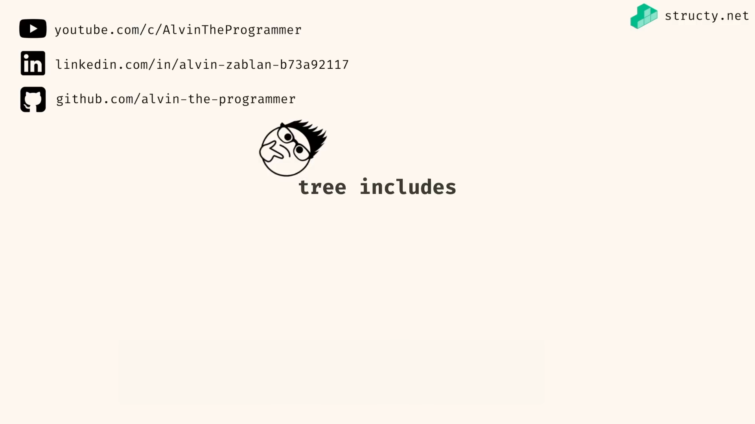

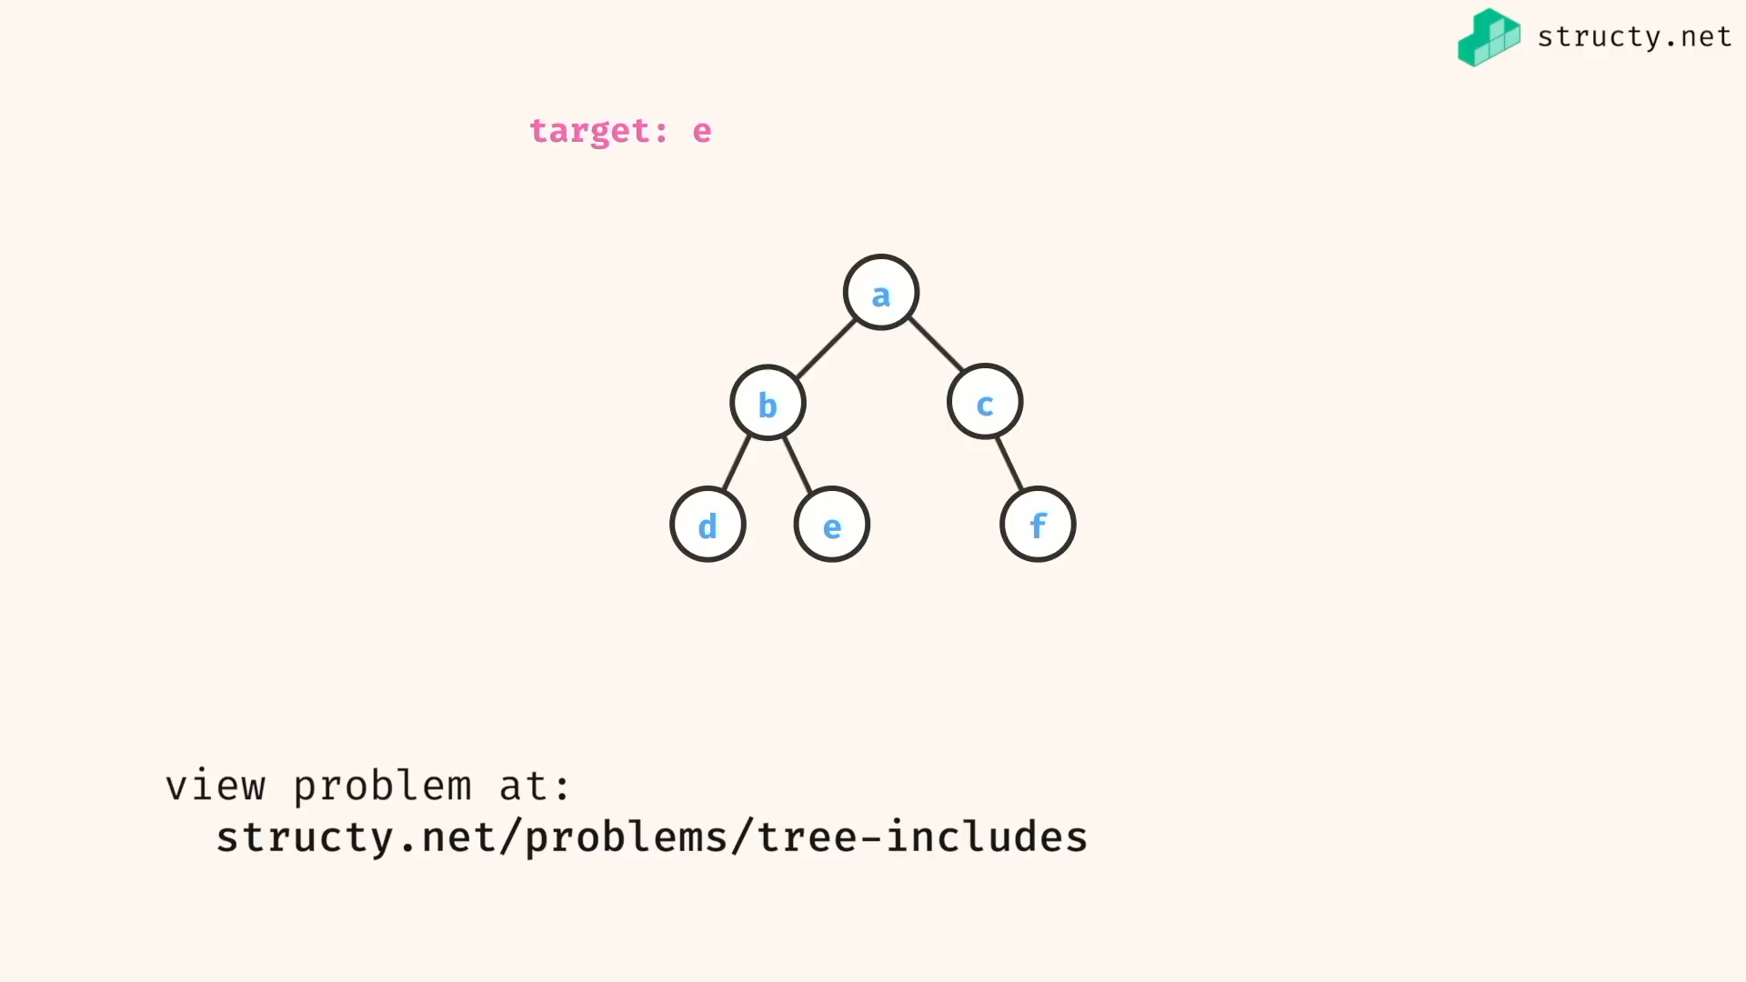

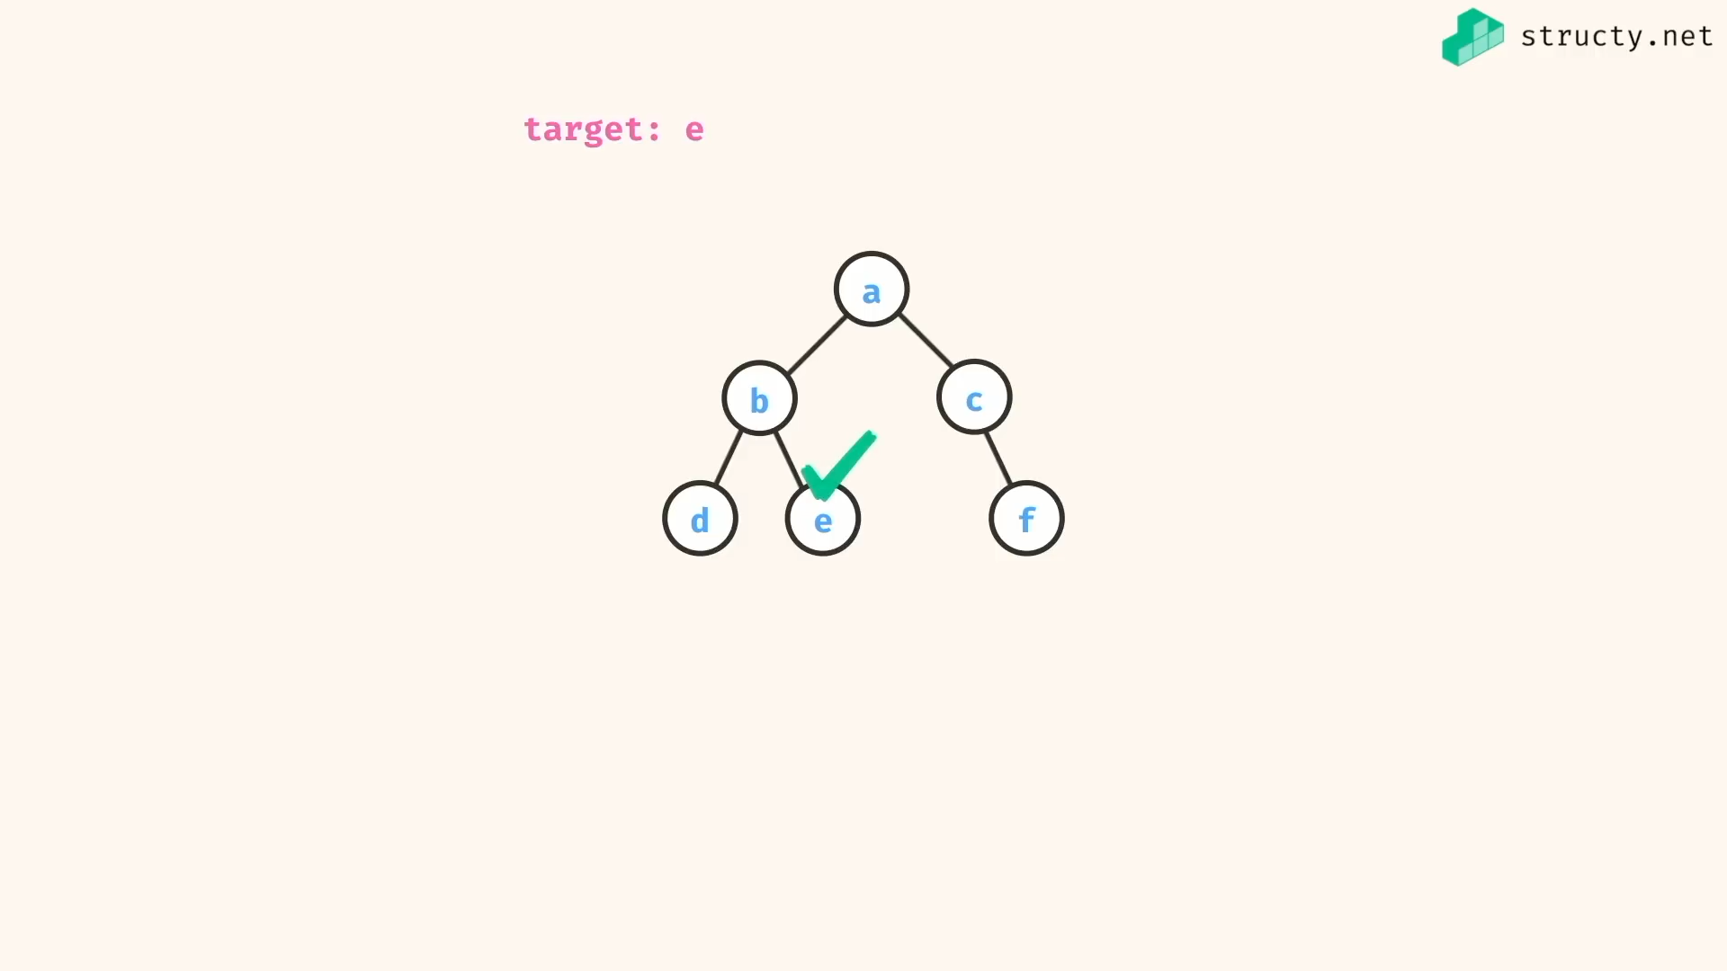

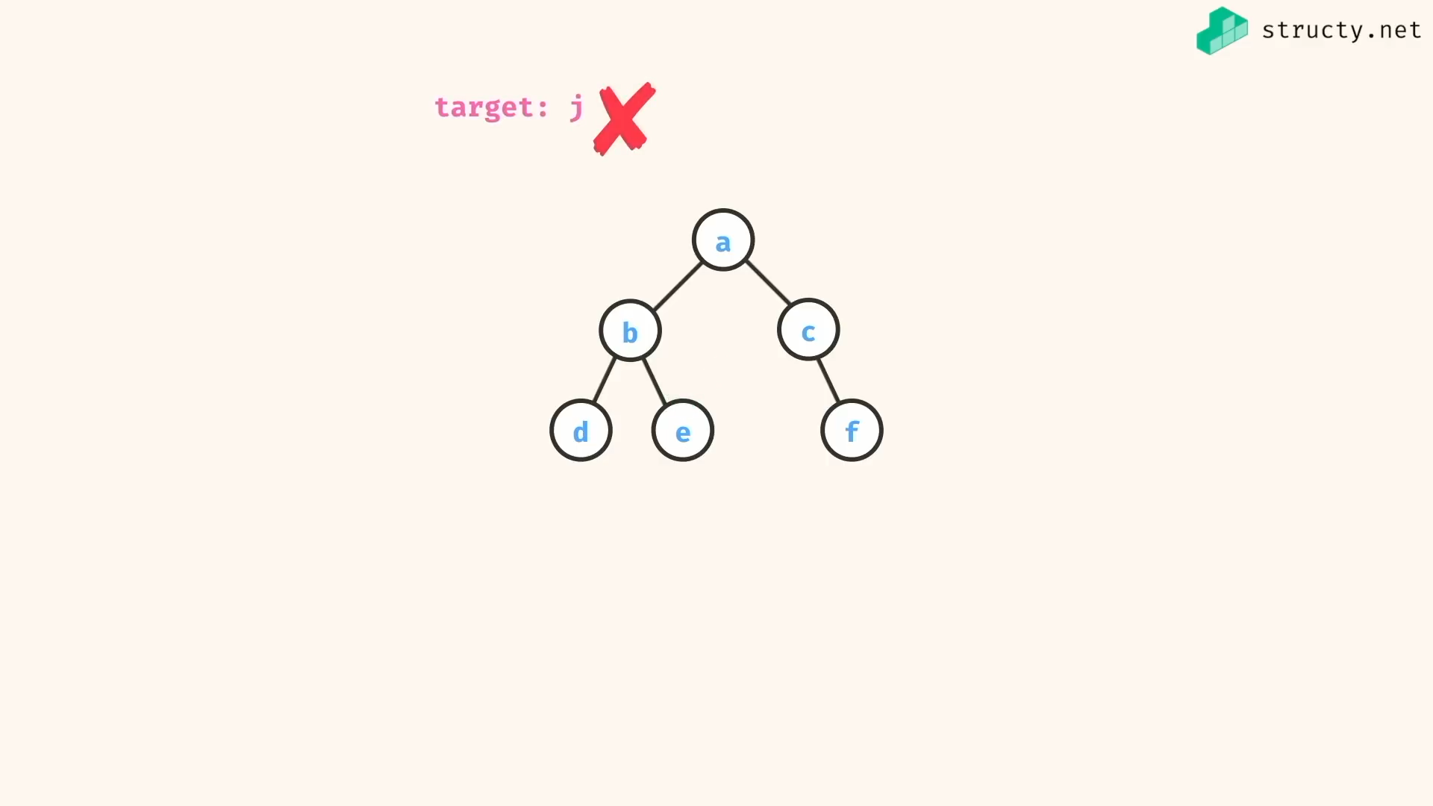

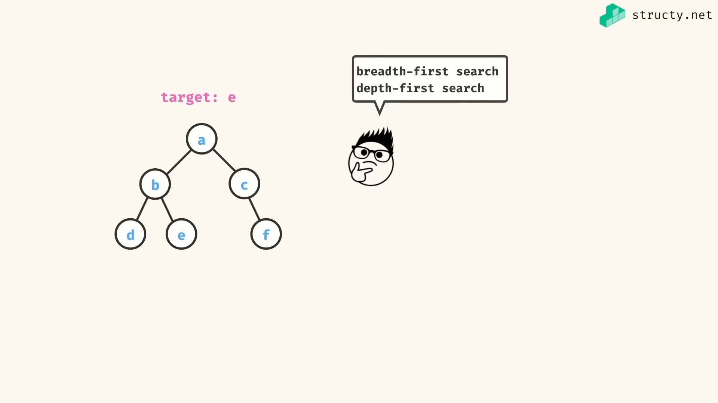

We will do breadth first search…

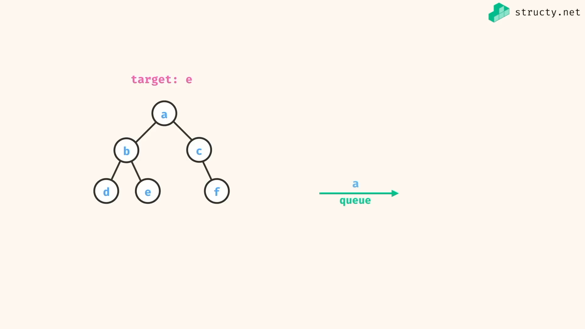

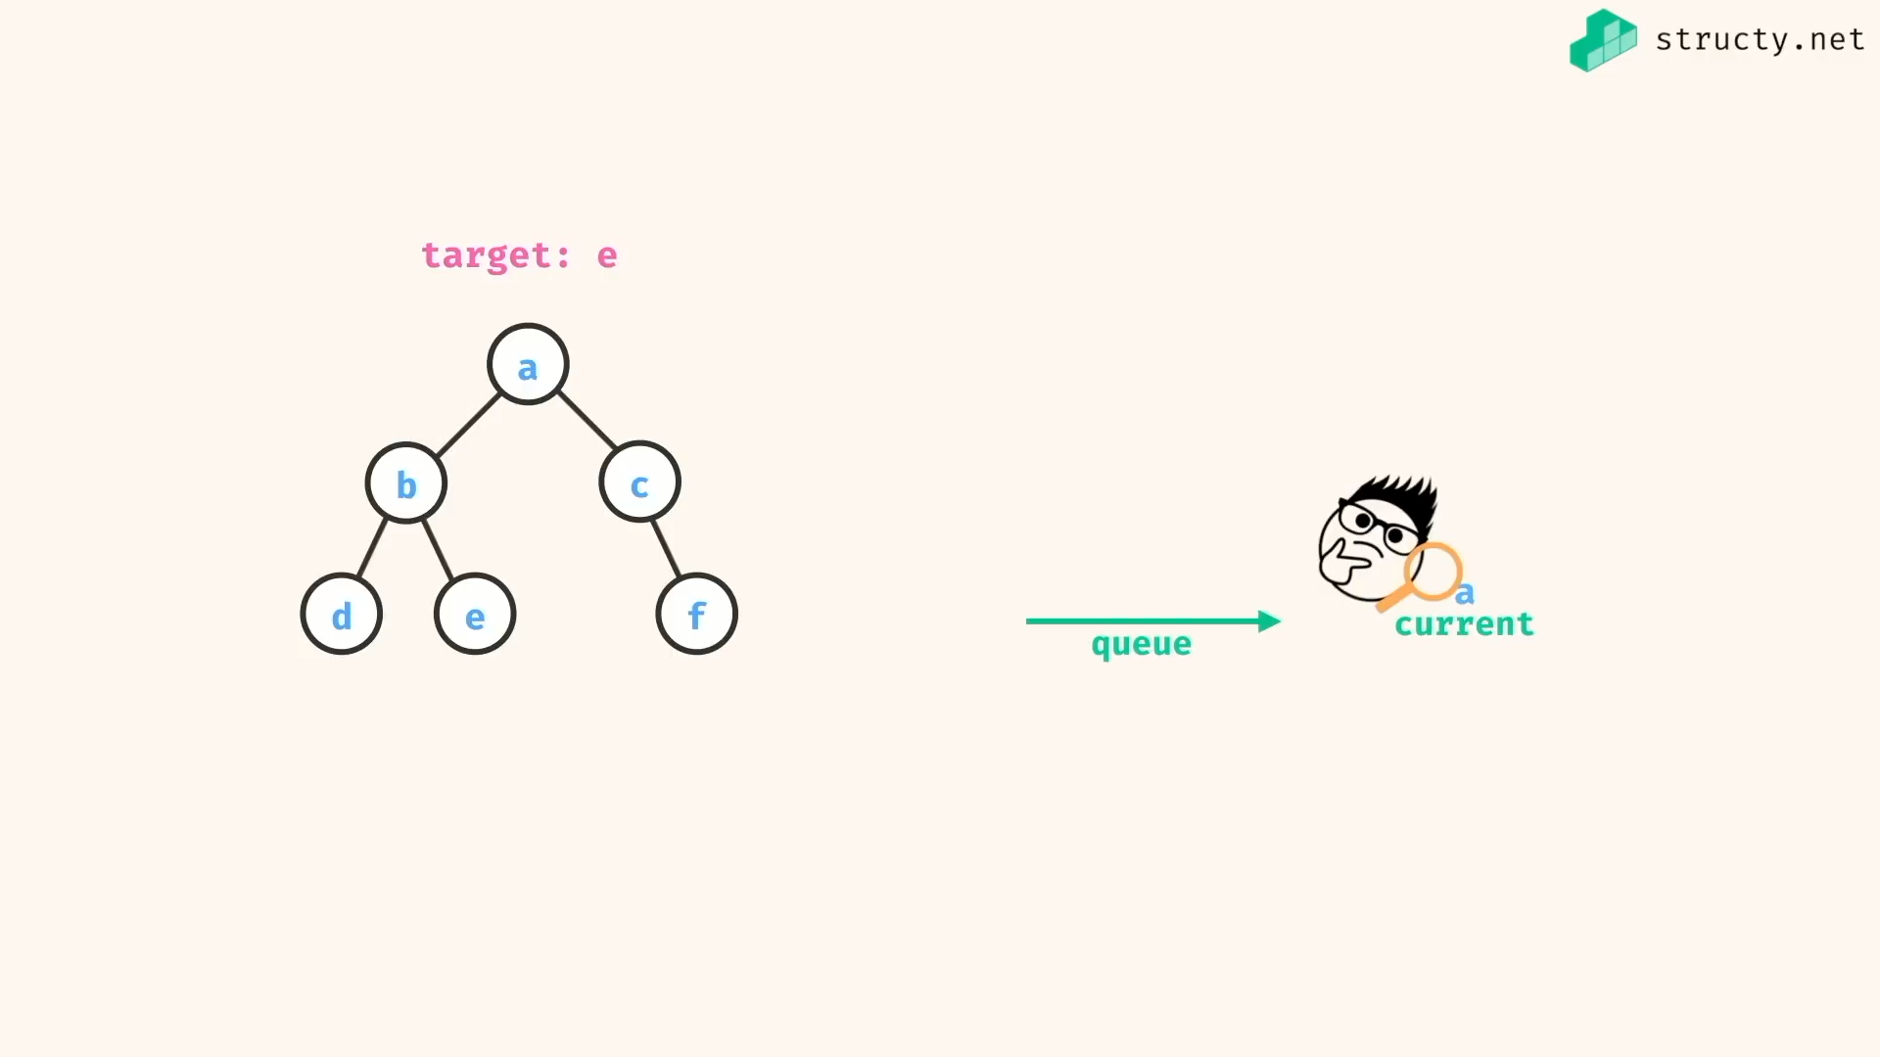

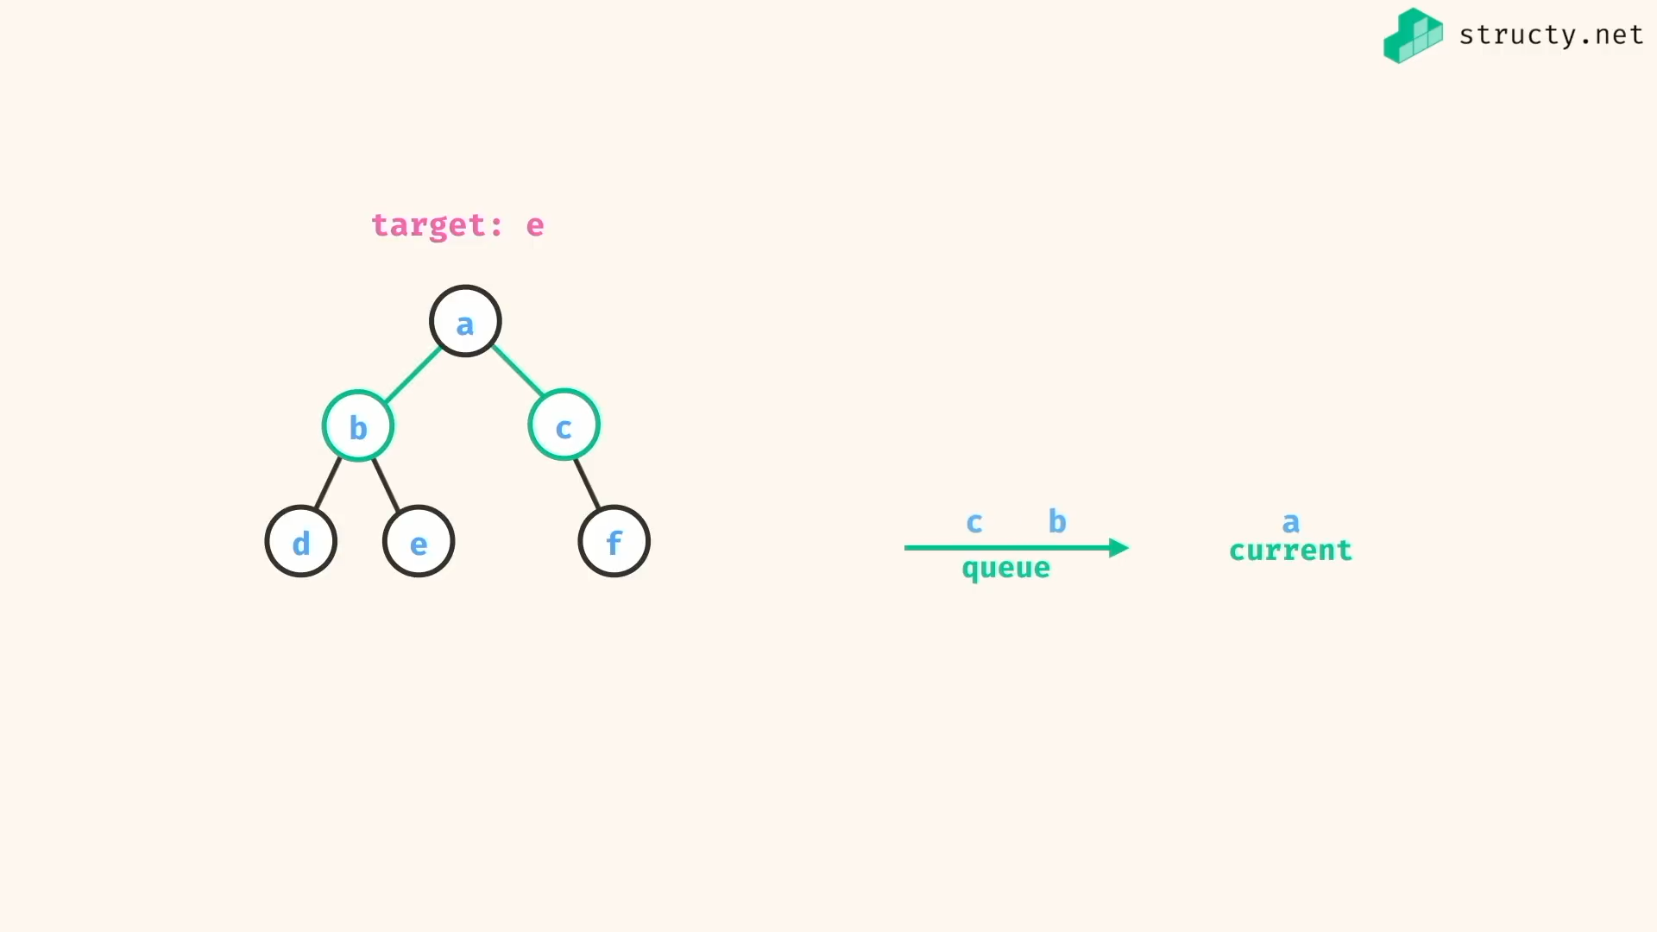

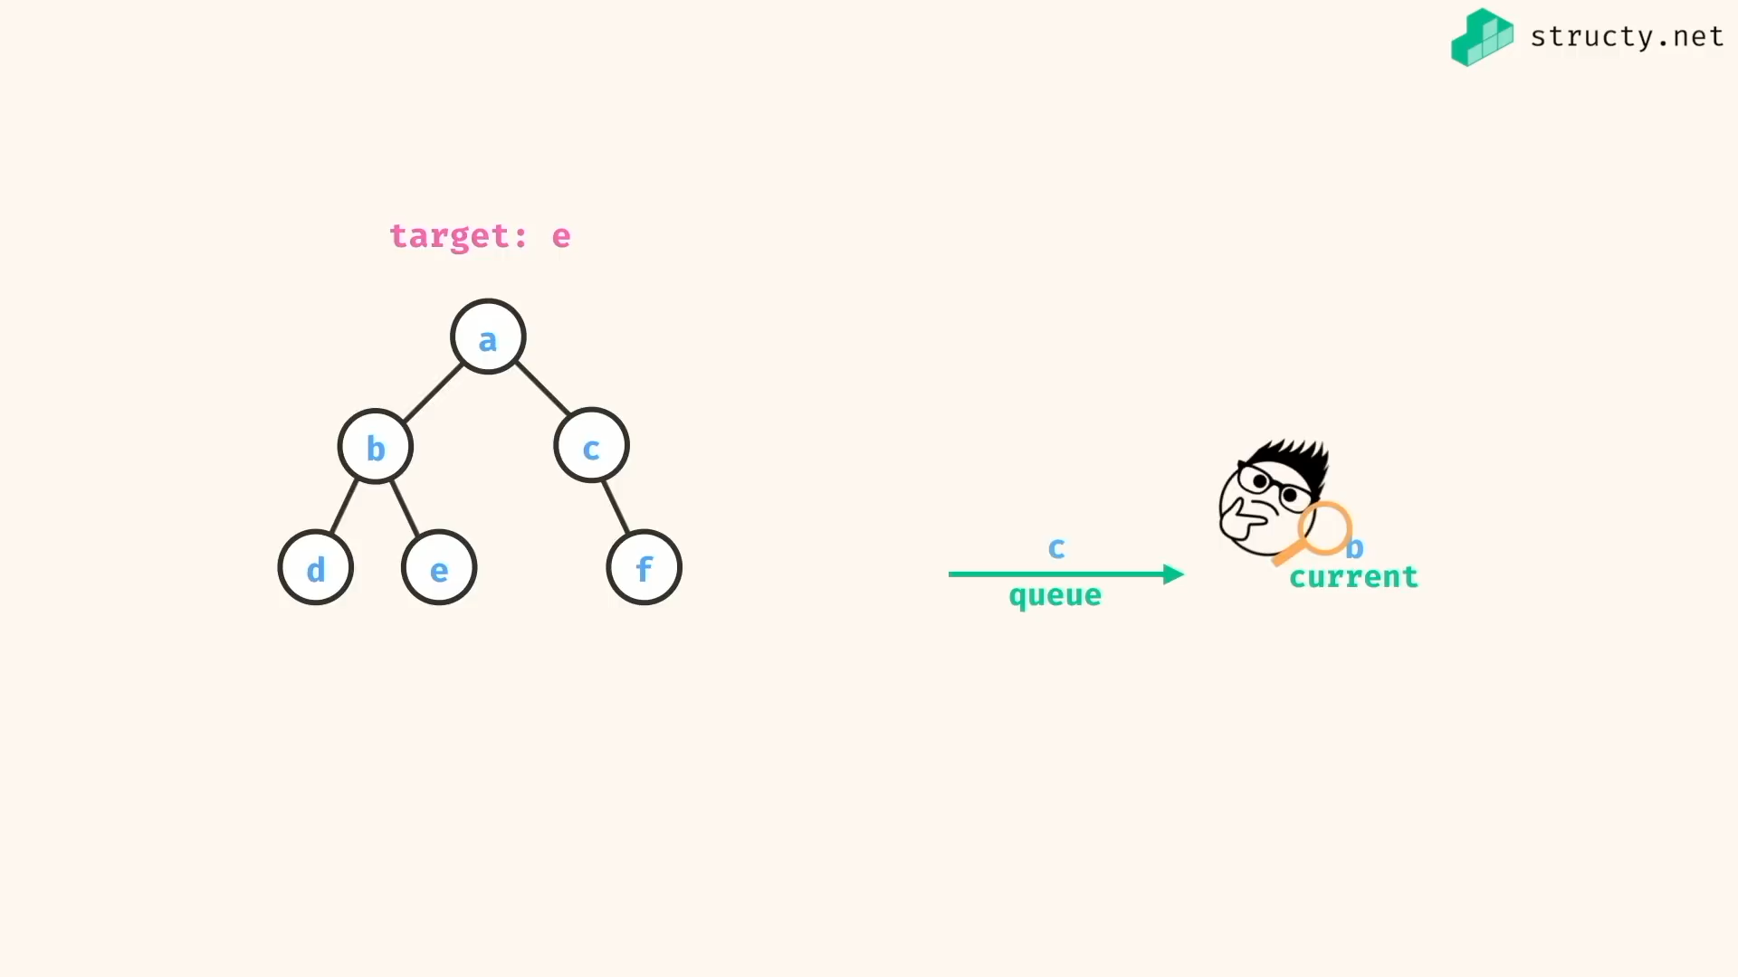

Etc…

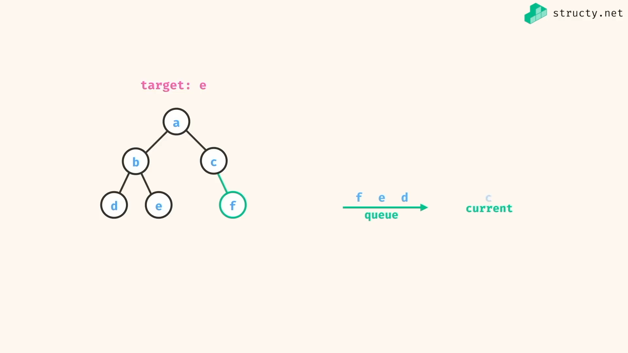

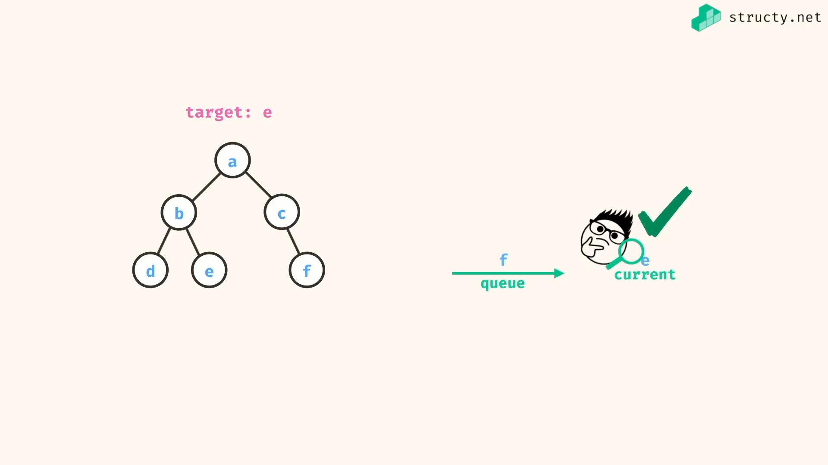

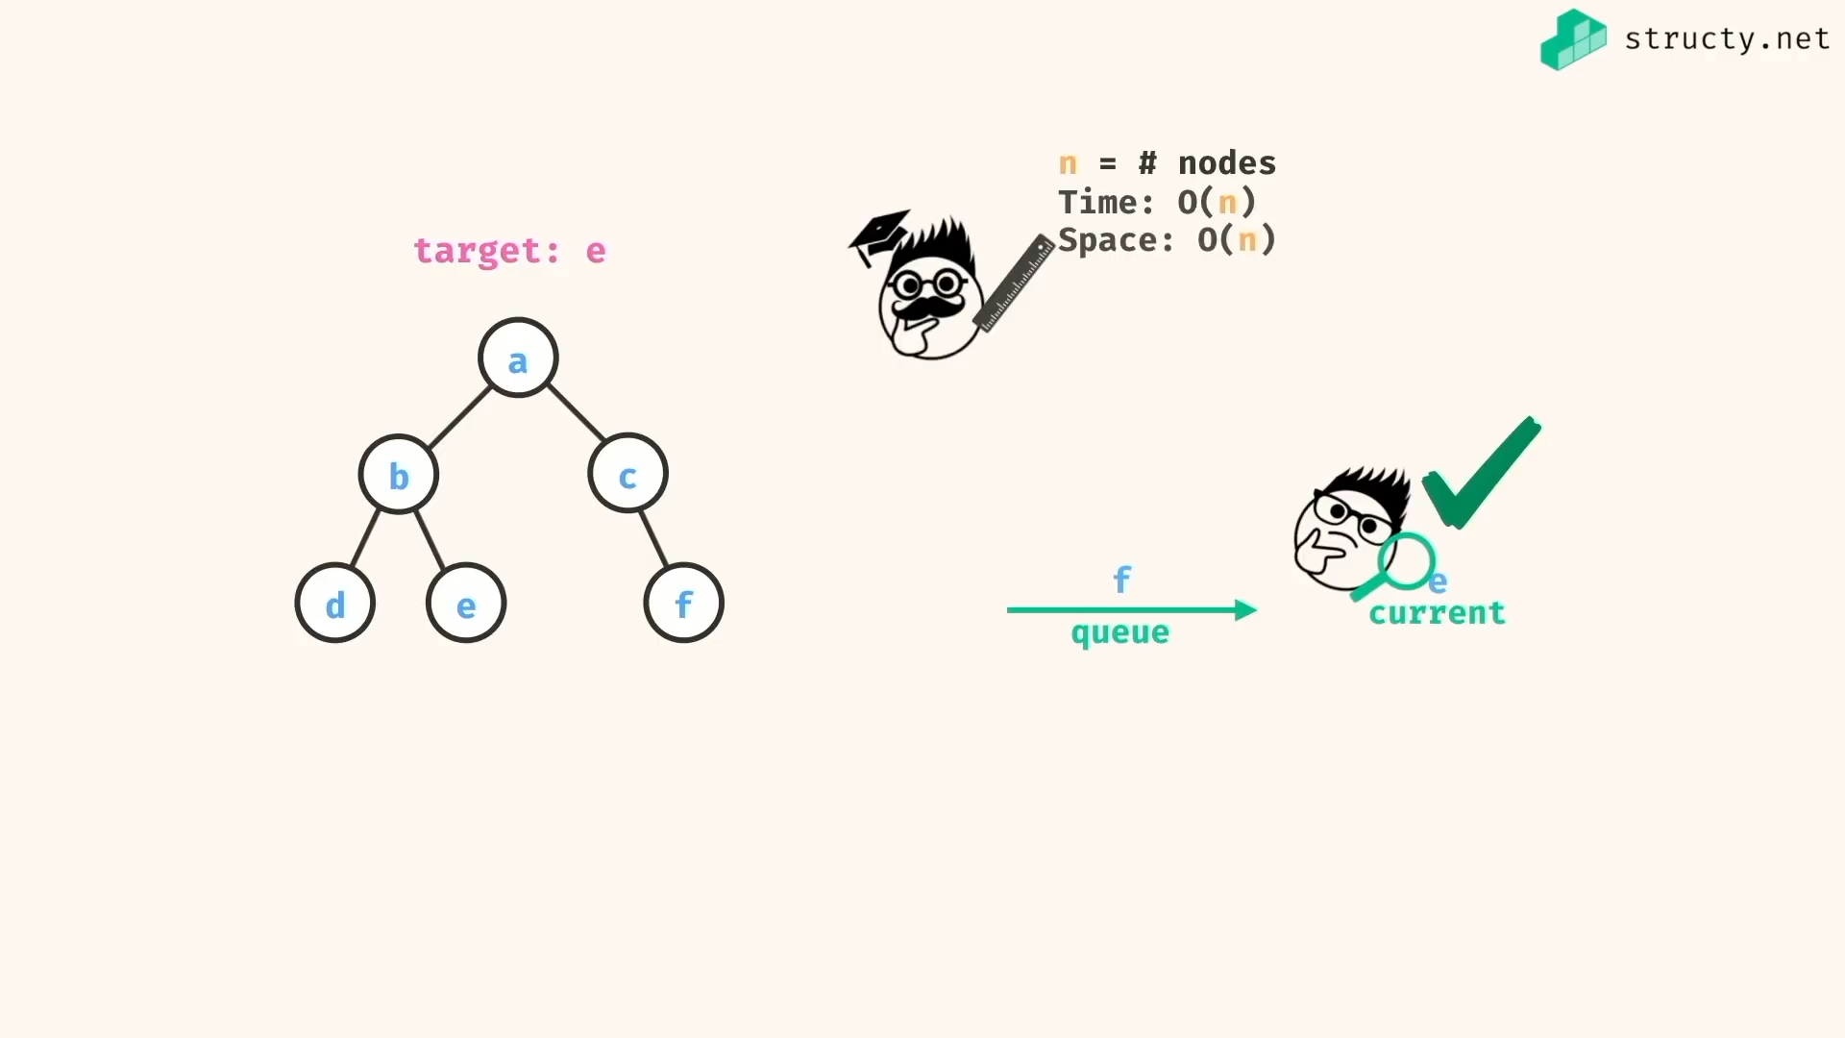

DFS for this problem:

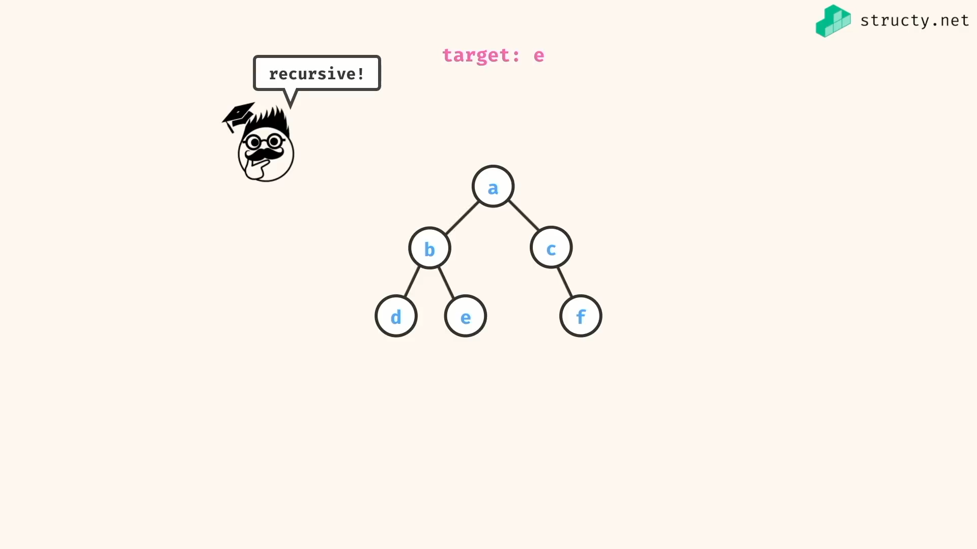

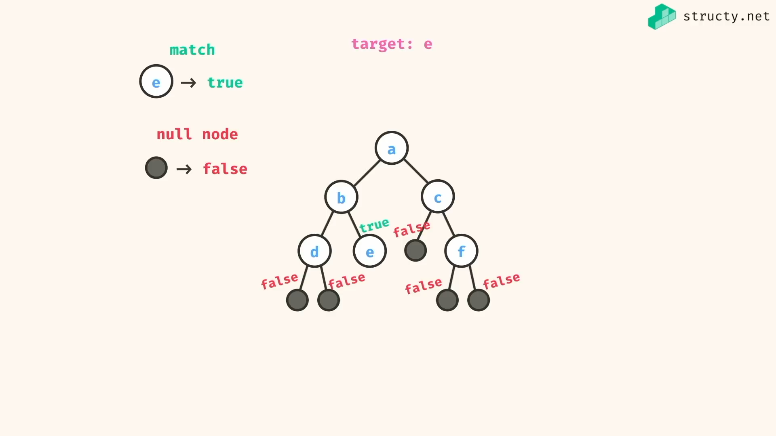

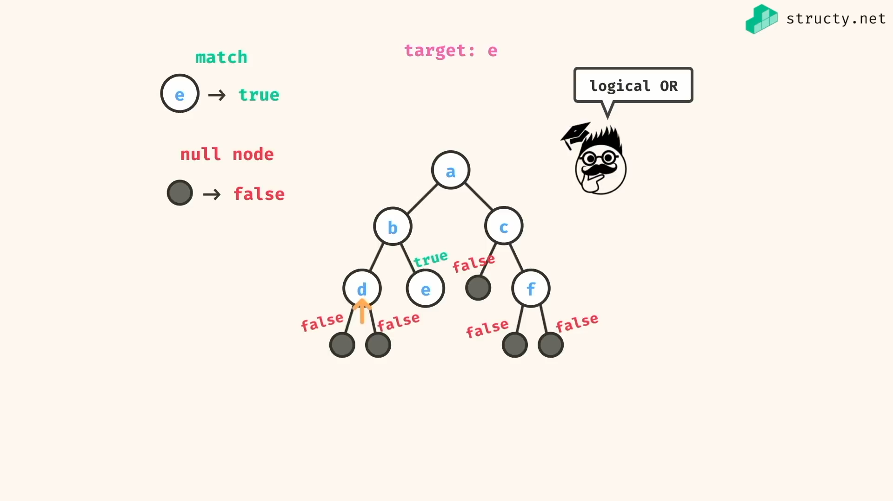

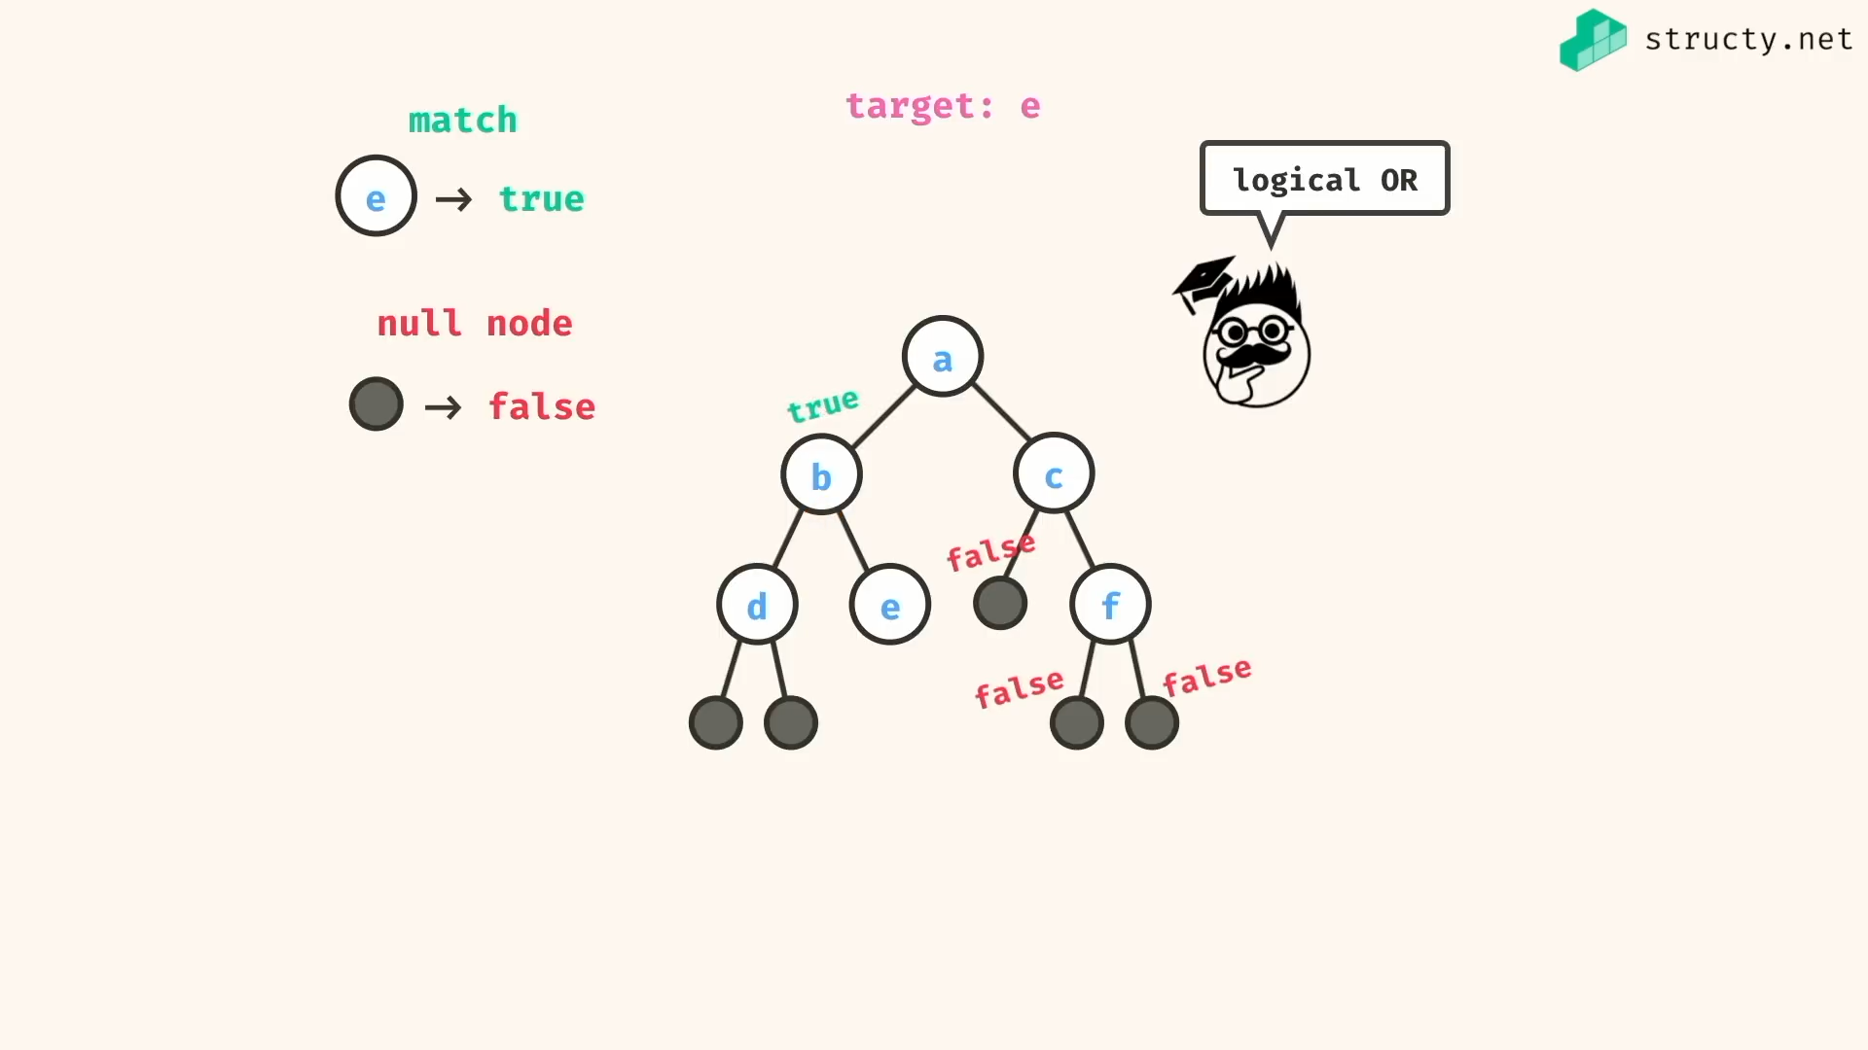

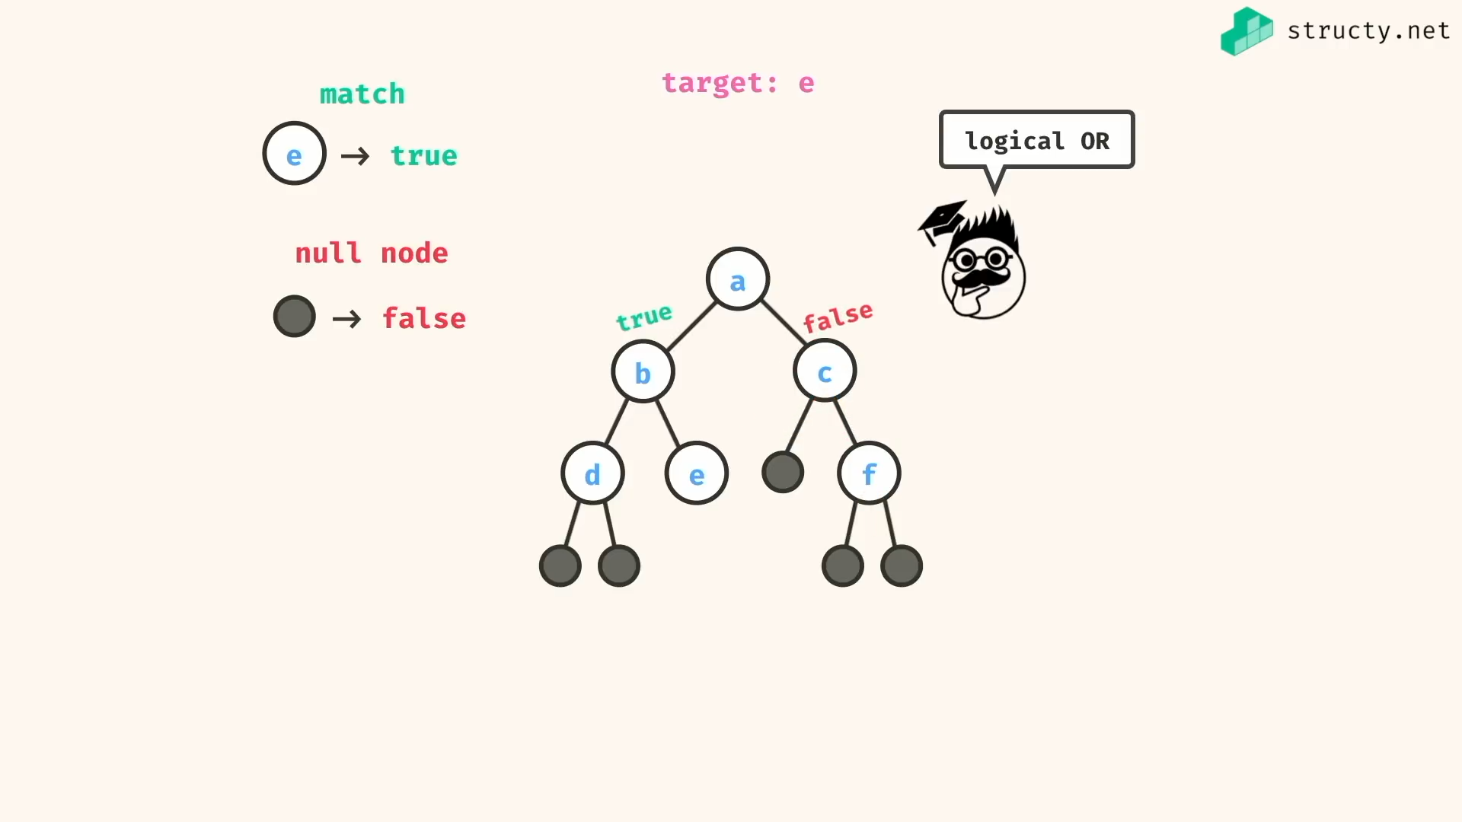

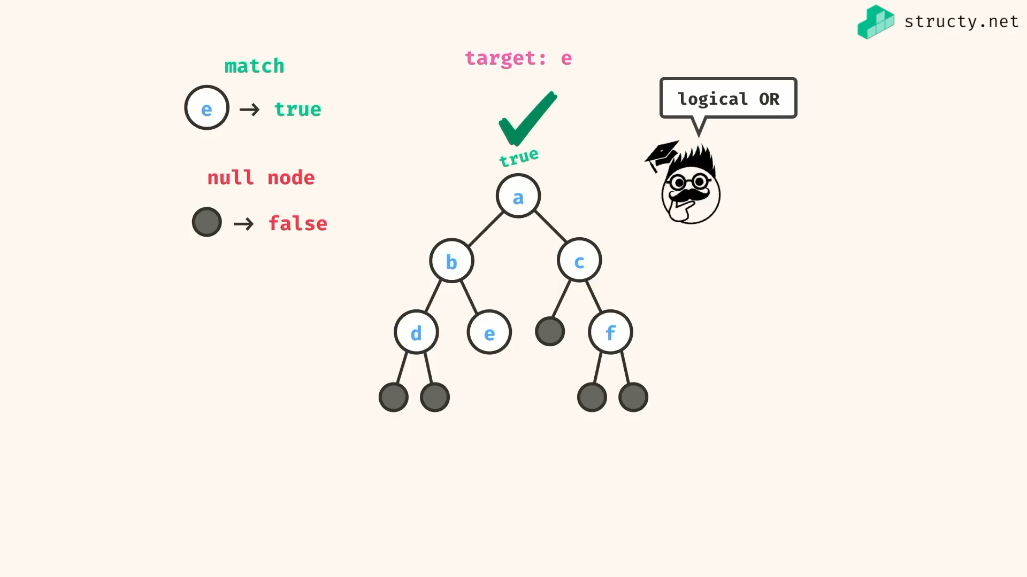

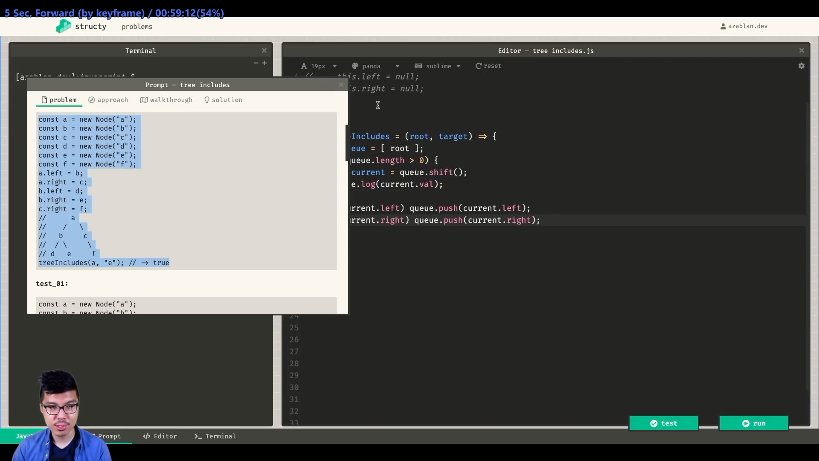

Solution:

*const* treeIncludesBFS = (*root*, *find*) *=>* {

if(root){

*const* queue = [ root ];

while(queue.length){

*const* current = queue.pop();

if(current.val === find) return true

// alternatively you can check find before pushing

current.left && queue.push(current.left)

current.right && queue.push(current.right)

}

}

return false;

}

*const* treeIncludesDFS = (*root*, *find*) *=>* {

return root ?

root.val === find || treeIncludesDFS(root.left,find) || treeIncludesDFS(root.right,find) :

false;

}

*class* Node {

constructor(*val*){

*this*.val = val;

*this*.left = null;

*this*.right = null;

}

}

*const* a = new Node('a')

*const* b = new Node('b')

*const* c = new Node('c')

*const* d = new Node('d')

*const* e = new Node('e')

*const* f = new Node('f')

a.left = b;

a.right = c;

b.left = d;

b.right = e;

c.right = f;

/\*

a

/ \

b c

/ \ \

d e f

\*/

*console*.log(treeIncludesBFS(a,'e'))//=> true

*console*.log(treeIncludesDFS(a,'m'))//=> false

*console*.log(treeIncludesDFS(null,'e'))//=> false

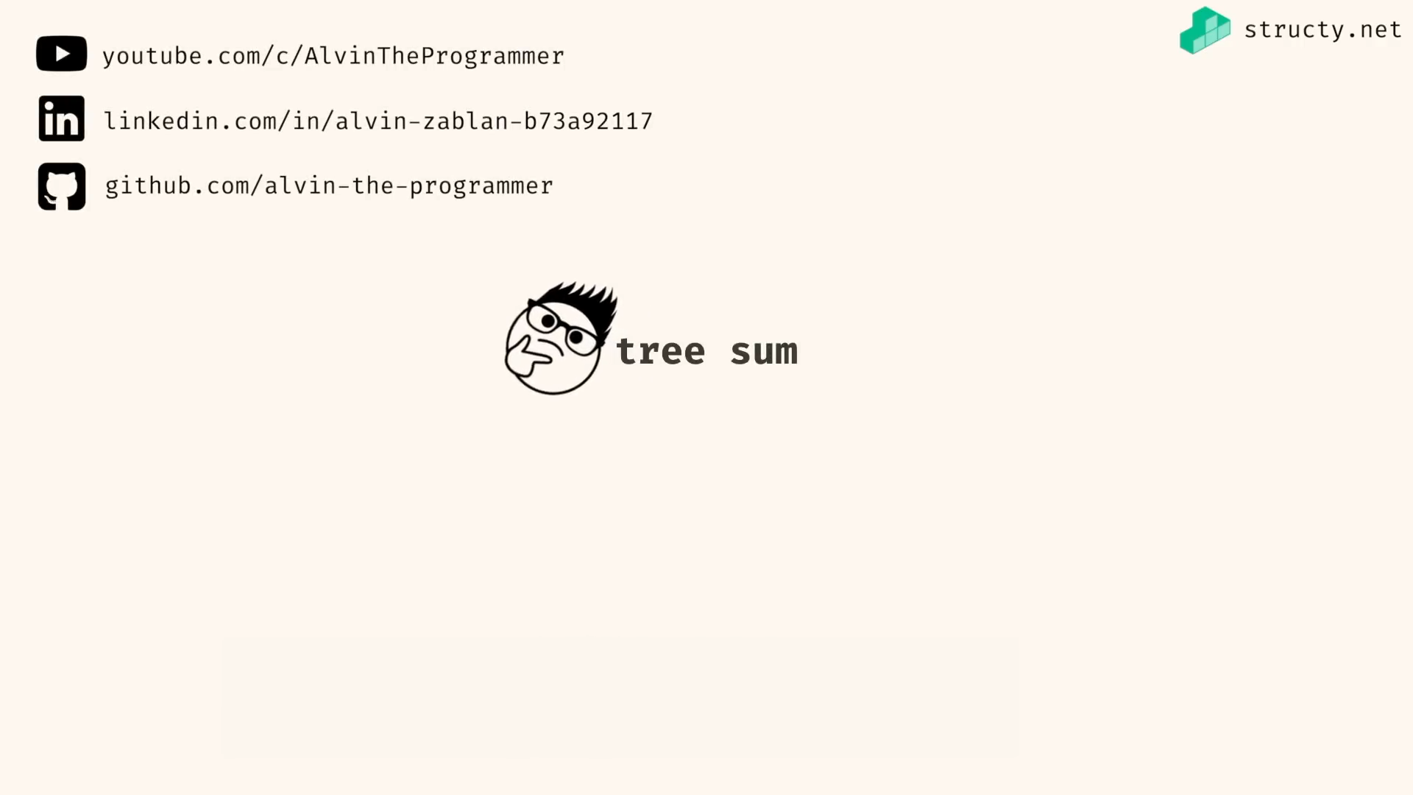

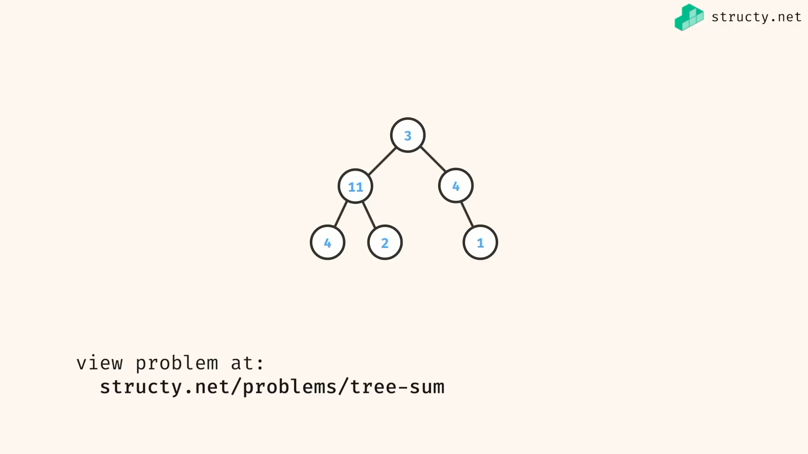

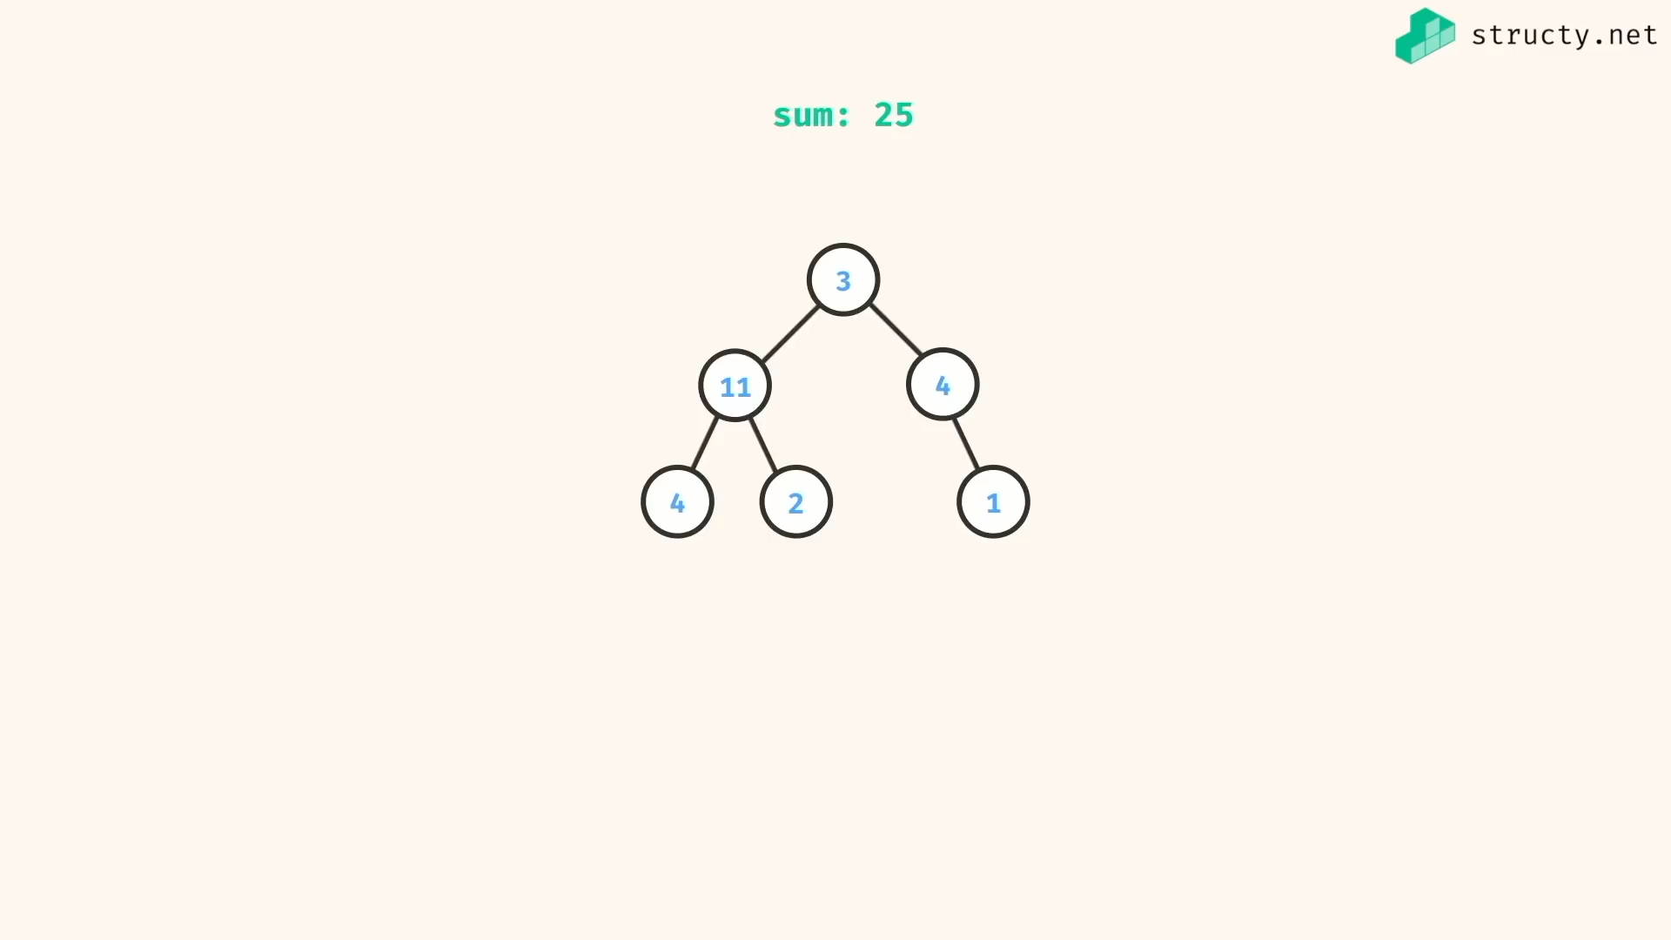

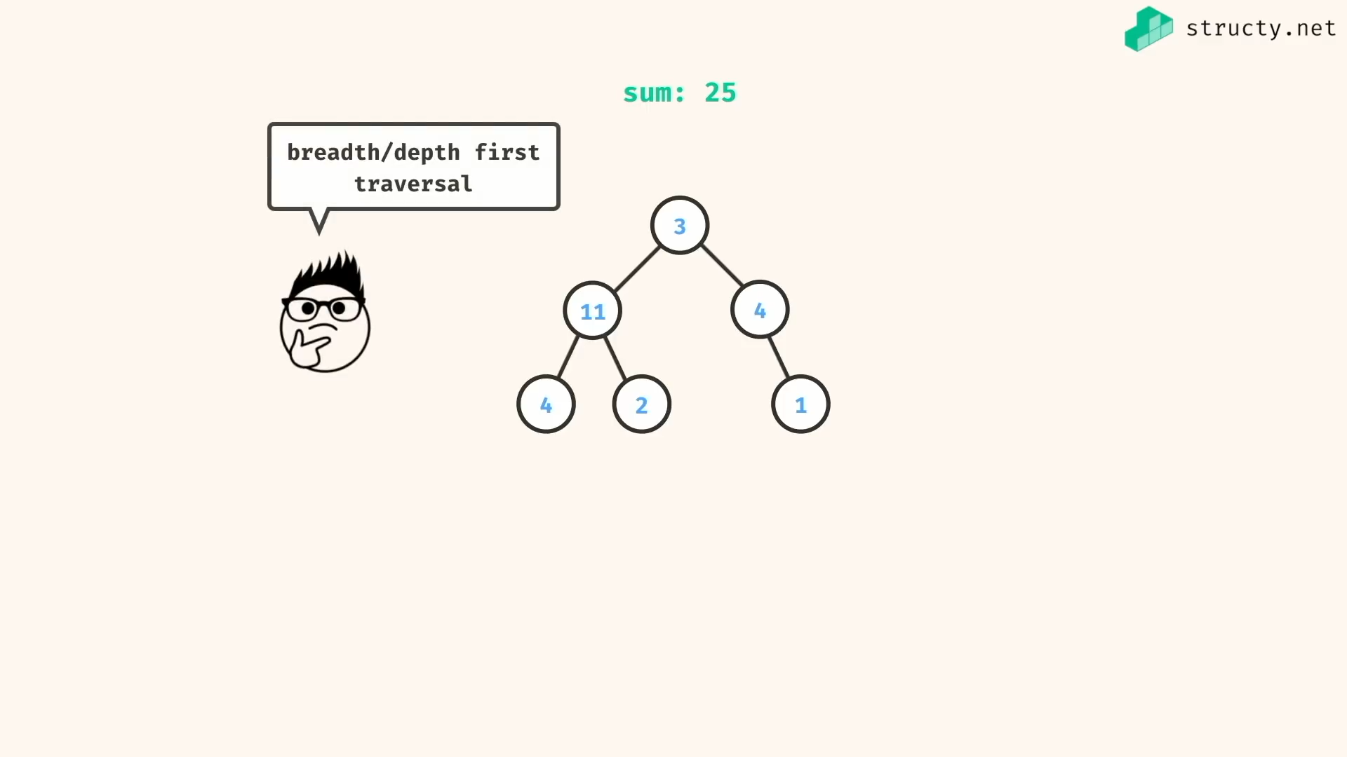

Either BFS or DFS…

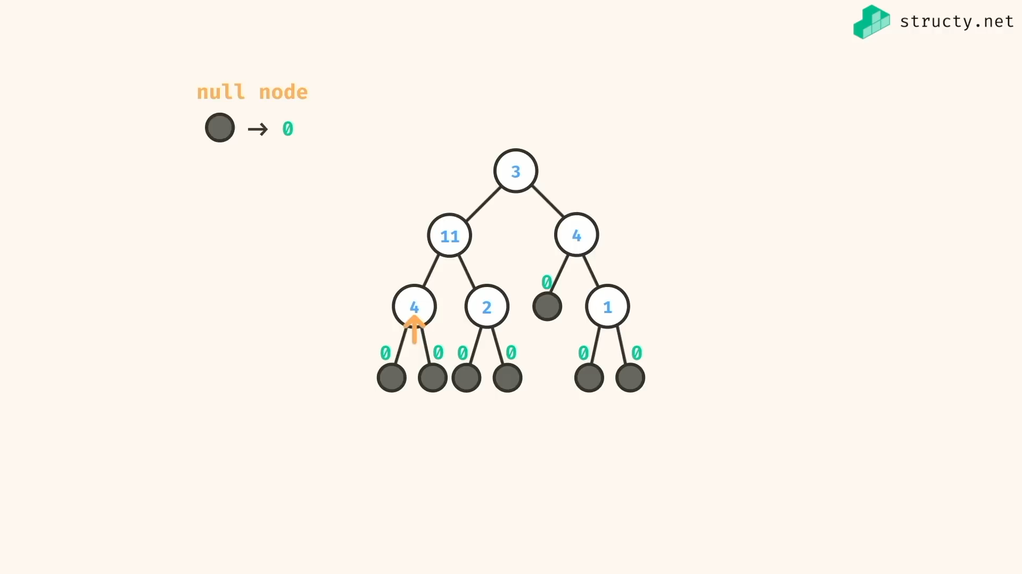

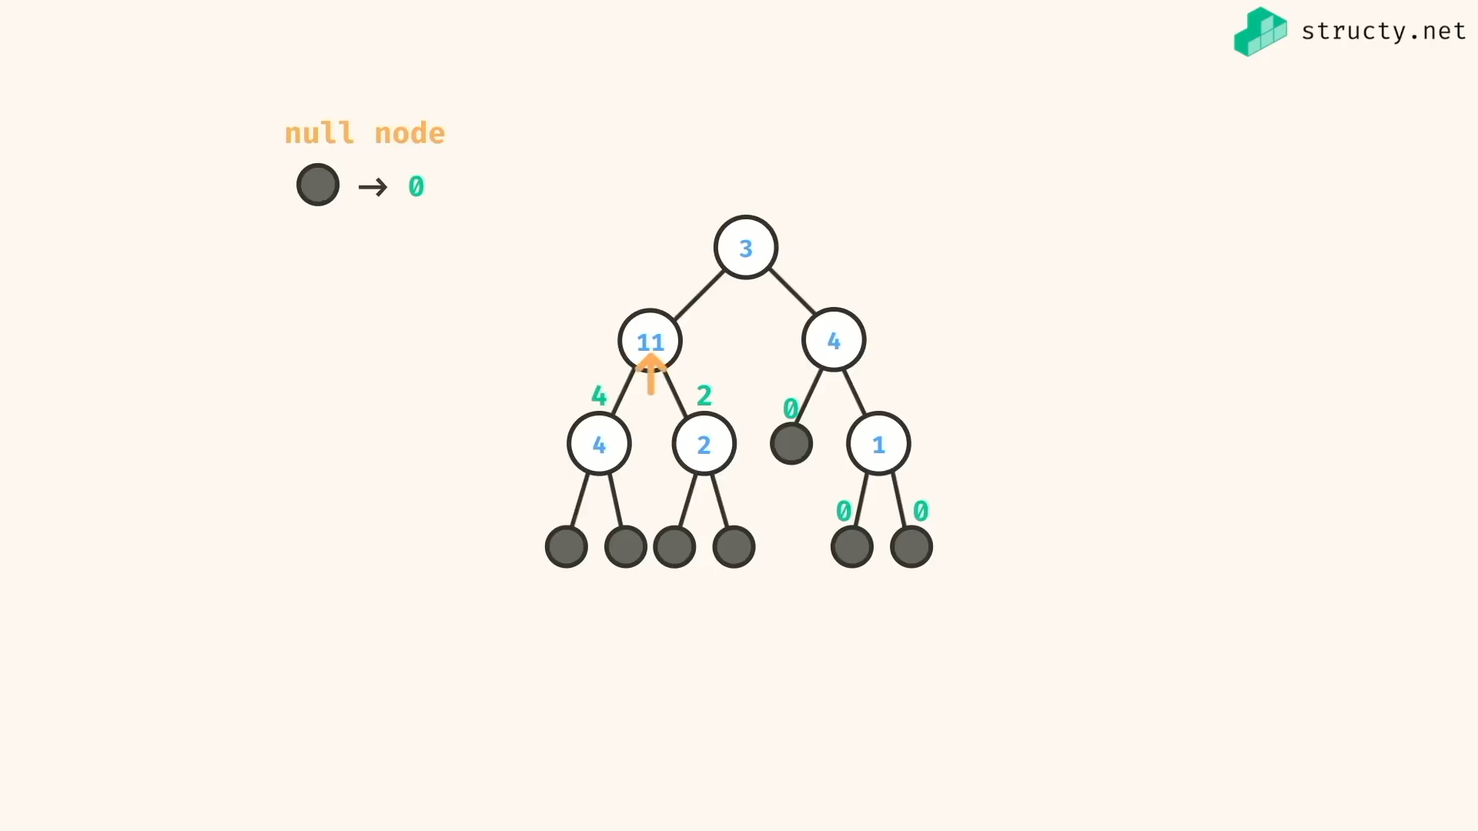

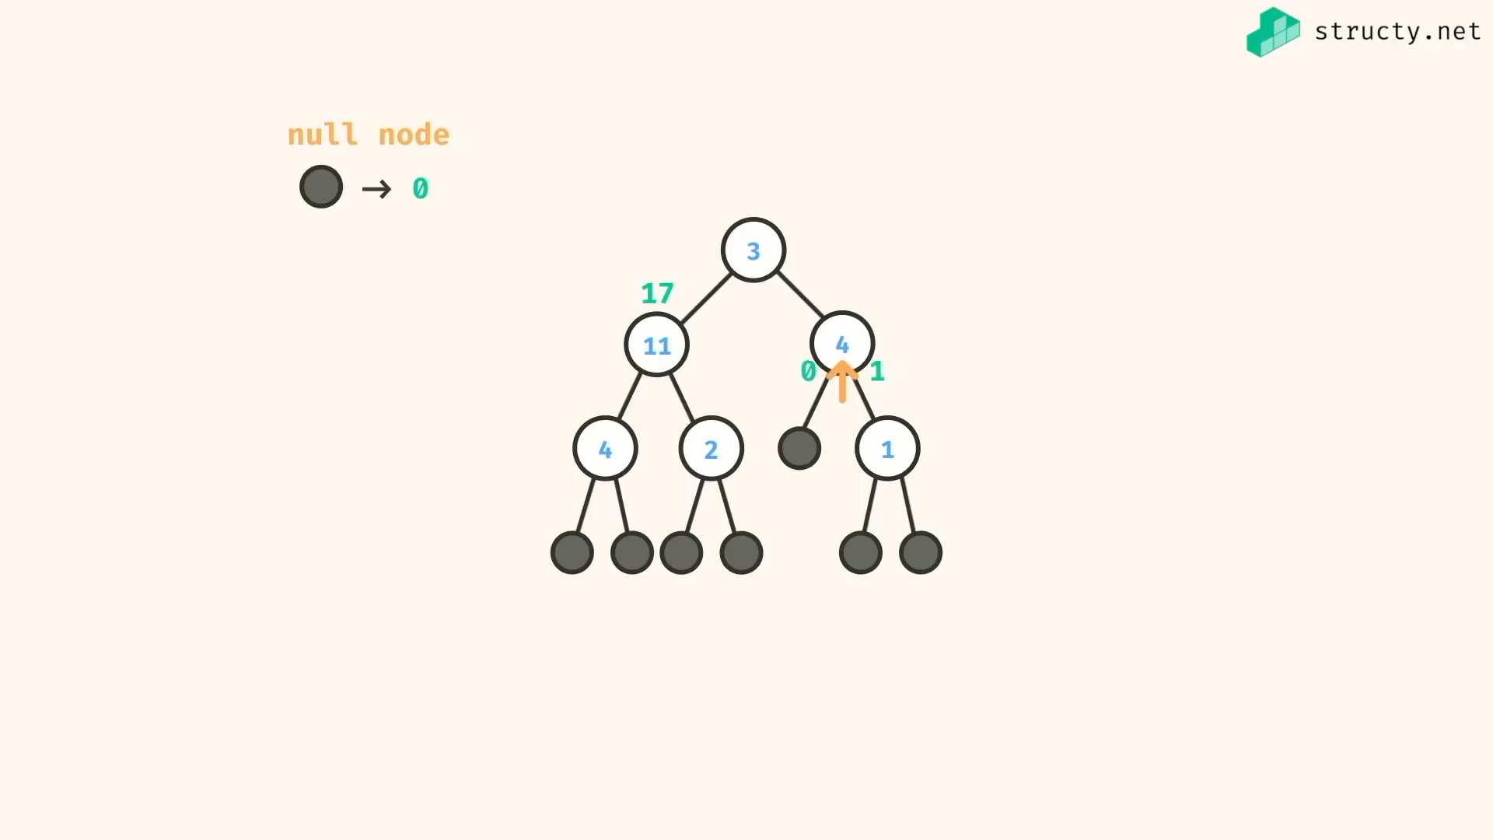

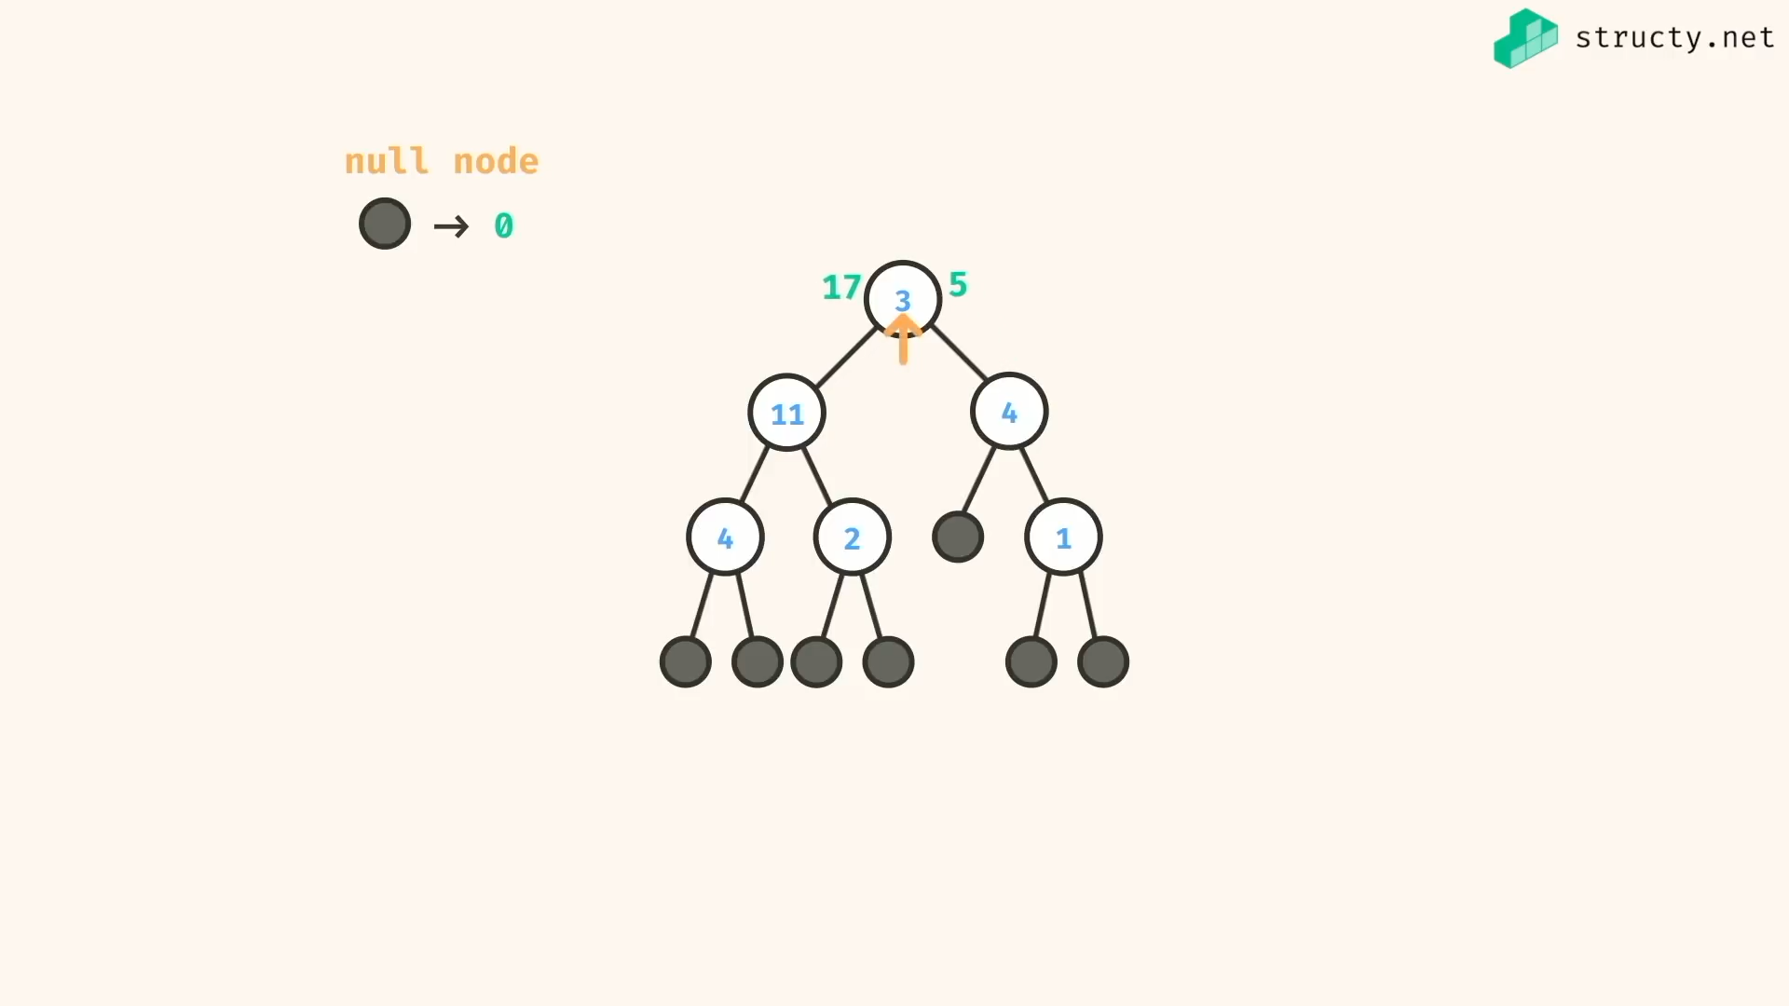

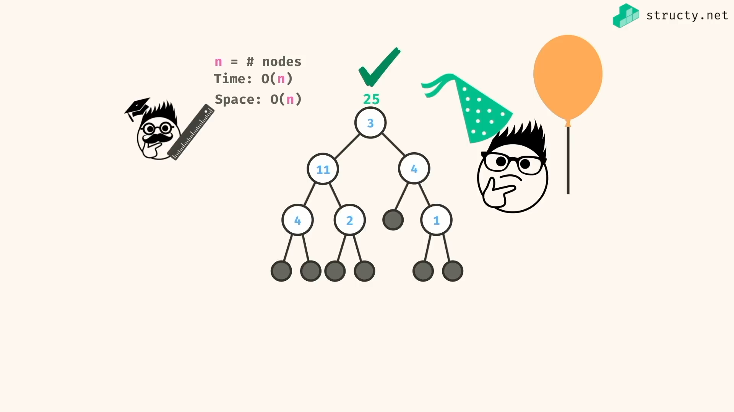

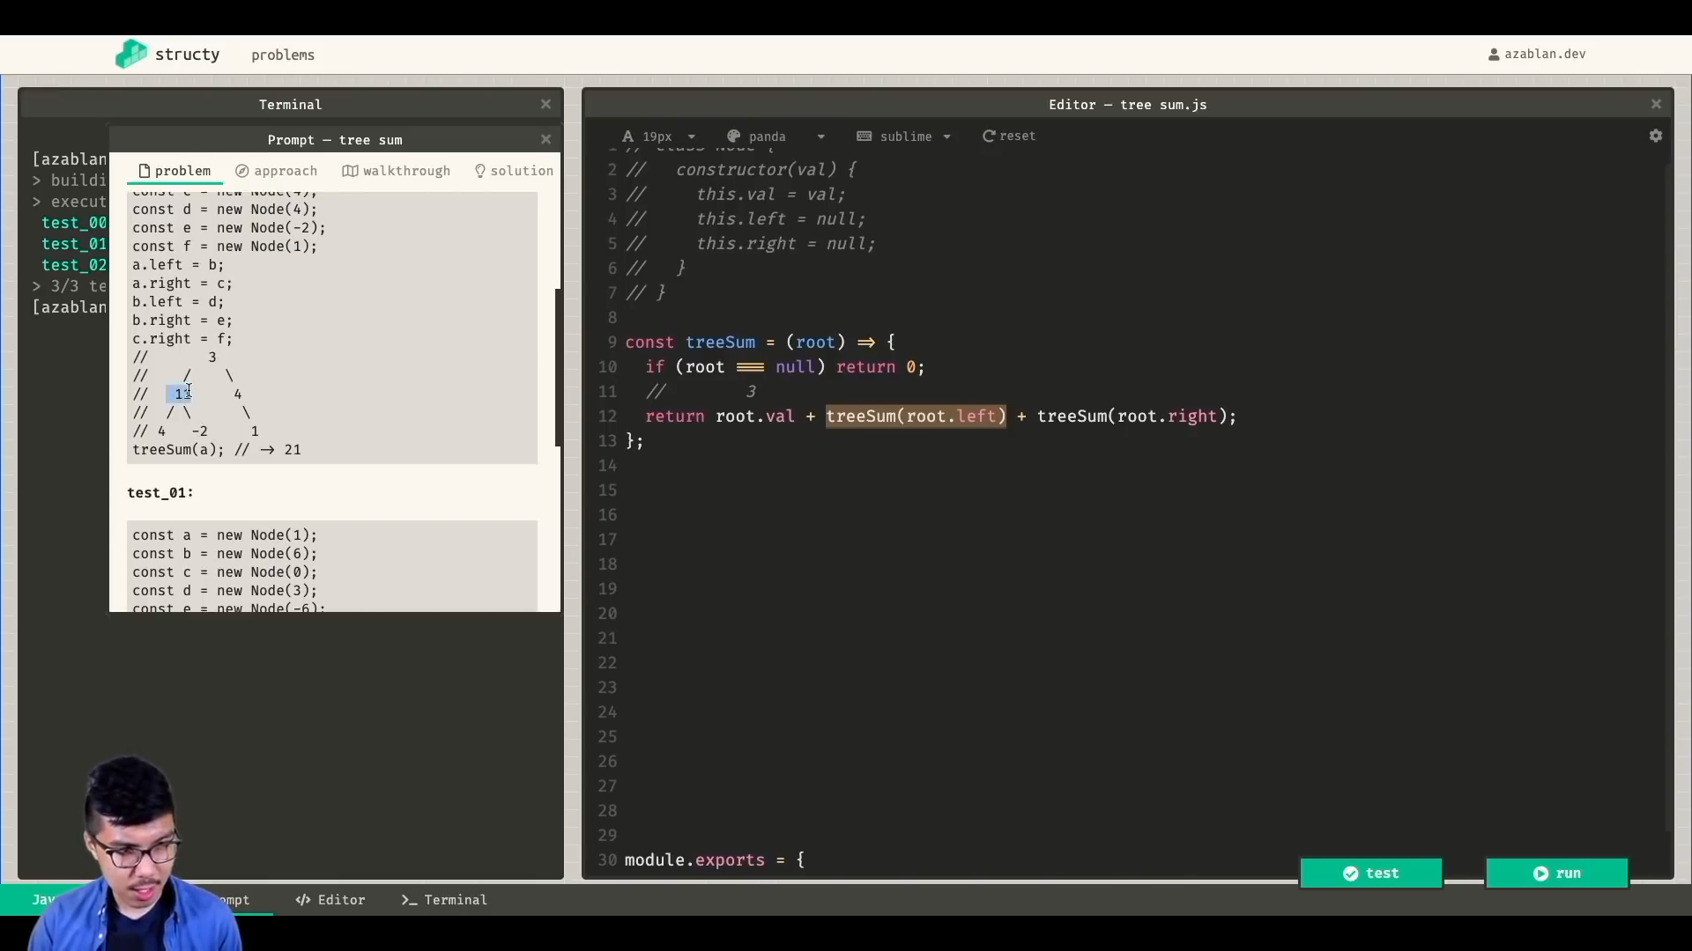

Solution:

*const* treeSumDFS1 = (*root*) *=>* {

return root ? root.val + treeSumDFS1(root.left) + treeSumDFS1(root.right) : 0

}

*const* treeSumDFS2 = (*root*) *=>* {

if(!root) return 0;

*let* totalSum = root.val;

*const* queue = [ root ];

while(queue.length){

*const* current = queue.shift();

if(current.left){

totalSum += current.left.val;

queue.push(current.left);

}

if(current.right){

totalSum += current.right.val;

queue.push(current.right);

}

}

return totalSum;

}

*class* Node {

constructor(*val*){

*this*.val = val;

*this*.left = null;

*this*.right = null;

}

}

*const* a = new Node(3)

*const* b = new Node(11)

*const* c = new Node(4)

*const* d = new Node(4)

*const* e = new Node(2)

*const* f = new Node(1)

a.left = b;

a.right = c;

b.left = d;

b.right = e;

c.right = f;

/\*

3

/ \

11 4

/ \ \

4 2 1

\*/

*console*.log(treeSumDFS1(a)); //=> 25

*console*.log(treeSumDFS2(a)); //=> 25

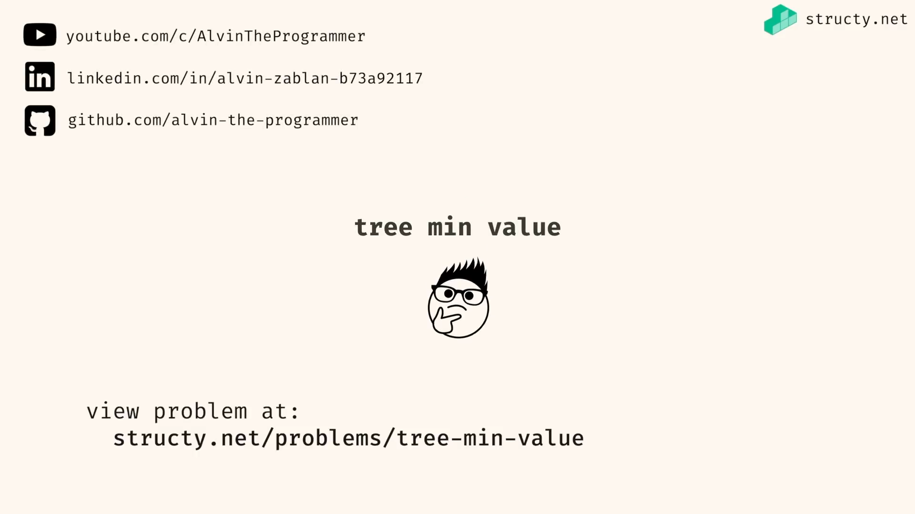

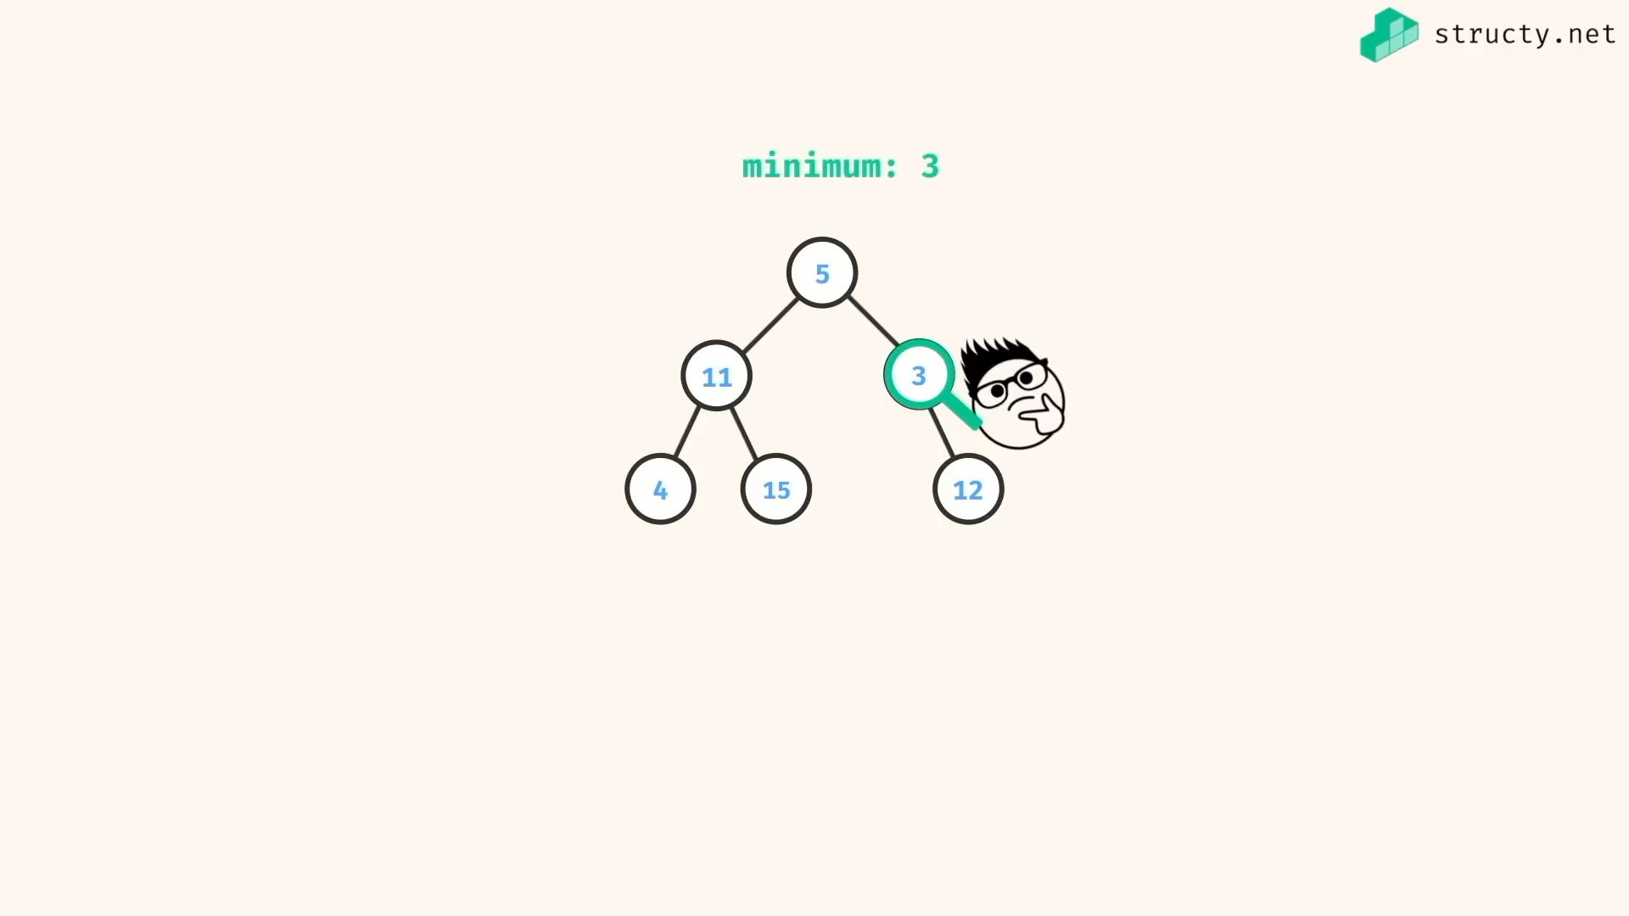

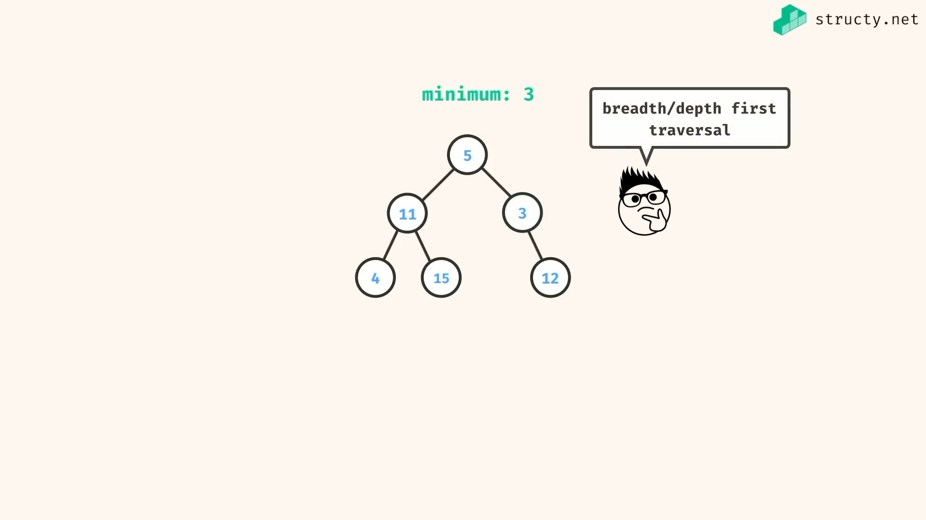

Both DFS and BFS can be used…

Recursive:

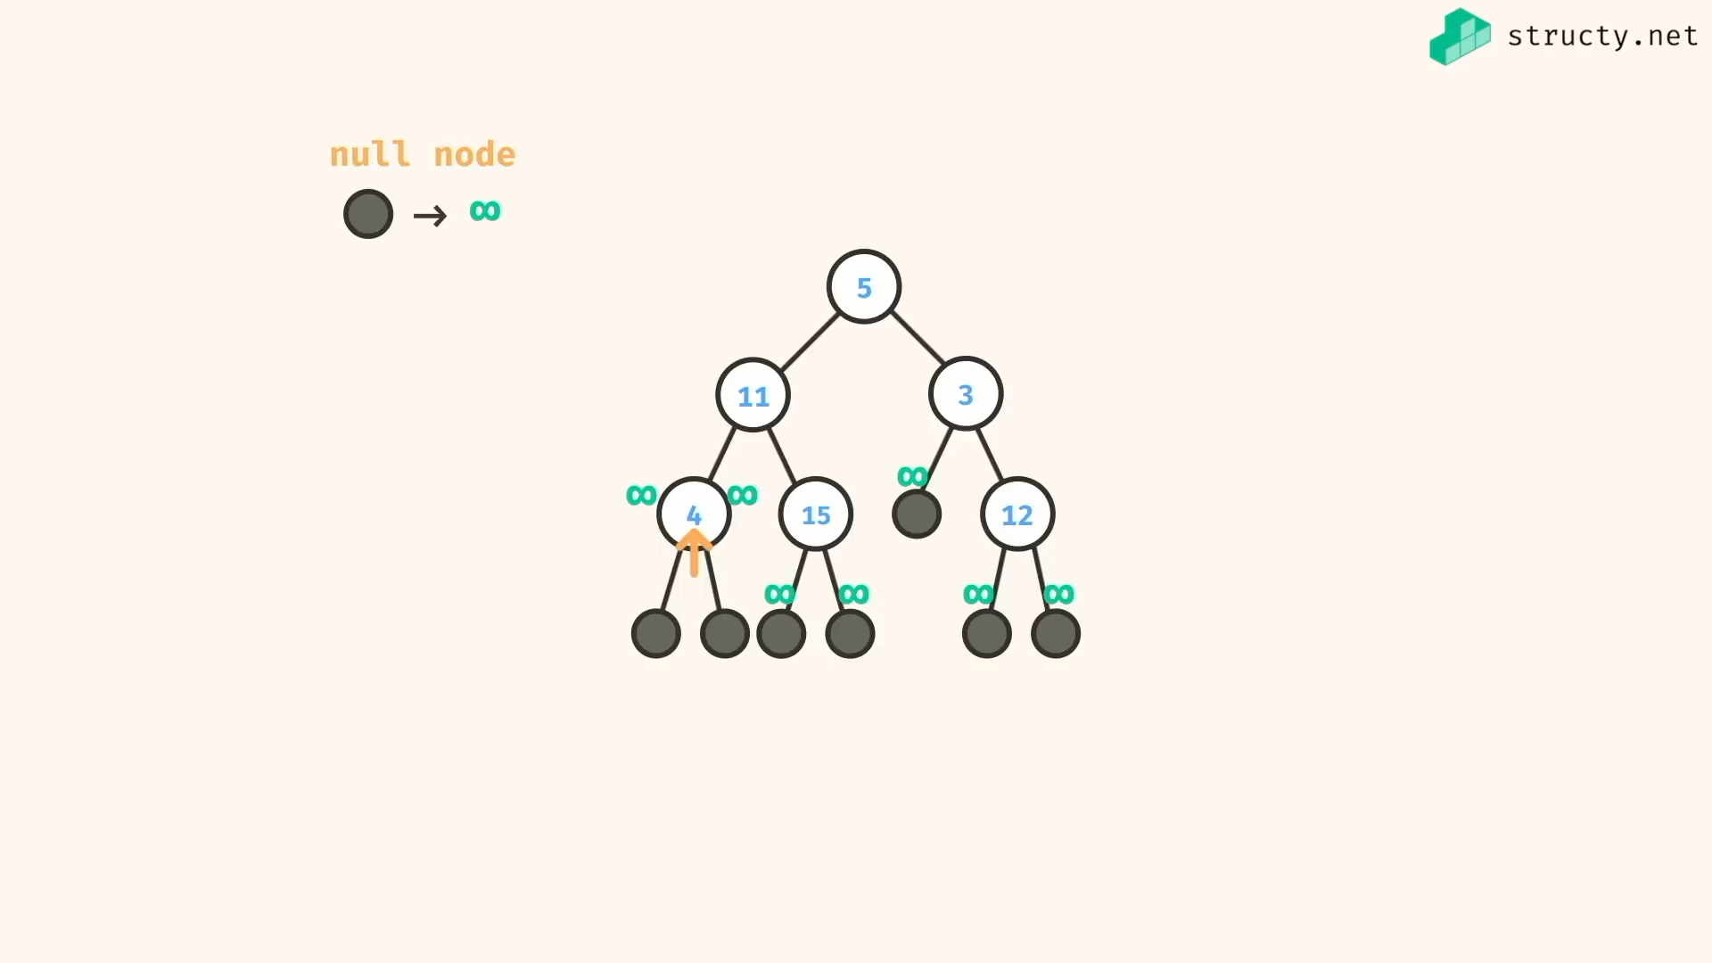

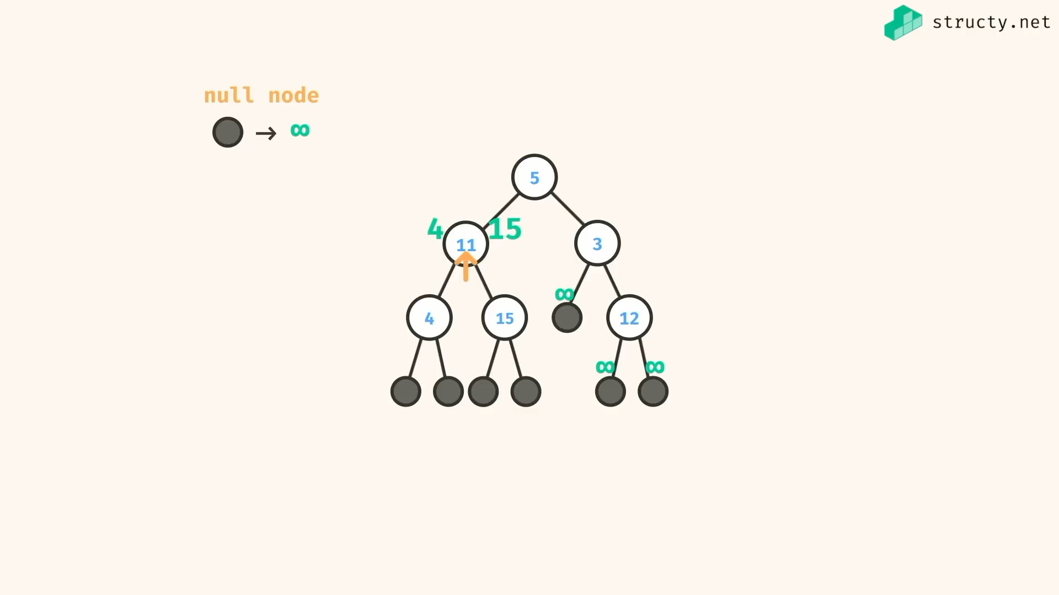

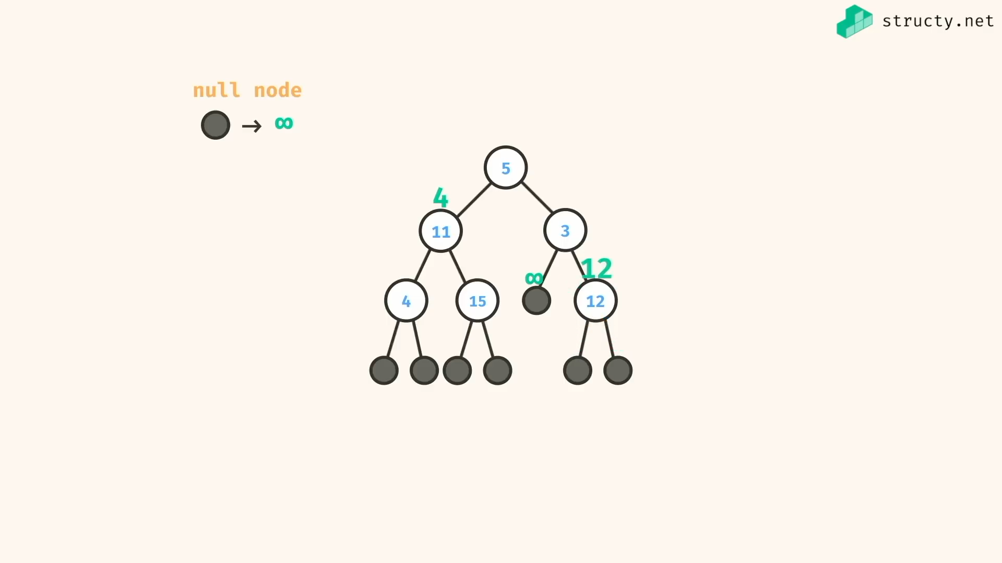

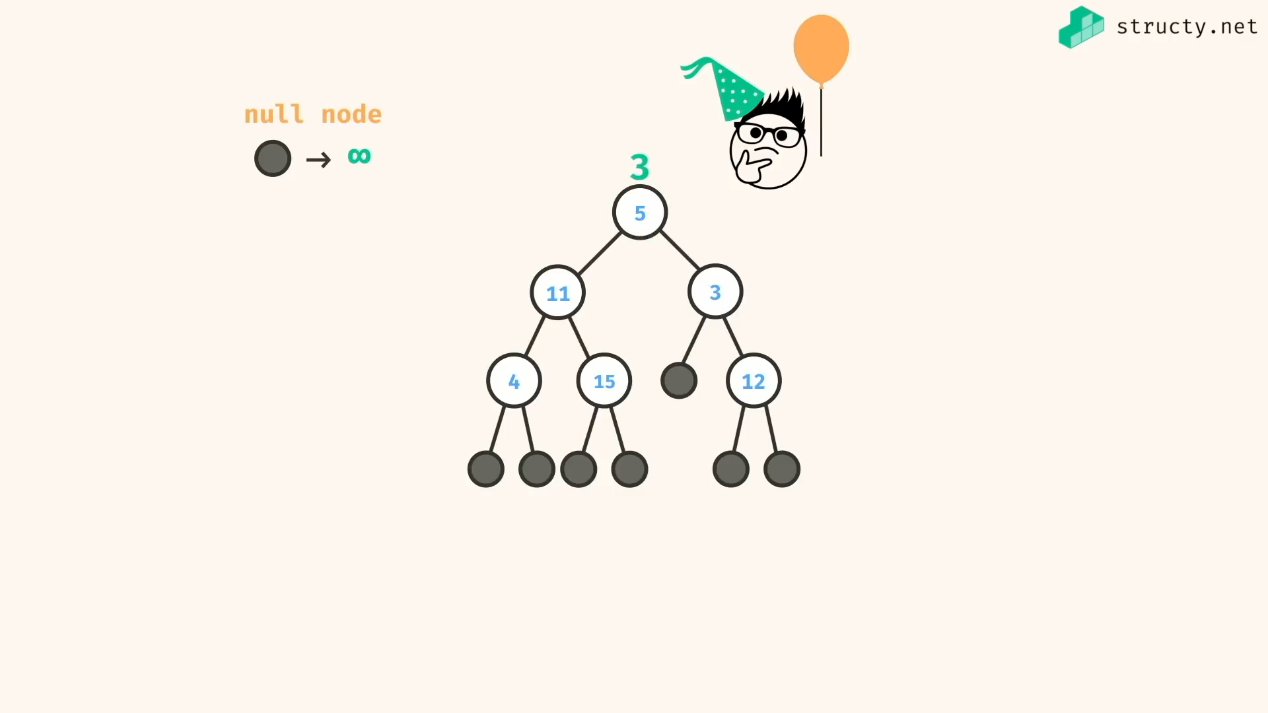

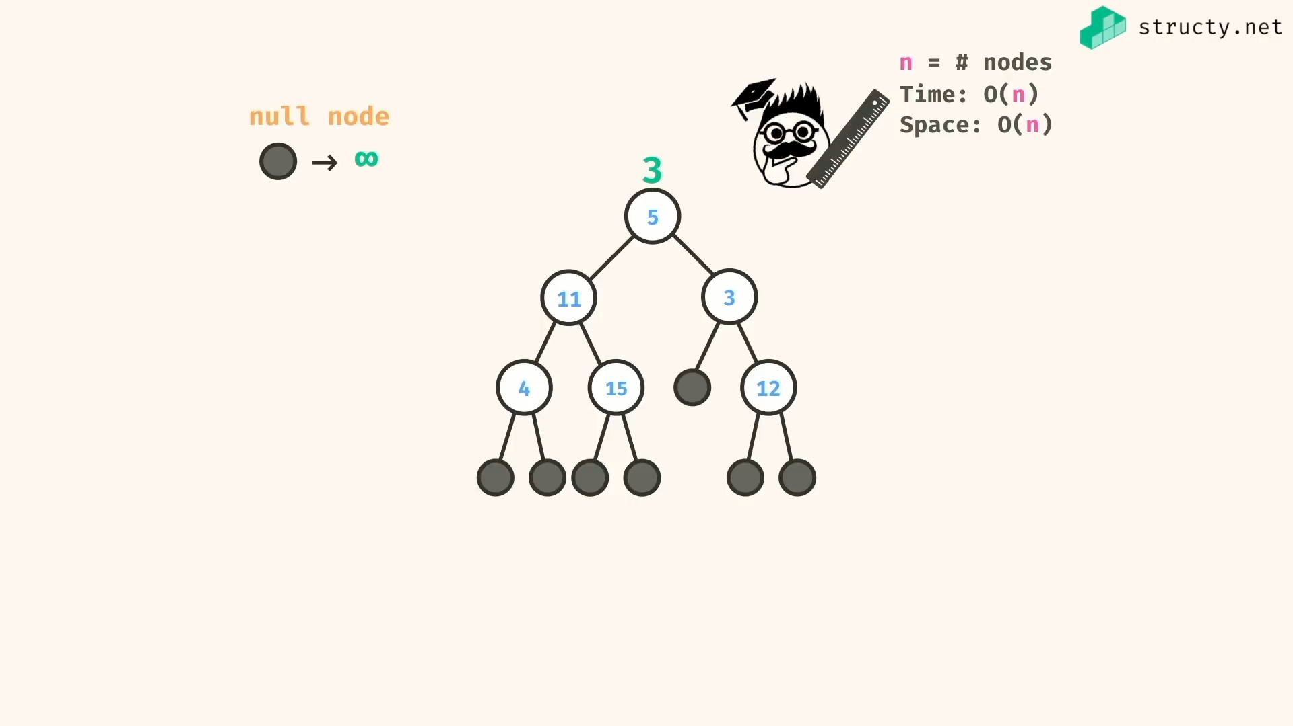

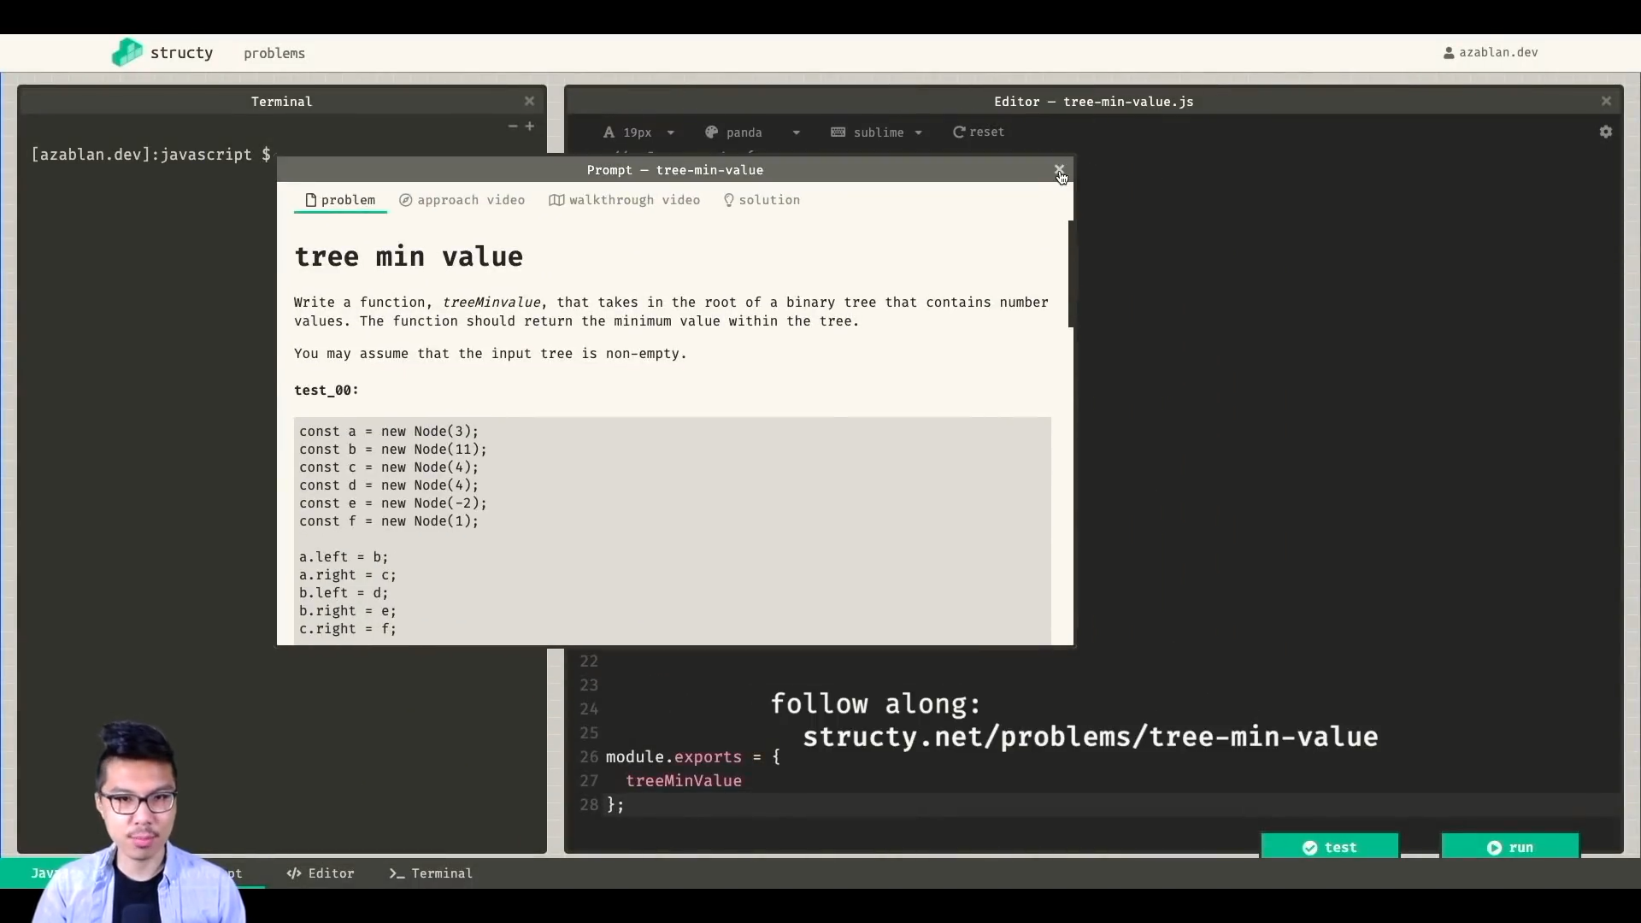

Soln:

Note:

If you using queue.shift() in js for queue implementation, for single shift() .. it replaces other elements position to previous element’s position.. so single shift takes O(n) time complexity.. so its better to use inbuilt collections for queue implementation..

Solution:

*const* treeMinValRecur = (*root*) *=>* {

if(!root) return Infinity;

*const* currentValue = root.val;

*const* leftTreeMinValue = root.left ?

treeMinValRecur(root.left) :

Infinity;

*const* rightTreeMinValue = root.right ?

treeMinValRecur(root.right) :

Infinity;

// alternatively we can use Math.min(a,b,c) here

if(currentValue <= leftTreeMinValue && currentValue <= rightTreeMinValue){

return currentValue;

}else if(leftTreeMinValue <= currentValue && leftTreeMinValue <= rightTreeMinValue ){

return leftTreeMinValue;

}else{

return rightTreeMinValue;

}

}

*const* treeMinValIter = (*root*) *=>* {

if(!root) return Infinity;

*let* currentMin = Infinity;

// alternatively we can implement queue here

*const* stack = [ root ];

while(stack.length){

*const* current = stack.pop();

if(current.val < currentMin) currentMin = current.val;

if(current.left) stack.push(current.left);

if(current.right) stack.push(current.right);

}

return currentMin;

}

*class* Node {

constructor(*val*){

*this*.val = val;

*this*.left = null;

*this*.right = null;

}

}

*const* a = new Node(3)

*const* b = new Node(11)

*const* c = new Node(4)

*const* d = new Node(4)

*const* e = new Node(2)

*const* f = new Node(1)

a.left = b;

a.right = c;

b.left = d;

b.right = e;

c.right = f;

/\*

3

/ \

11 4

/ \ \

4 2 1

\*/

*console*.log(treeMinValRecur(a)); //=> 1

*console*.log(treeMinValIter(a)); //=> 1

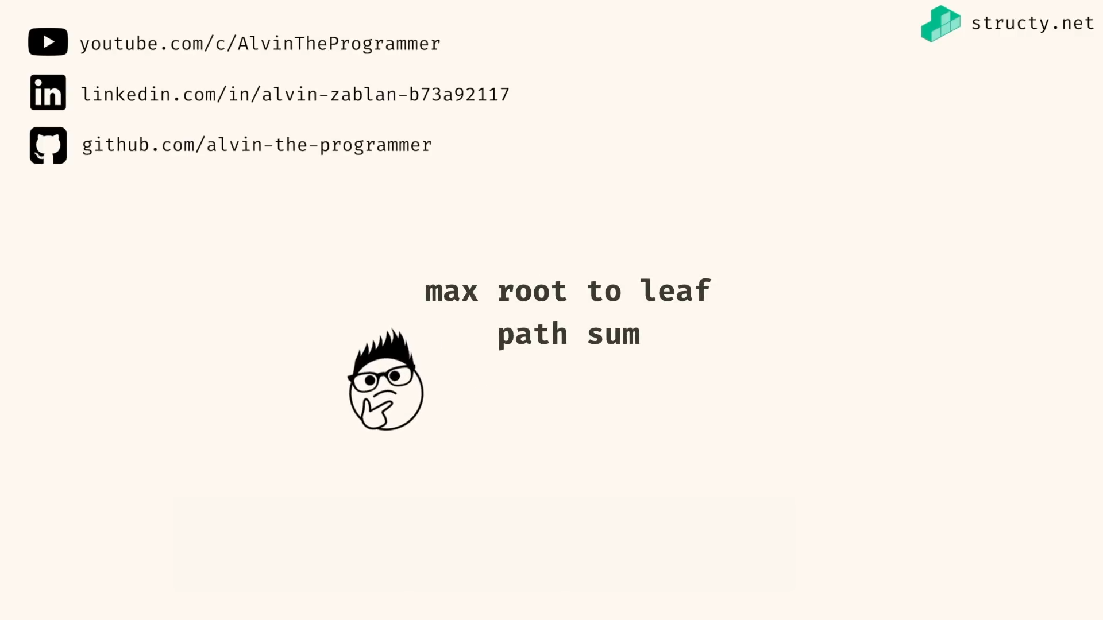

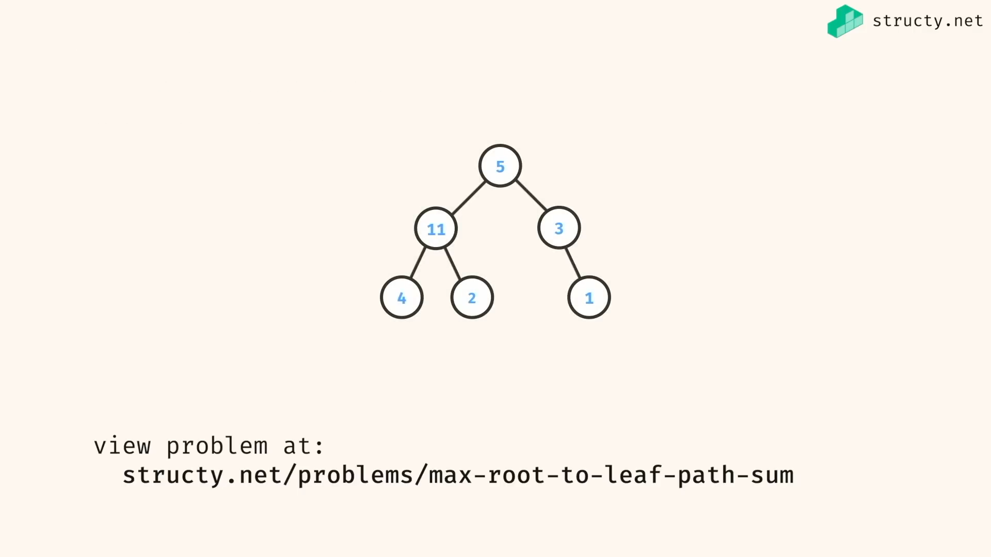

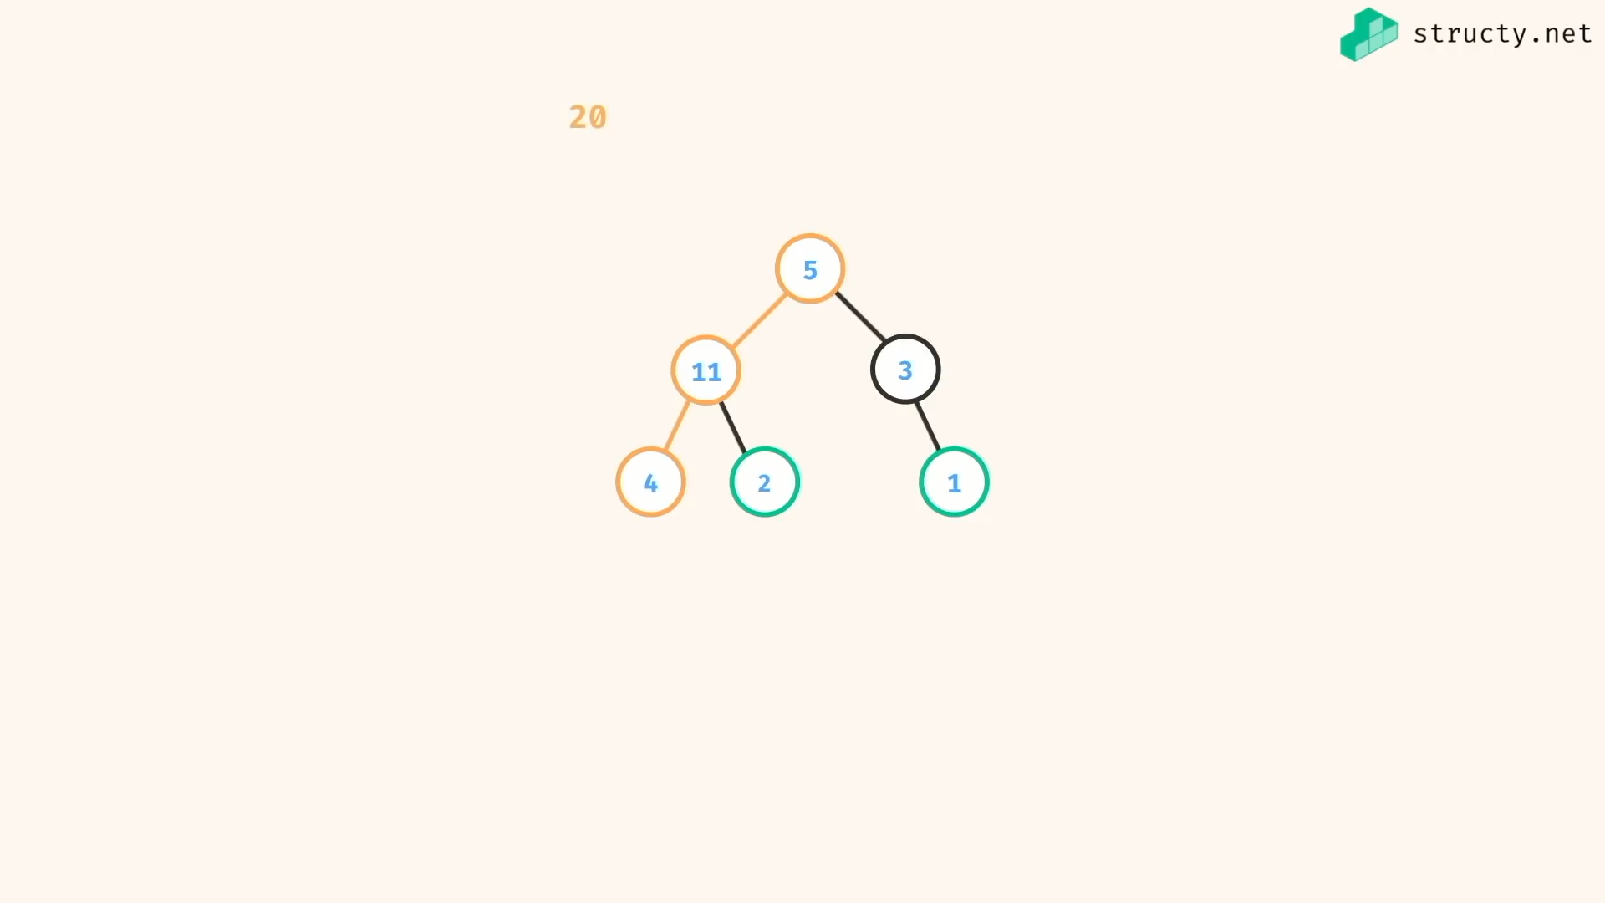

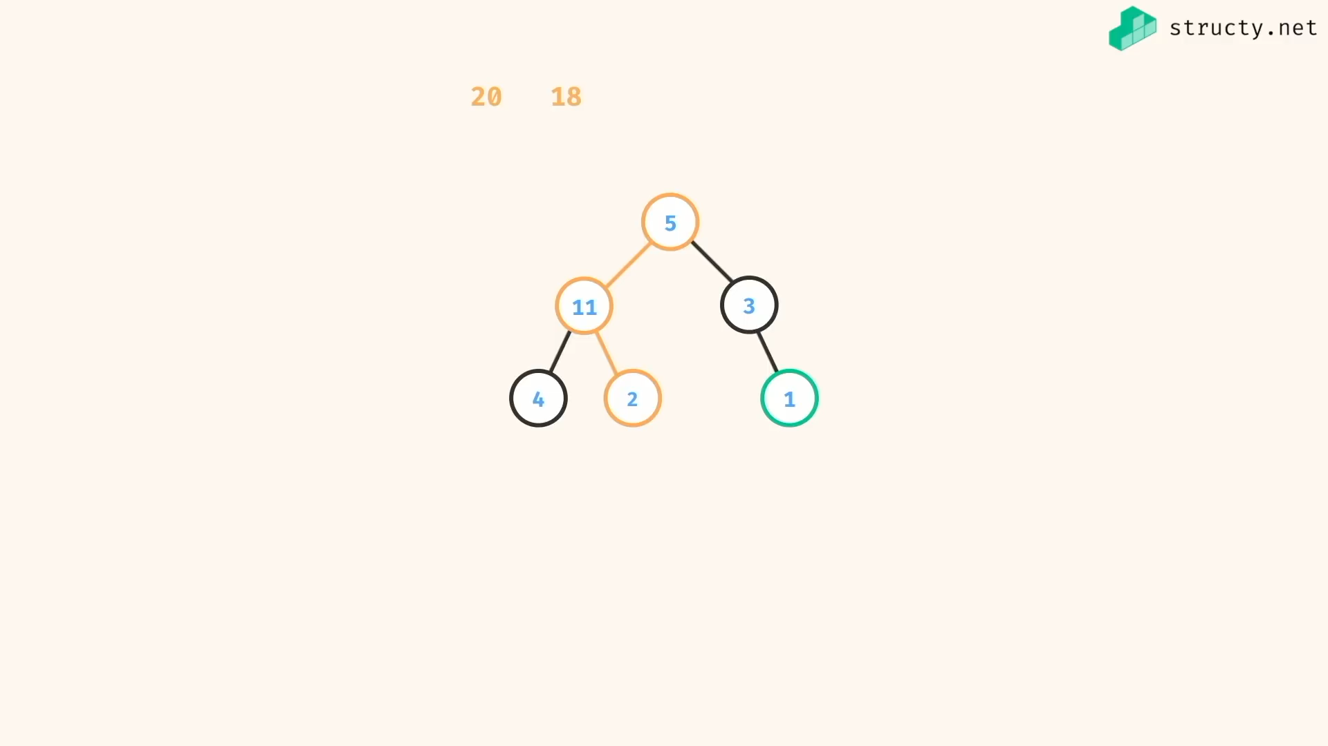

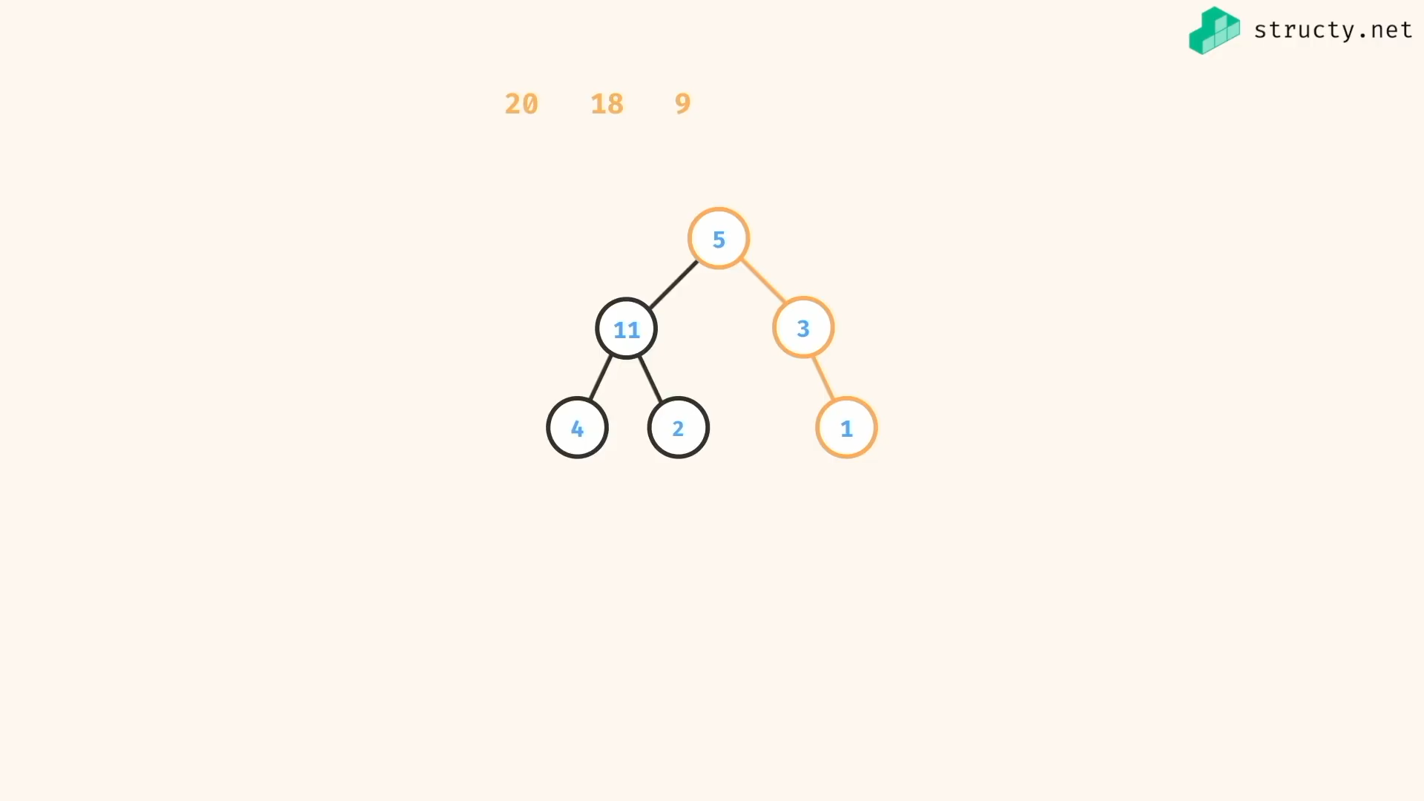

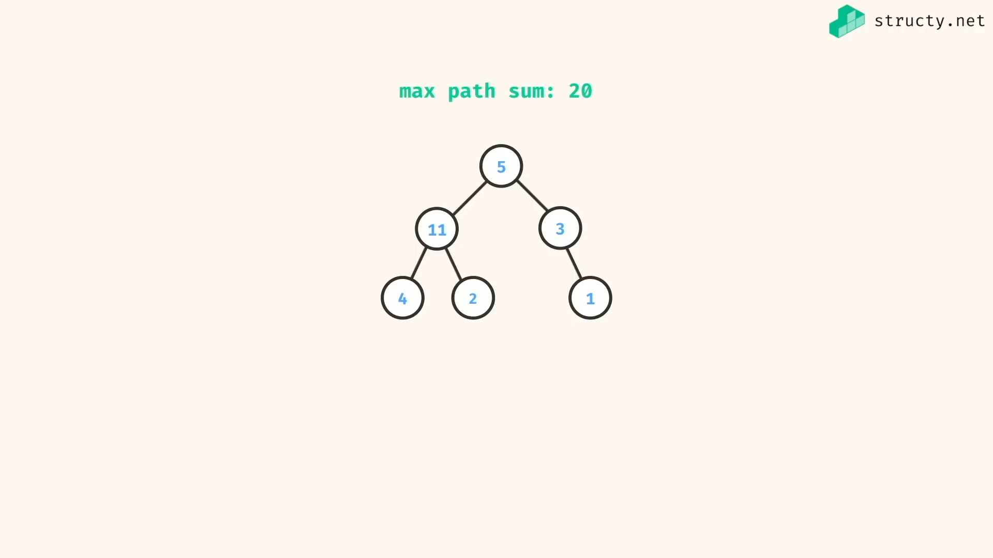

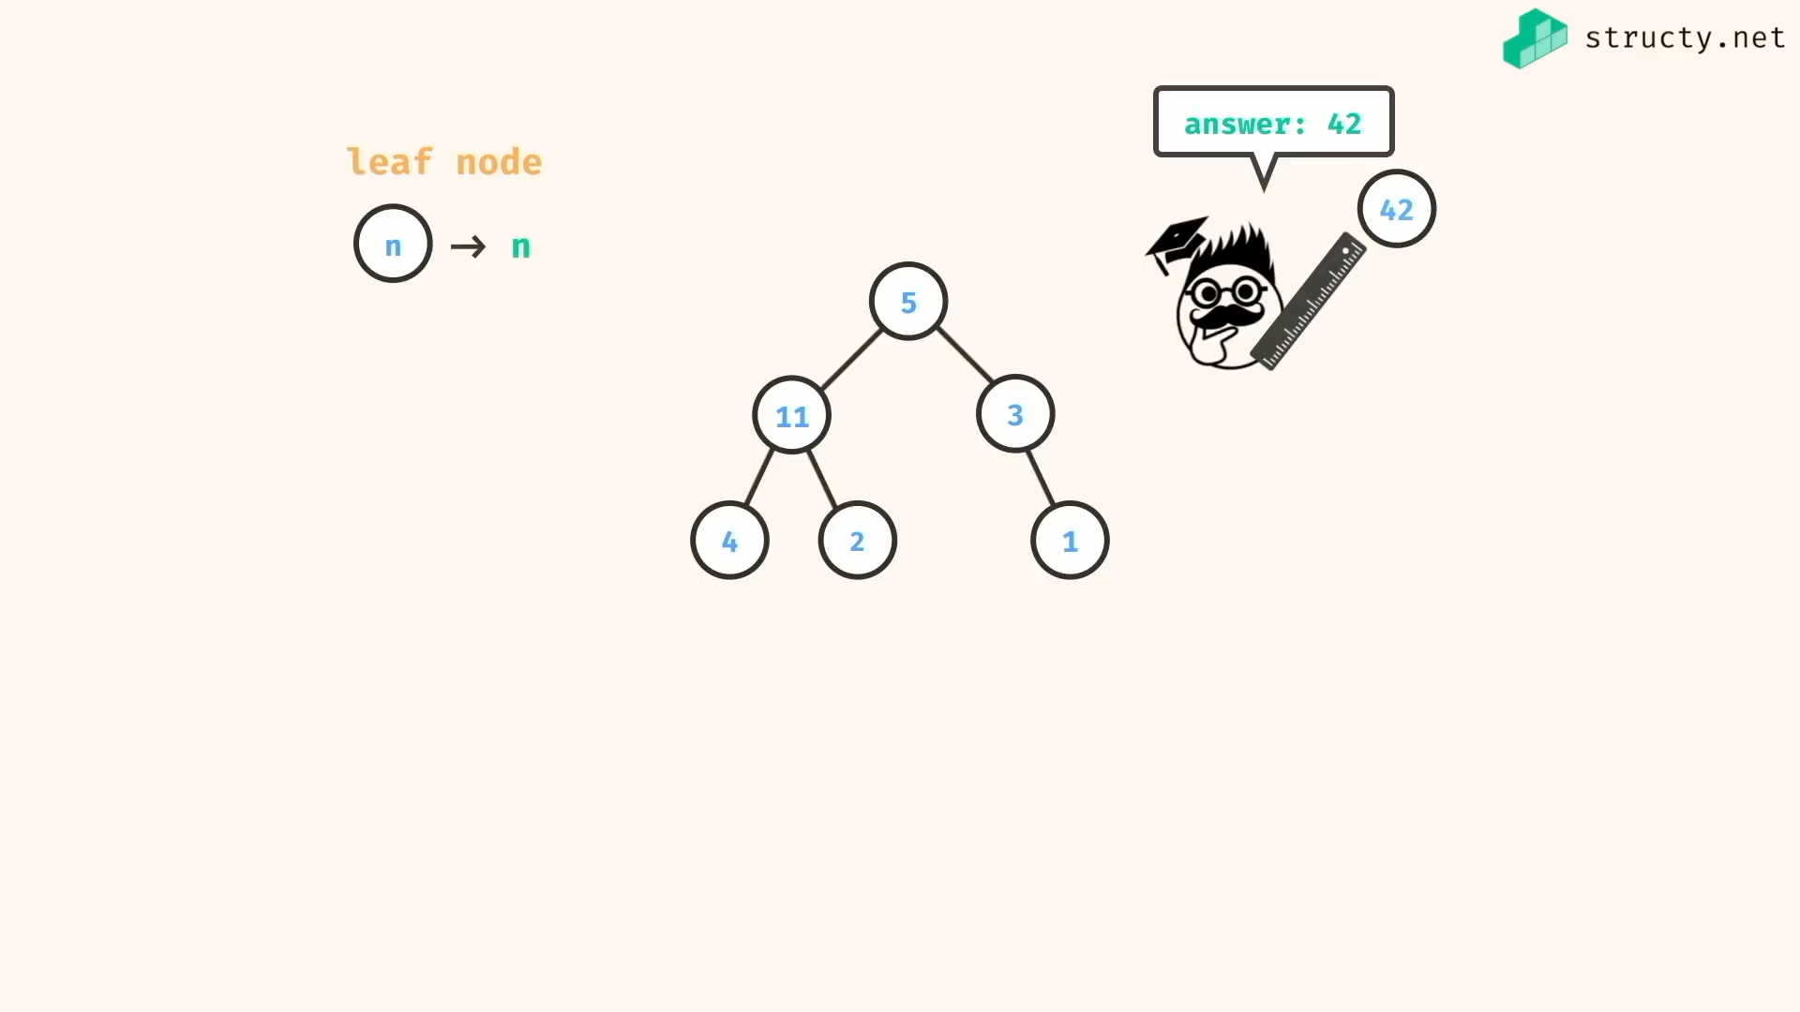

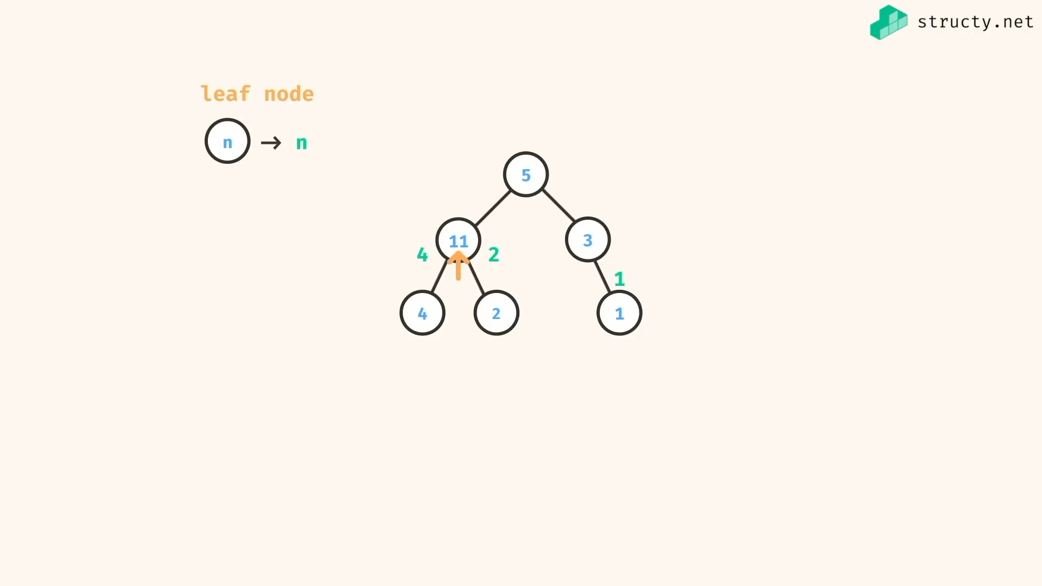

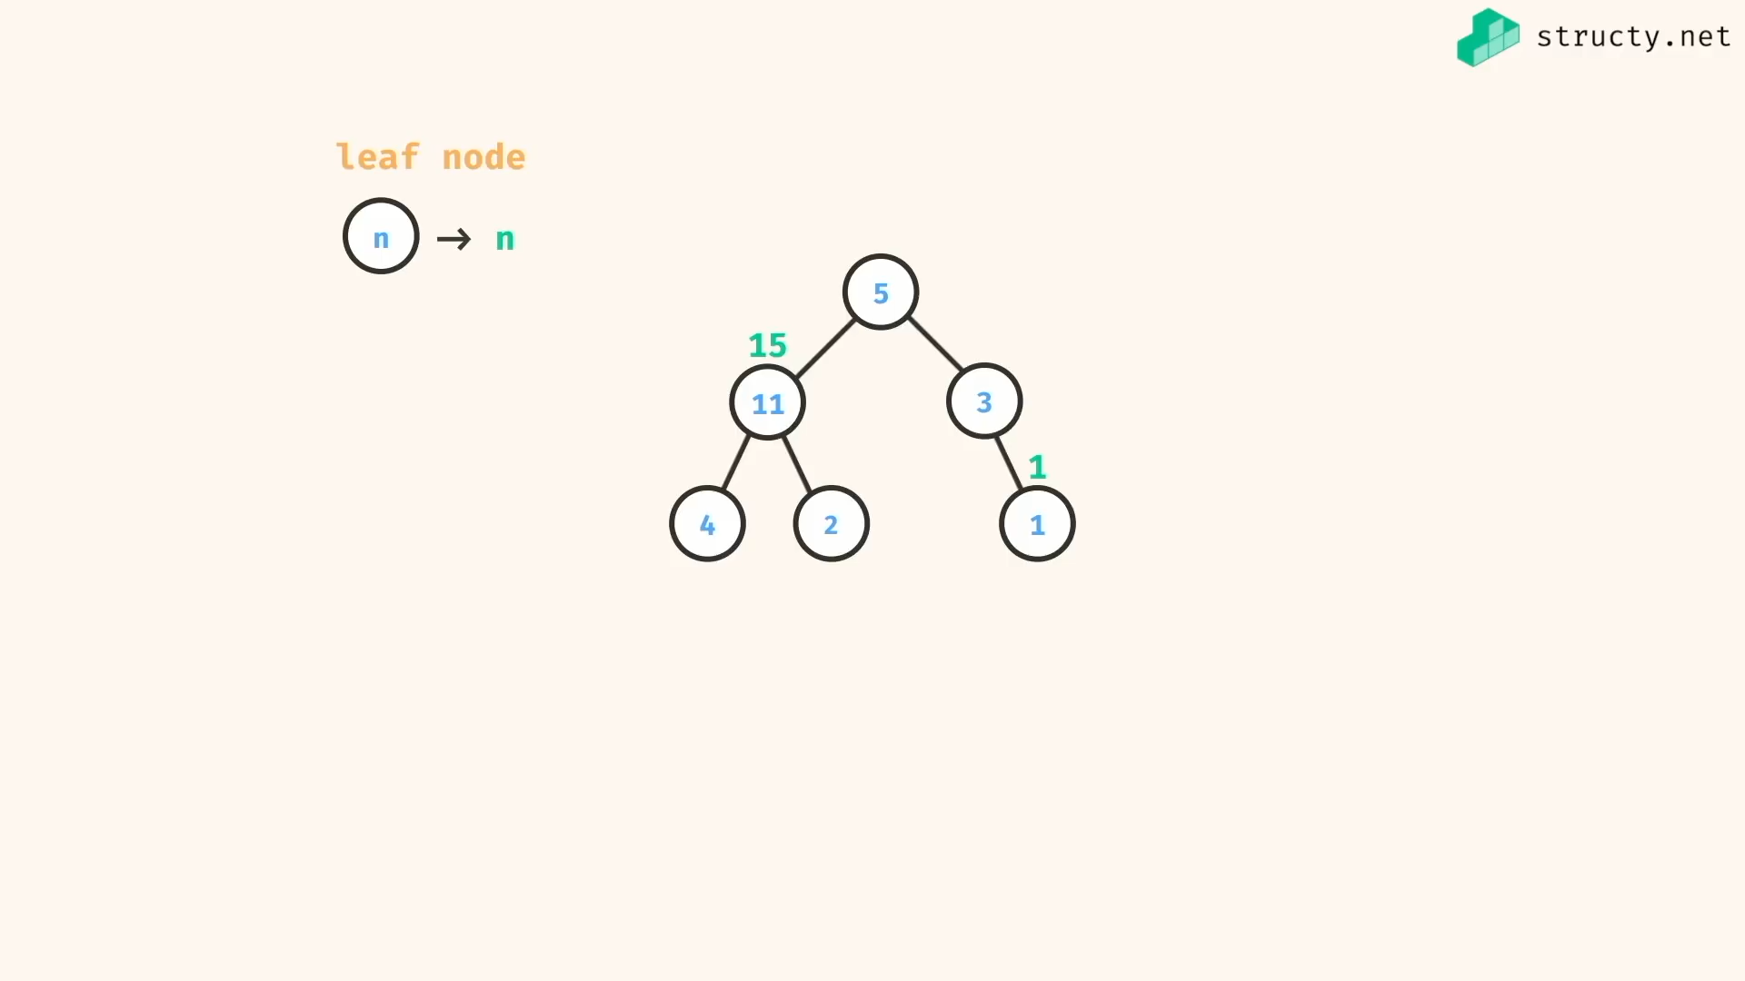

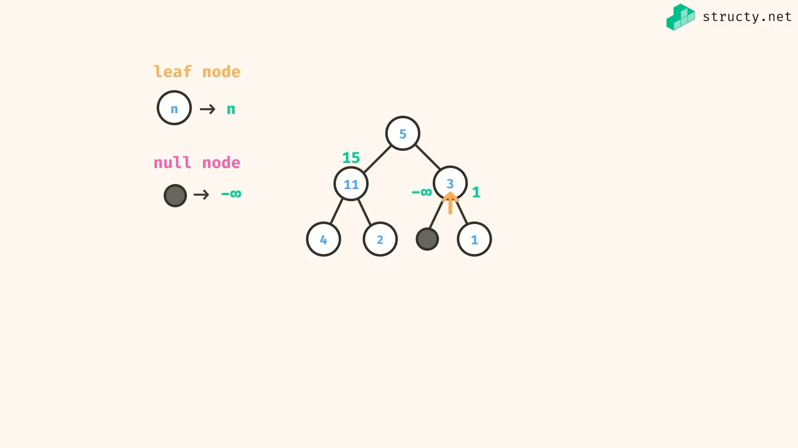

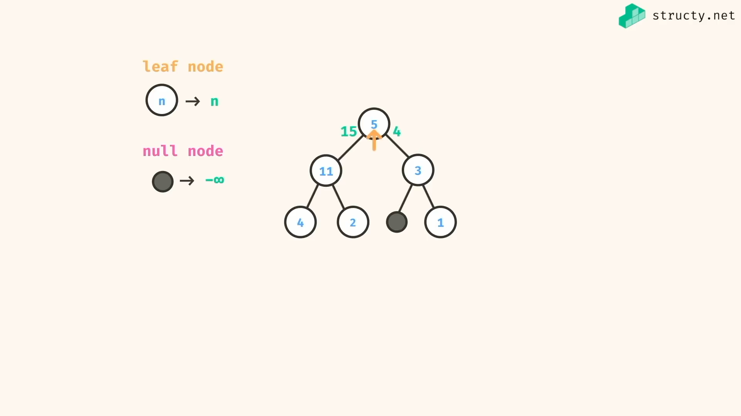

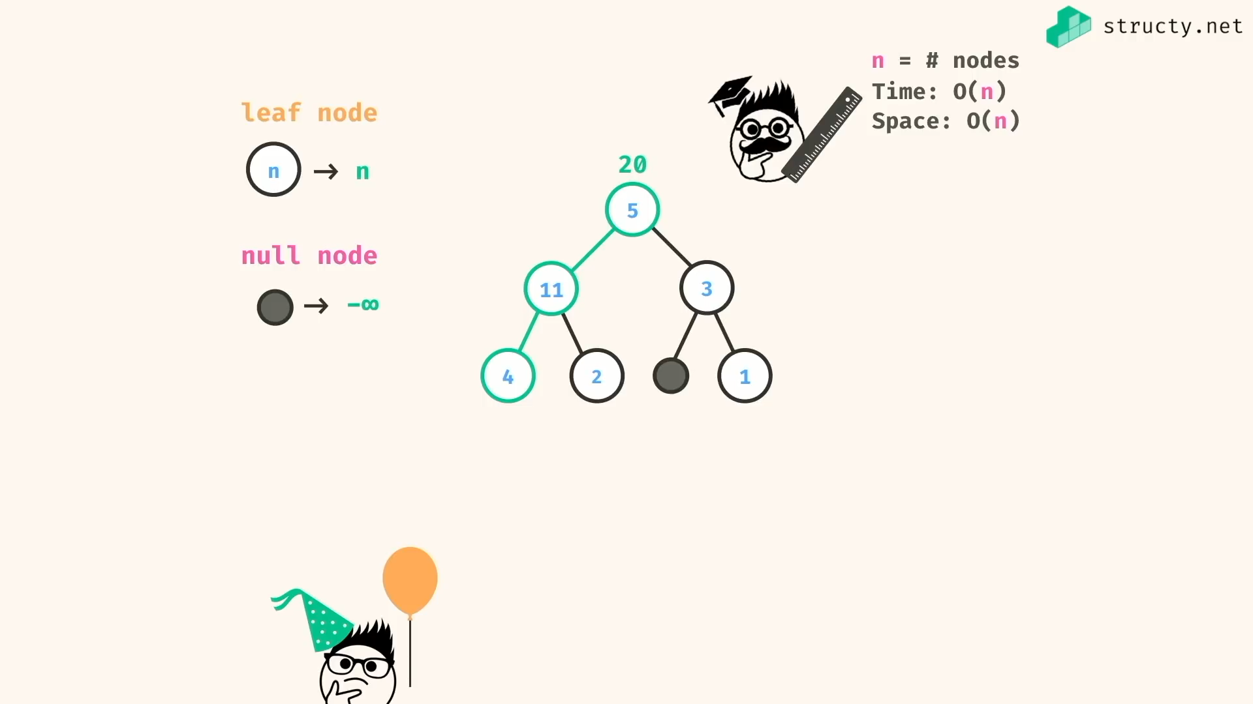

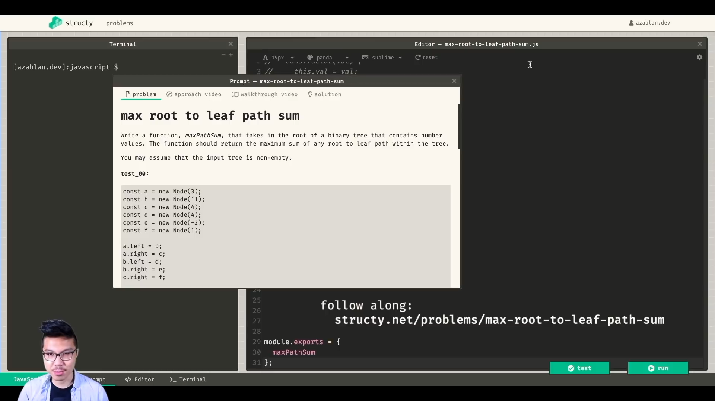

*const* maxPathSumRecur1 = (*root*) *=>* {

if(!root) return -Infinity;

*const* currentValue = root.val;

*const* leftTreeMaxValue = root.left ?

maxPathSumRecur1(root.left) :

-Infinity;

*const* rightTreeMaxValue = root.right ?

maxPathSumRecur1(root.right) :

-Infinity;

if(leftTreeMaxValue === rightTreeMaxValue && leftTreeMaxValue === -Infinity){

return currentValue;

}else if(leftTreeMaxValue > rightTreeMaxValue){

return currentValue + leftTreeMaxValue;

}else{

return currentValue + rightTreeMaxValue;

}

}

*const* maxPathSumRecur2 = (*root*) *=>* {

if(!root) return -Infinity;

if(!root.left && !root.right) return root.val;

return currentValue + Math.max(maxPathSumRecur2(root.left),maxPathSumRecur2(root.right));

}

*class* Node {

constructor(*val*){

*this*.val = val;

*this*.left = null;

*this*.right = null;

}

}

*const* a = new Node(3)

*const* b = new Node(11)

*const* c = new Node(4)

*const* d = new Node(4)

*const* e = new Node(2)

*const* f = new Node(1)

a.left = b;

a.right = c;

b.left = d;

b.right = e;

c.right = f;

/\*

3

/ \

11 4

/ \ \

4 2 1

\*/

*console*.log(maxPathSumRecur1(a)); //=> 18

*const* x = new Node(3)

*console*.log(maxPathSumRecur2(x)); //=> 3

*const* z = new Node(null)

*console*.log(maxPathSumRecur1(z)); //=> null

*console*.log(maxPathSumRecur2(z)); //=> null

To check {

Iterative soln of this problem

}

check{

Need to check application of BFS , DFS and its problems…

}

To see{

<https://www.slideshare.net/aakashdeepsinghal/lecture-8-e>

<https://leetcode.com/problems/invert-binary-tree/discuss/180395/Recursive-DFS-BFS-JavaScript>

<https://www.hackerearth.com/practice/algorithms/graphs/depth-first-search/tutorial/>

}